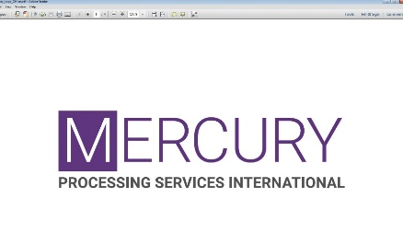te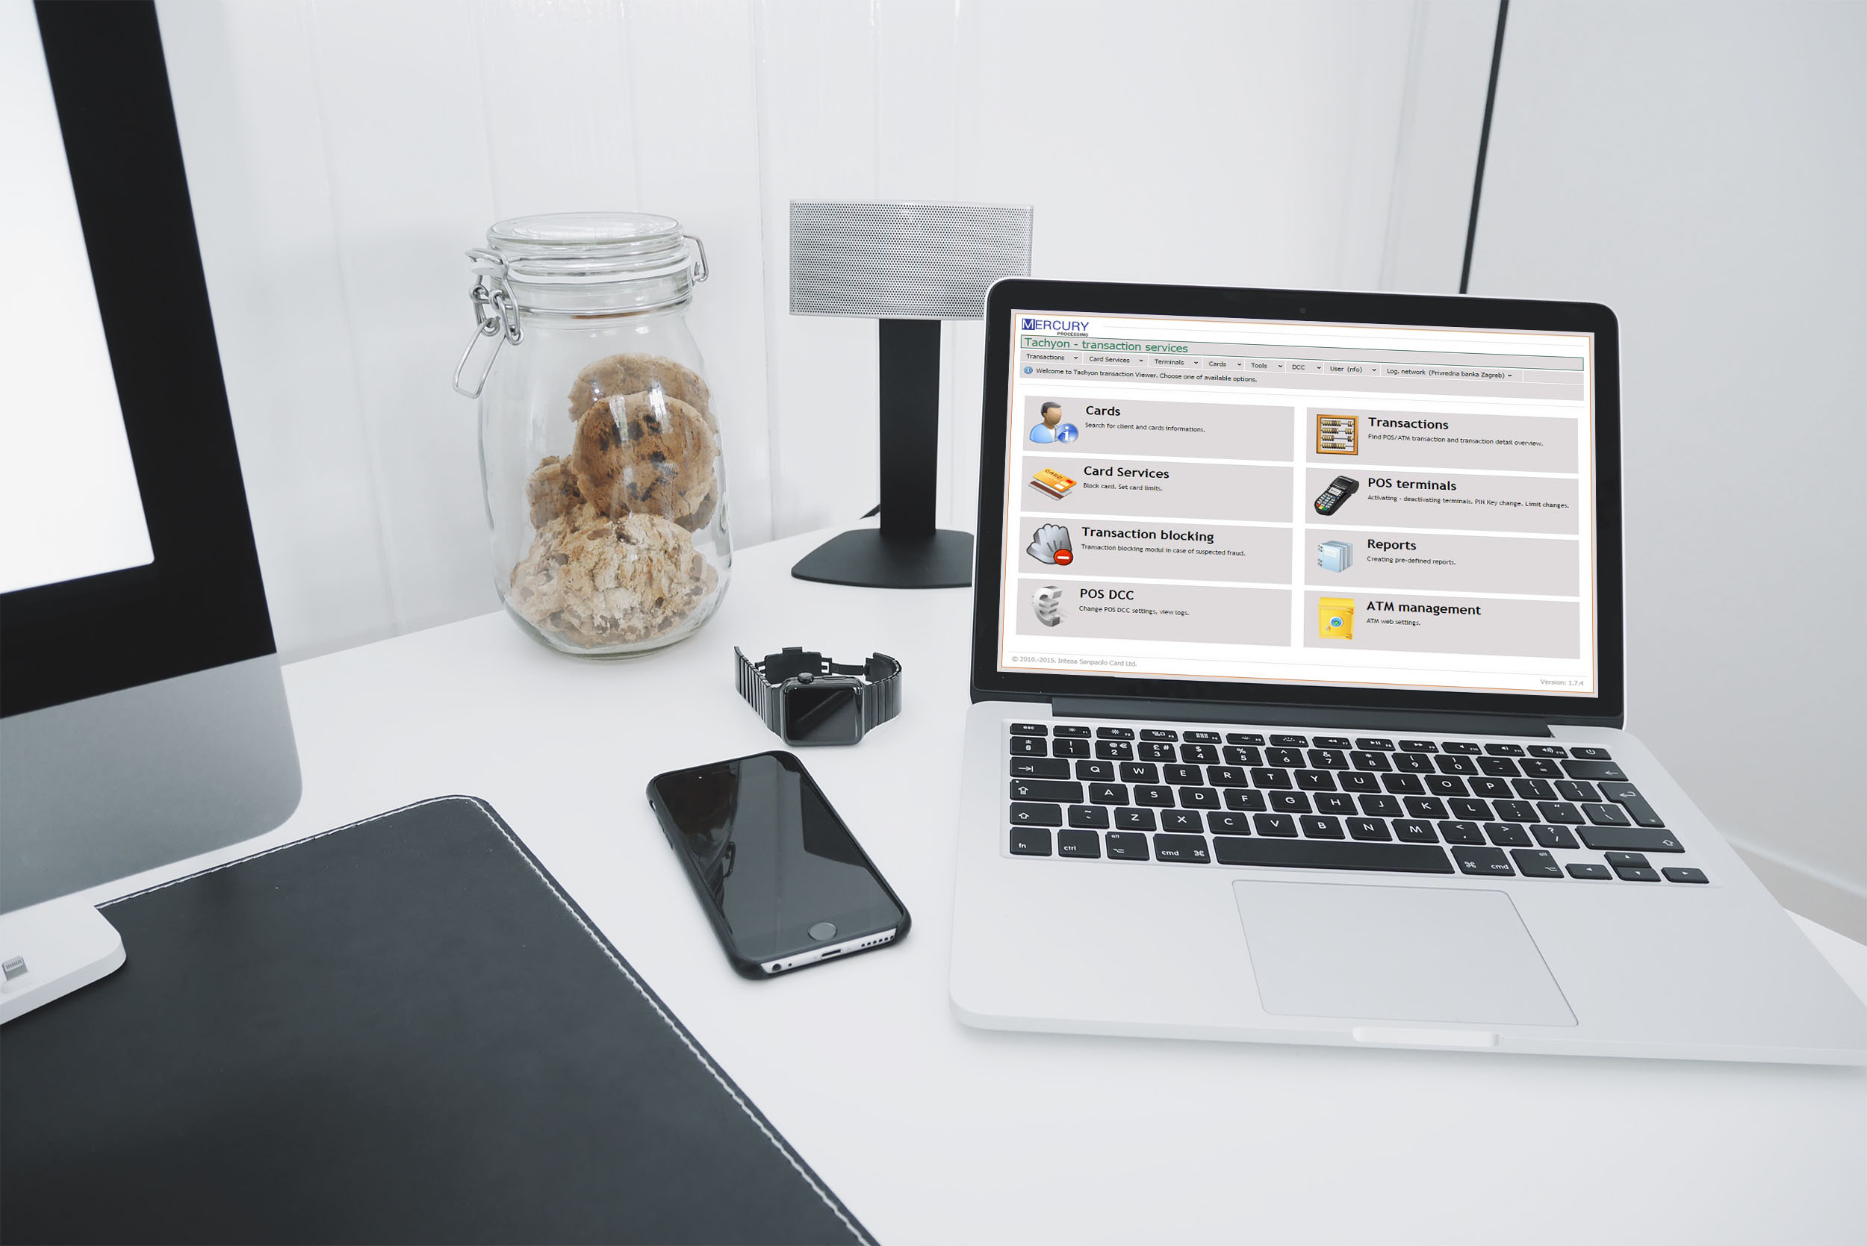

Zagreb, February 2018.

**vub - cms2exact migration**

**pos use cases**

**v 009**

# Table of contents

Table of contents 2

1. Change history 4

2. Document approval 4

3. Document distribution list 5

4. General provisions 5

5. Contents 5

5. 1. General instructions 5

5.1.1. Quick search option 6

5.1.2. Detailed search option 6

5.1.3. Data export 7

5.1.4. Entity browsing 8

5.1.5. History 9

5.1.6. Log of changes 10

5.2. UC POS 001: Add new customer through WS(s) 10

5.2. UC POS 002: Add new customer through web application 11

5.2. UC POS 003: Get customer data by WS(s) 20

5.2. UC POS 004: Update customer through WS 21

5.2. UC POS 005: Update customer through web application 22

5.2. UC POS 006: Cancel customer 24

5.2. UC POS 007: Reactivate customer 25

5.2. UC POS 008: Retrieve customer(s) 26

5.2. UC POS 009: Add new address & Statement definition 27

5.2. UC POS 010: Update address (additional / permanent) 31

5.2. UC POS 012: Retrieve address(es) 34

5.2. UC POS 013: Add new contract through WS(s) 35

5.2. UC POS 014: Add new contract through web application 36

5.2. UC POS 015: Update contract 41

5.2 UC POS 016: Update contract basic data 42

5.2. UC POS 017: Cancel contract 43

5.2. UC POS 018: Reactivate contract 44

5.2. UC POS 019: Contract transfer to same or different customer 45

5.2. UC POS 020: Retrieve contract(s) 48

5.2. UC POS 021: Update payment definiton 49

5.2. UC POS 022: Update payment definition validity 50

5.2. UC POS 023: Cancel payment definiton 51

5.2. UC POS 024: Reactivate payment definiton 52

5.2. UC POS 025: Retrieve payment definition(s) 53

5.2. UC POS 026: Add new retailer through WS(es) 54

5.2. UC POS 027: Add new retailer through web application 55

5.2. UC POS 028: Update retailer 59

5.2. UC POS 029: Cancel retailer 60

5.2. UC POS 030: Reactivate retailer 62

5.2. UC POS 031: Assign retailer to second contract 63

5.2. UC POS 033: Add new terminal through WS(s) 66

5.2. UC POS 034: Add new terminal (POS) through web application 67

5.2. UC POS 035: Add new terminal (e-Commerce) through the web application 72

5.2. UC POS 036: Update terminal 76

5.2. UC POS 037: Change terminal status 77

5.2. UC POS 038: Add/Update dual new terminal 78

5.2. UC POS 039: Cancel/Reactivate dual TID terminal 78

5.2. UC POS 040: Retrieve terminal(s) 79

5.2. UC POS 041: Add/Update standard commission model 80

5.2. UC POS 042: Add/Update dynamic commission model 83

5.2. UC POS 043: Add fees/discounts model 85

5.2. UC POS 044: Assign fees/discounts model to terminal 86

5.2. UC POS 045: Cancel fees/discounts model 88

5.2. UC POS 046: Add statement definition 89

5.2. UC POS 047: Update statement definition 92

5.2. UC POS 048: Update Statement definition validity 93

5.2. UC POS 049: Cancel statement definition 94

5.2. UC POS 050: Reactivate statement definition 95

5.2. UC POS 051: Retrieve unfinished wizard case(s) 96

5.2. UC POS 052: Publish unfinished wizard case 97

5.2. UC POS 053: Add/Update sales person 98

5.2. UC POS 054: Retrieve clearing transaction 99

5.2. UC POS 055: Search for transactions/ Add manual transaction 100

5.2. UC POS 056: Duplicate transaction 101

5.2. UC POS 057: Reverse transaction 102

5.2. UC POS 058: Reverse transaction (Chargeback reasons) 104

5.2. UC POS 059: Retrieve rejected transaction 105

5.2. UC POS 060: Update rejected transaction 106

5.2. UC POS 061: Retrieve nonfinancial transaction 107

5.2. UC POS 062: Retrieve pending transaction 108

5.2. UC POS 063: Update pending transaction 109

5.2. UC POS 064: Wizard validations report 111

6. References 112

7. Appendices 113

7.1. Links to the web services schemas 113

7.2. Appendix A – Terminal status change diagram (UC POS 035, UC POS 038): 114

7.3. Appendix B - UML sequence diagram 115

7.4. ACQ-POS Create Customer 115

7.5. ACQ-POS Create Contracts 116

7.6. ACQ-POS Create Retailers & Terminals 117

# 1. Change history

The following table shows the history of document changes.

|  |  |  |  |  |
| --- | --- | --- | --- | --- |
| **Document**  **version** | **Description** | **Pages** | **Issue Date** | **Author** |
| 001 | Initial version |  | 2017-02-28 | Stjepan Meseljević |
| 002 | Added additional use cases |  | 2017-03-14 | Stjepan Meseljević |
| 003 | Changes in use cases for updates of entities |  | 2017-04-25 | Stjepan Meseljević |
| 004 | Additions and corrections | 53 | 2017-11-27 | Anita Rendulic |
| 005 | Additions and corrections | 84 | 2017-12-12 | Anita Rendulic |
| 006 | Additions (e.g. financial options) and corrections | 98 | 2018-01-08 | Anita Rendulic |
| 007 | Additions and corrections | 103 | 2018-01-22 | Martin Ćosić |
| 008 | Additions and corrections | 118 | 2018-02-09 | Martin Ćosić |
| 009 | Additions and corrections | 117 | 2018-02-16 | Martin Ćosić |

# 2. Document approval

The following table shows a list of stakeholders who have approved the document.

|  |  |  |  |
| --- | --- | --- | --- |
| **Stakeholder** | **Role** | **Approval Date** | **Approval method** |
|  |  |  |  |

# 3. Document distribution list

The following table shows a list to which the document is mandatory to be distributed.

|  |  |
| --- | --- |
| **Name and Surname** | **Role** |
|  |  |
|  |  |
|  |  |
|  |  |

# 4. General provisions

The main purpose of this document is to explain through the Use Cases functionalities in *Acquiring*, *Administration* and *Other* modules of eXact application, and system activities that have significance to the users.

Use Case specification should be written from the user’s perspective and explains the functional requirements of developed software, that end-user is able to understand relatively easily. Also give to analysts, designers, developers and testers sufficient understanding what they have to do.

Definitions of used abbreviations in this document:

UC - Use Case

WS - web service

VUB - Všeobecná úverová banka

MPSI - Mercury Processing Services International

CM - commission model

DB - database

TBD – to be defined

We recommend to use this document with *Navigation Pane* option activated (*View* tab in Word) for easier to handle through Use Cases.

Hyperlins are also used for better navigation through document.

With track changes are marked changes in the last document version, compared to the previous verison. Every new version will accept first all existing track changes, before further document modifications.

# 5. Contents

# 5. 1. General instructions

This chapter gives general instructions how to use search, data export and entity browsing functionalities from the *Review 2* form in eXact web application.

To enter the form, click on: **Acquiring** > **Review 2** > choose one of the possible option from dropdown list:

* Customers
* Addresses
* Contracts
* Retailers
* Terminals
* Payment definitions
* Statement definitions
* Unfinished wizard cases
* New contract
* New customer

Depending of chosen option, different fields for search criteria insert will be shown on the screen and offer better and easier access to desired data.

# 5.1.1. Quick search option

This option allows insert of any search criteria (e.g. number, name… etc), eXact will show in results list grid all records that contain search inserted values. Search will be performed according to entity IDs.

Merchant offers entity type VUB will use with DCC transactions for POS terminals.

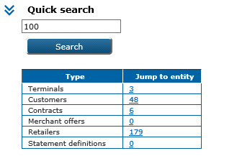

# 5.1.2. Detailed search option

This option allows more detailed and specific search. Search criterias enter is done via built in function of search results module, which has 2 working modes:

* Search mode
* Review mode

While in *Search mode*, search results module has following parts:

* **Functions:**
  + Apply filter - apply searching with defined search criteria(s) and switch to review mode
  + Clear filter - apply searching with no search criteria(s) and switch to review mode,
* **Fields for search criteria enter** – first enter search criteria(s) and then apply search by click on the button *Apply filter*
* **Results listing** – data results with applied filters will be shown in the grid
* **Pager** with search results counter.

Switching between modes can be done by functions:

a) Apply filter

b) Clear filter

c) Filter.

While in *Review mode*, search results module has following parts:

* **Results listing** - results with applied filter are shown in grid
* Functions
  + Refresh - refresh with current criteria
  + Filter - switch to search mode
  + Save settings - save user options (column sorting, column visibility etc.)
* **Pager** with search results counter.

User have the following options if he click on grid column names line with right mouse button:

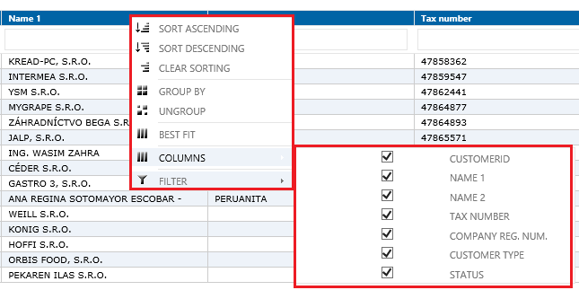

# 5.1.3. Data export

Data presented in list grid can be exported to the following file formats:

* Excel
* CSV
* PDF.

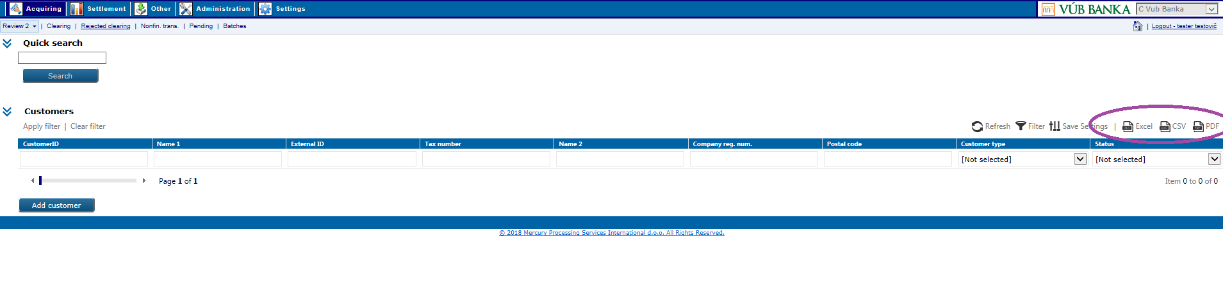

# 5.1.4. Entity browsing

*Review 2* have enhanced search capabilities called „Entity browsing“, so you can quickly change level of search (customer, contract, retailer, terminal, … ) without typing any data. With just click on the icon in grid you can quickly change your view/search percpective and find data you need.

Entity browsing can be performed:

„Down“ - from customer level down to contract/retailer/terminal

„Up“ – from terminal level up to retailer/contract/customer.

Entity level is your position in the hierarchy of the data structure and it is shown above the search grid.

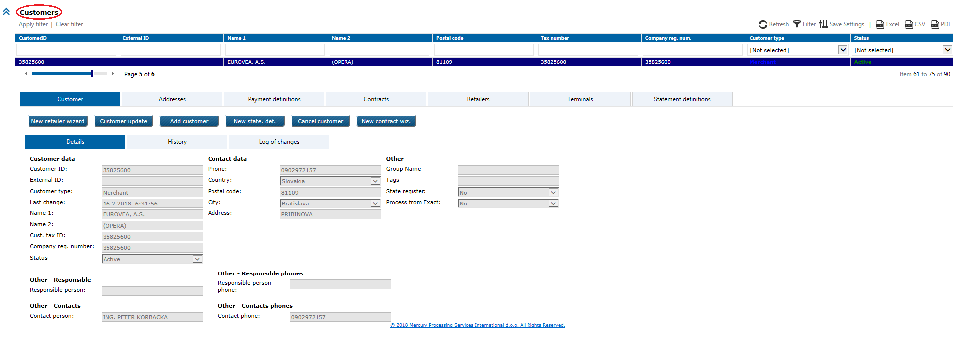

If you are positioned on entity level - *Customers*, under tab *Retailers* you will see list of all retailers belong to particular customer.

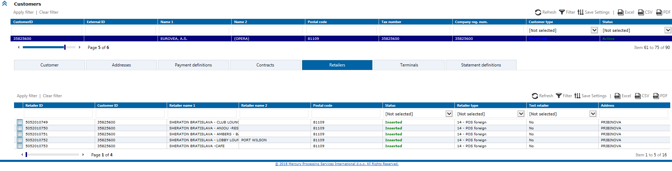

For example, you may want to find out details of one particular retailer. Instead of typing *Retailer ID* to search form for retailer, you can easily change your search view by click on small icon in front of particular retailer in grid.

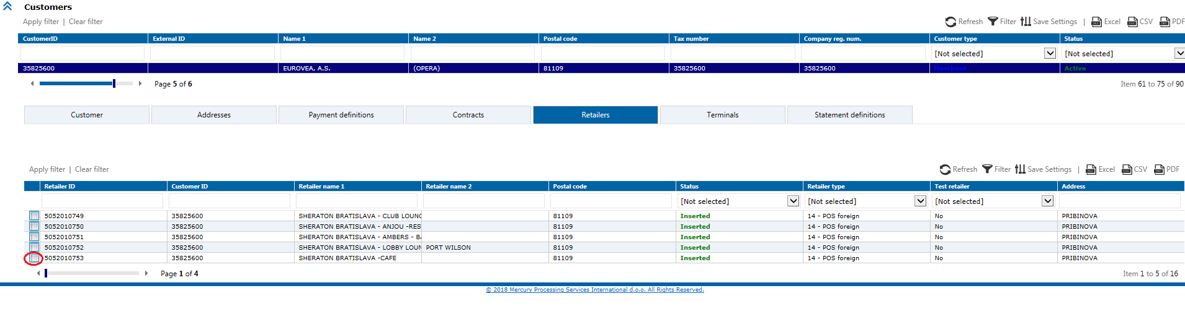

eXact will perform search for this *Retailer ID* and present search results as shown on the screenshot bellow:

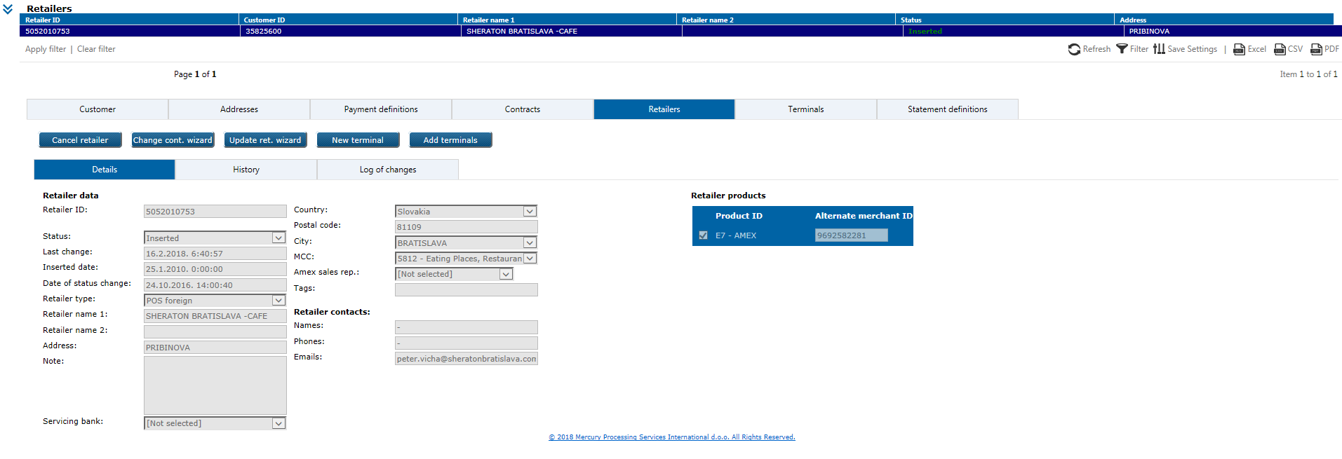

Note that your entity level has changed, now is retailer level and you can see all details for particular retailer.

# 5.1.5. History

Each change in entity data will be logged forever in *History* tab.

*History* tab gives information about change date and time along with the username which changed data. Example at the following picture shows history of changes for particular terminal.

By click on each history record, it’s details will be shown as they were before and after the change.

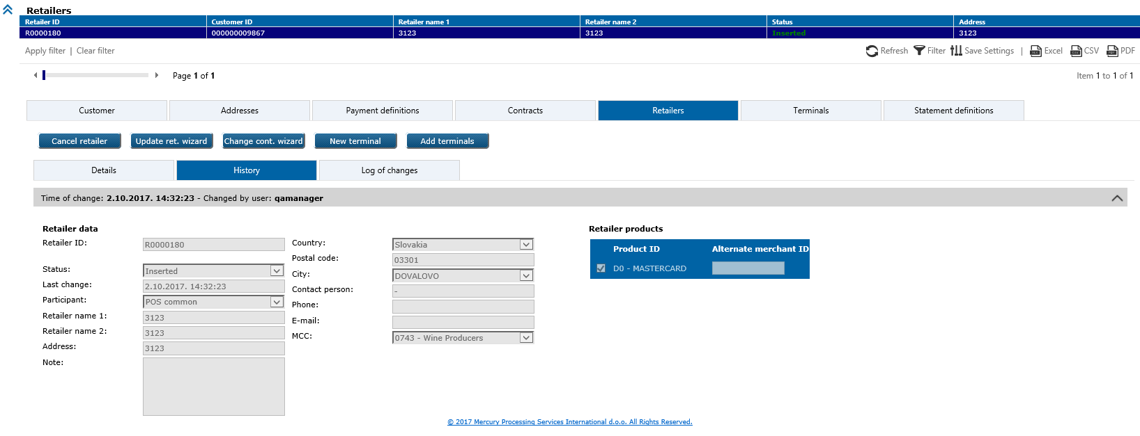

# 5.1.6. Log of changes

This tab shows forever all changed data by chronological order, the newest listed on the top:

* data modified
* changed field name
* old value
* new value
* User ID.



# 5.2. UC POS 001: Add new customer through WS(s)

Entry of new customer type ‘Merchant*’* in the system, through web service(s).

**Preconditions**

* partner should exist in the system,
* customer which you want to add in eXact, should exist in VUB customer database and should not exist in eXact system,

**Triggers**

1) *AddCustomer* WSmethod with customer data as elements. New customer added on this way

will be directly inserted in the database and automatically published.

2) Add new customer per sequences (to create unfinished wizard case in web application),

possible WS methods are:

*StartWizardSequence* - *UseCaseTemplateID* should have value ‘50’ (Add customer wizard)

- if will be successfully executed, user will receive *SequenceID* in response

message

*AddCustomer* - in request message should be input the same *SequenceID* which you got

in response for *StartWizardSequence* method

*FinishWizardSequence -* in request message should be input the same *SequenceID* which

you got in response for *StartWizardSequence* method.

Status ‘0’ in response means, that WS was successfully executed.

Successfully input customer’s data in database, possible are to use in web application:

*Acquiring* module > *Review2* form > *Unfinished wizard cases* option

Detailed explained in US POS 052

Appendix B - UML sequence diagram

**Business & system rules**

* for customer creation explained in the next UC POS 002,
* for unfinished wizard cases explained in UC POS 051 (retrieve) and UC POS 052 (publish),
* *External ID* (VUB internal customer ID) is mandatory to input in *AddCustomer* WS method.

# 5.2. UC POS 002: Add new customer through web application

Entry of new customer type ‘Merchant*’* in the system, through web application.

**Preconditions**

* partner should exist in the system,
* customer which you want to add in eXact, should exist in VUB customer database and should not exist in eXact system.

**Triggers**

1) *Acquiring* module *> Review2* form *> New customer* option

New customer wizard will open, enter/select relevant data (mandatory fields marked with red asterix) on each wizard step and if it was correctly done, user will be able to finish (publish) customer entry without error messages.

a) Basic customer info:

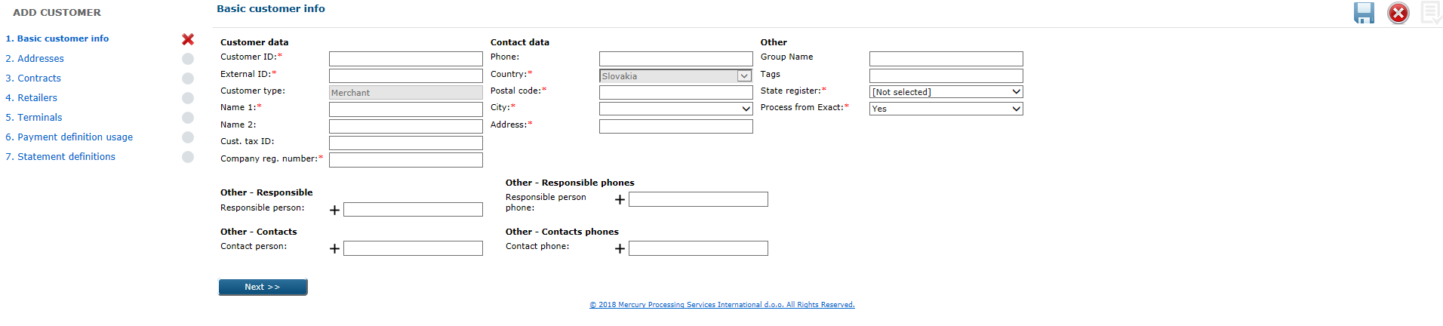

b) Addresses:

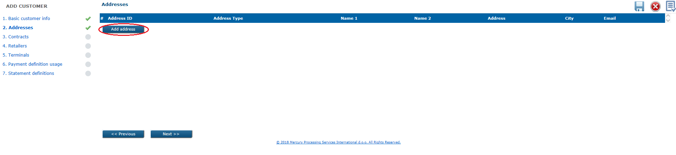

By click on the Add address button new wizard will open where you can add additional address for the customer (e.g. address for the statements distribution). Depends of selected *Address type*, relevant fields will be dynamically displayed:

Address type: Mailing address

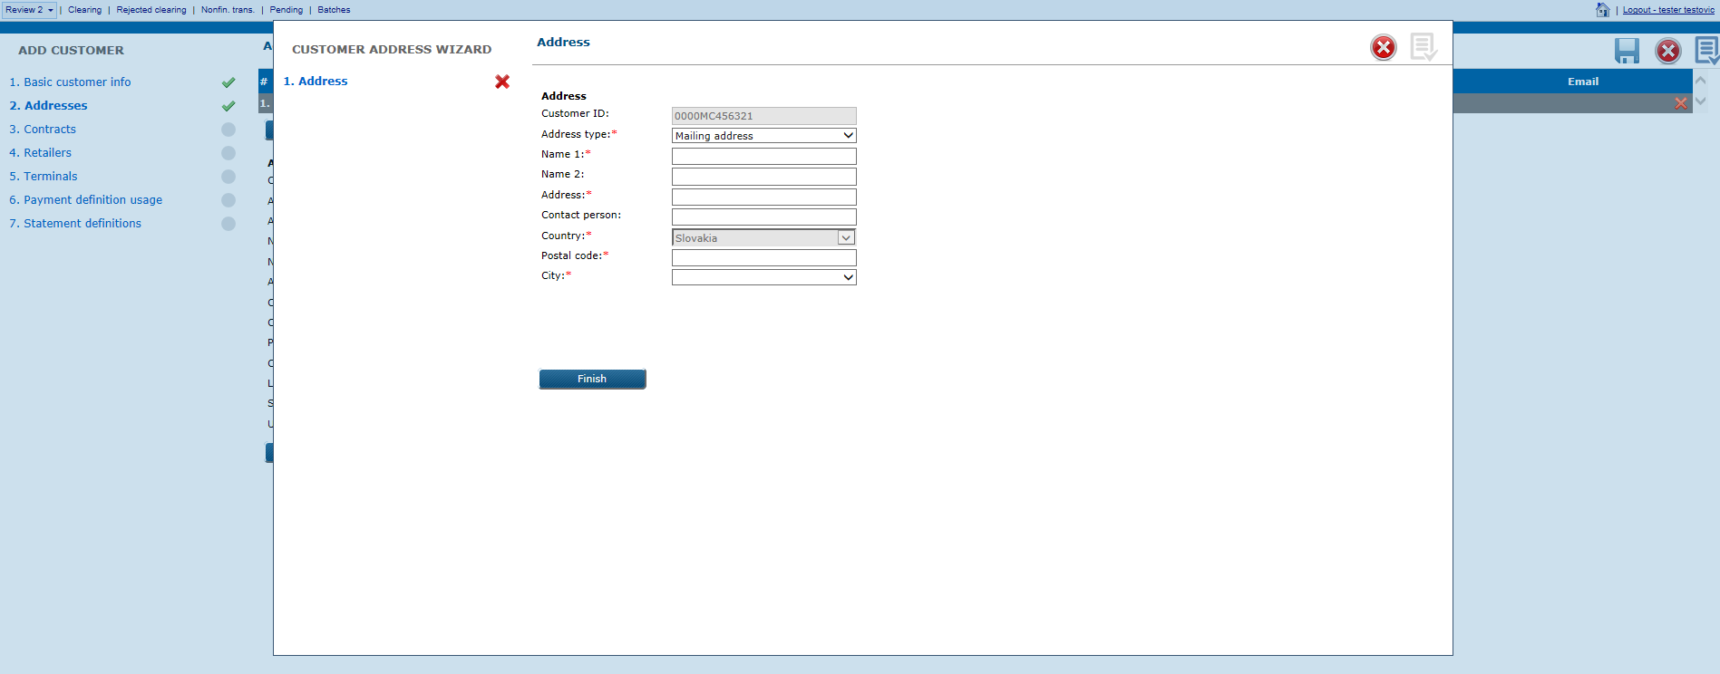

Address type: E-mail

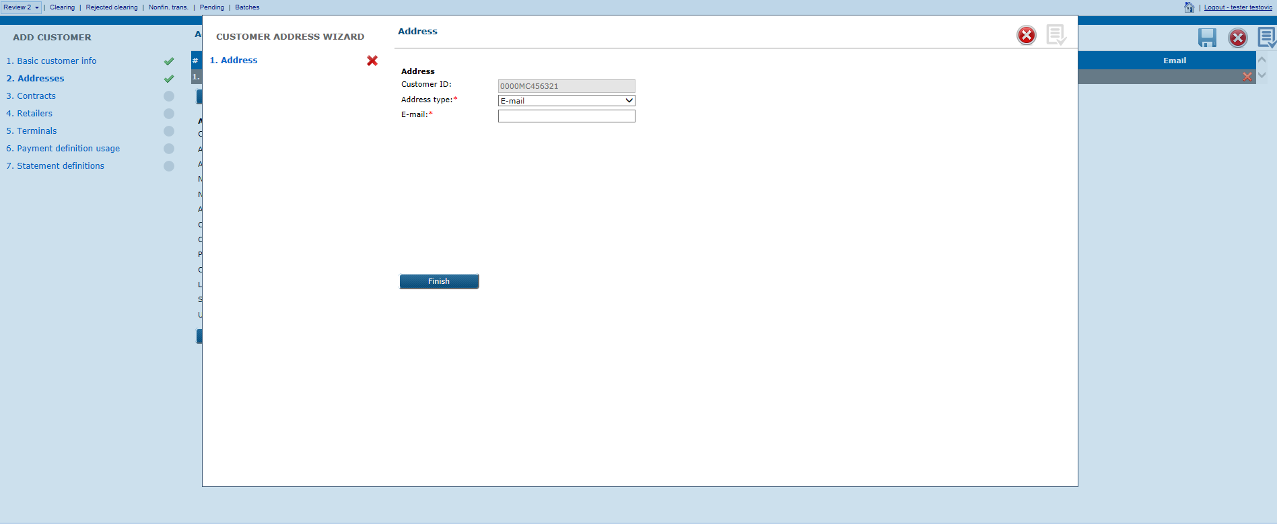

Address type: InBiz

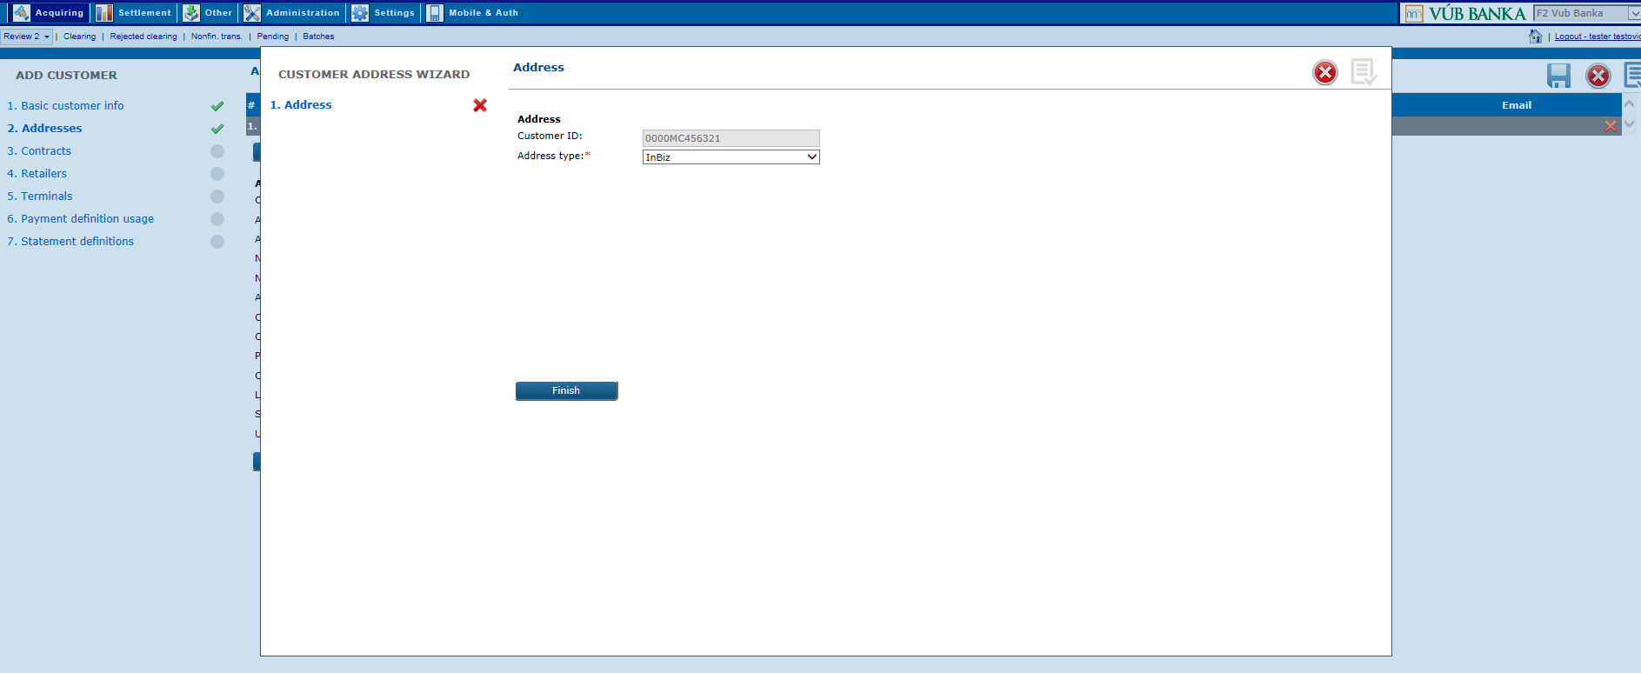

Additional address created by mistake, you can delete on the following screen by click on the right positioned orange X sign related to address data in that line:

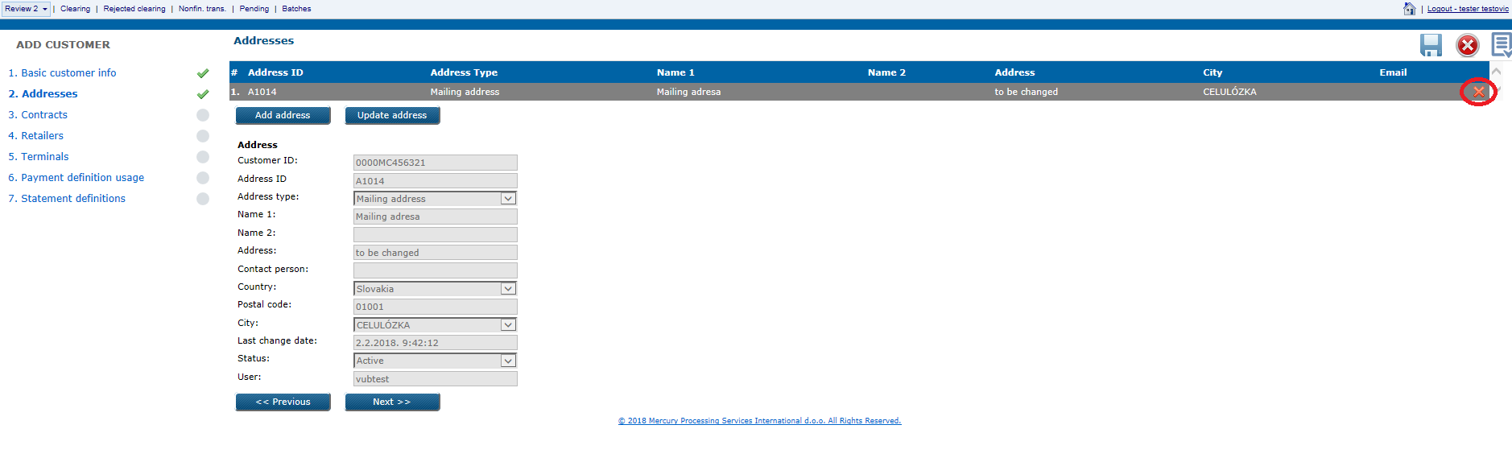

Or you can modify entered data by click on the Update address button.

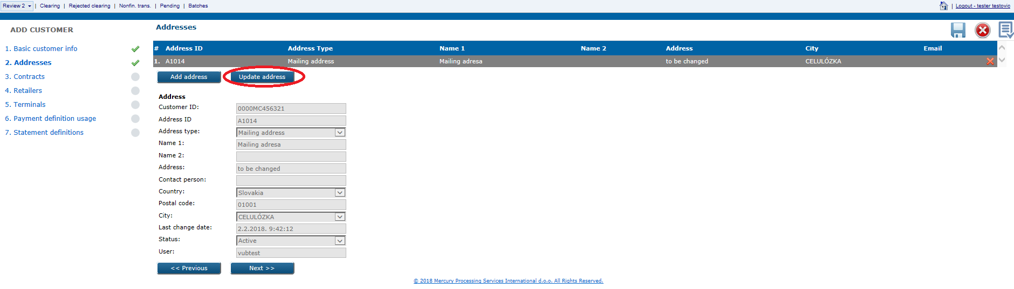

c) Contracts:

In the main new customer wizard, you can create directly new contract(s) by click on the Add contract button which will call new contract wizard:

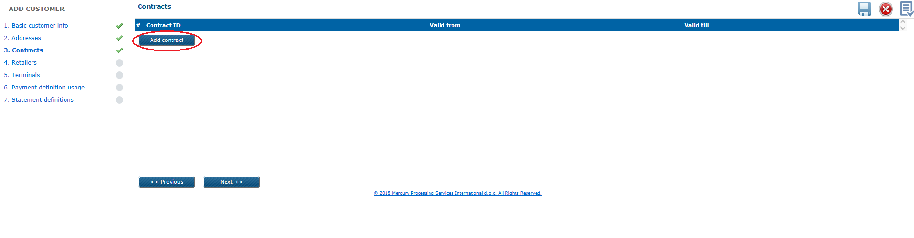

New contract wizard has the following steps (explained in US POS 014):

1. Basic contract data

2. Products & commissions

3. Payment definitions.

Created contract you can delete on the following screen by click on the right positioned orange X sign related to contract data in that line, you can modify entered data, add more contracts.

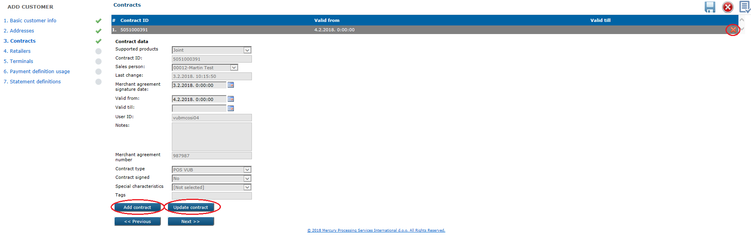

d) Retailers:

In the main new customer wizard, you can create directly new retailer(s) by click on the

Add retailer button which will call new retailer wizard:

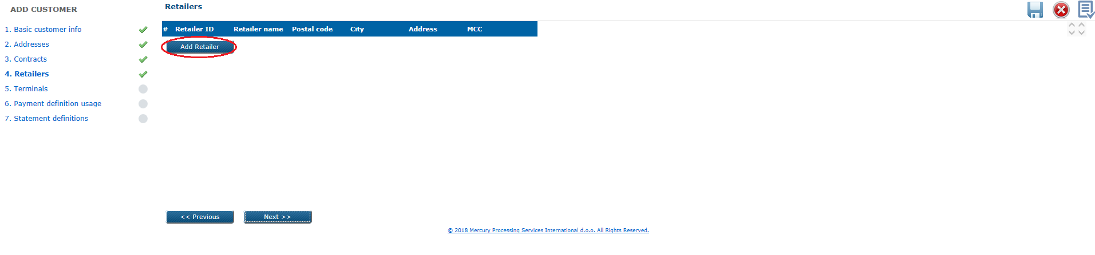

New retailer wizard has the following steps (explained in US POS 027):

1. Contract data

2. Retailer basic data

3. Retailer products

4. Payment definition.

On the following screen you can delete added retailer, by click on the right positioned orange X sign related to retailer data in that line, you can modify entered data, add more retailers

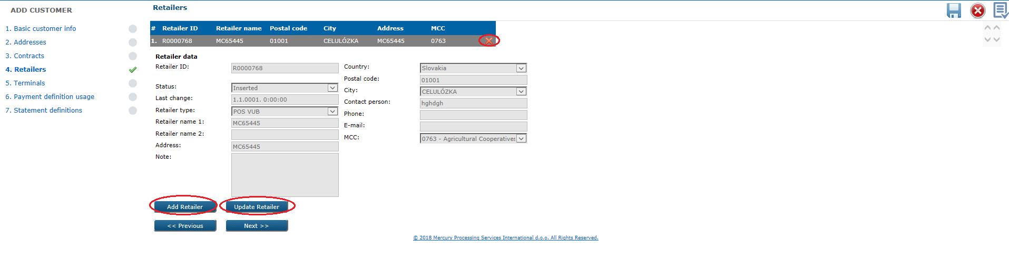

e) Terminals:

In the new customer wizard you can also add terminal(s) for the new retailer:

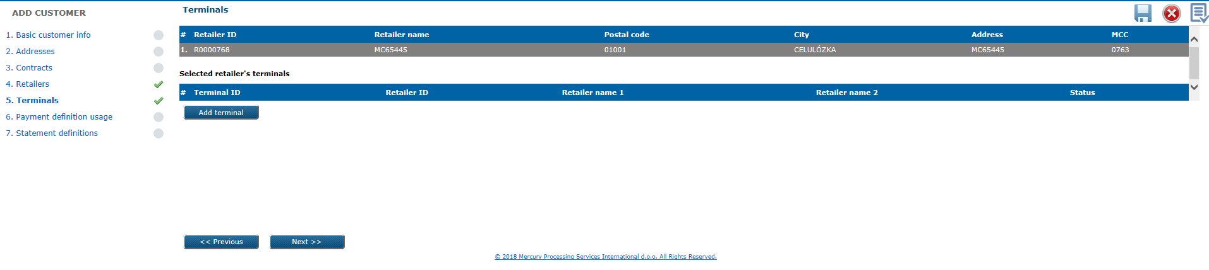

Select first on that screen retailer to which you want to add new terminal, then click on the Add terminal button and call new terminal wizard with the following steps (explained in US POS 035 and UC POS 34):

1. Basic terminal data

2. Terminal technical details

3. Terminal additional data

4. Terminal products

5. Terminal fees & discounts

6. Payment definitions.

On the following screen you can delete added terminal, by click on the right positioned orange X sign related to terminal data in that line, you can modify entered data, add more terminals.

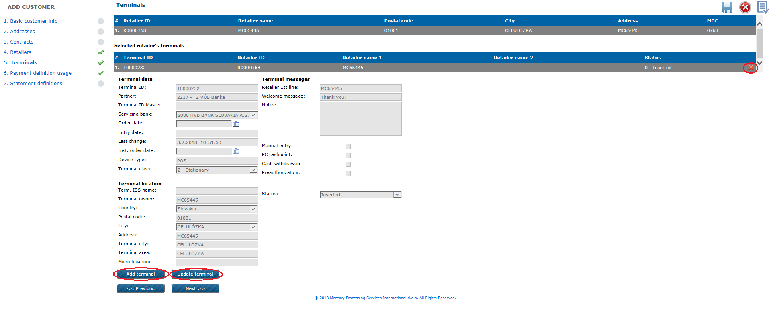

New terminal wizard can be used for *Retailer types*: POS VUB, POS foreign, Imprinter, MOTO, CASH advance, e-Commerce, Unattended. Cannot be used for Top-up (ATM) retailer type.

f) Payment definition usage:

On the next step in new customer wizard, you can see payment definition usage data for that customer:

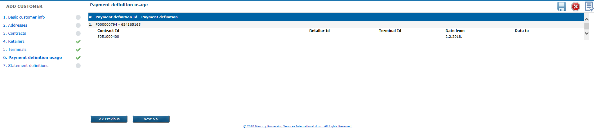

In case you have entered new payment definition in step 4 (explained in US POS 027) and/or step 5 (explained in US POS 34 and US POS 035) you will see on this view assignment of payment definitions for entities.

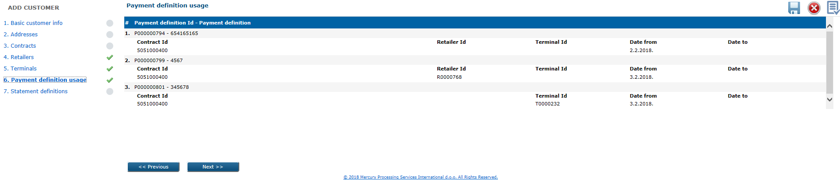

g) Statement definitions:

In new customer wizard you can also add statement definition(s) by click on the New state. def. button:

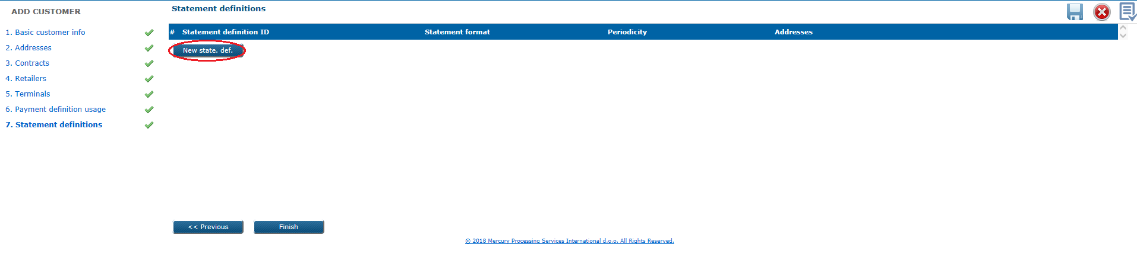

New statement definition wizard has the following steps (explained in UC POS 46):

1. Basic statement definition data

2. Statement definition addresses

3. Statement definition scope.

On the following screen you can delete added Statement definition, by click on the right positioned orange X sign related to statement definition data in that line, you can modify entered data, add more statement definitions.

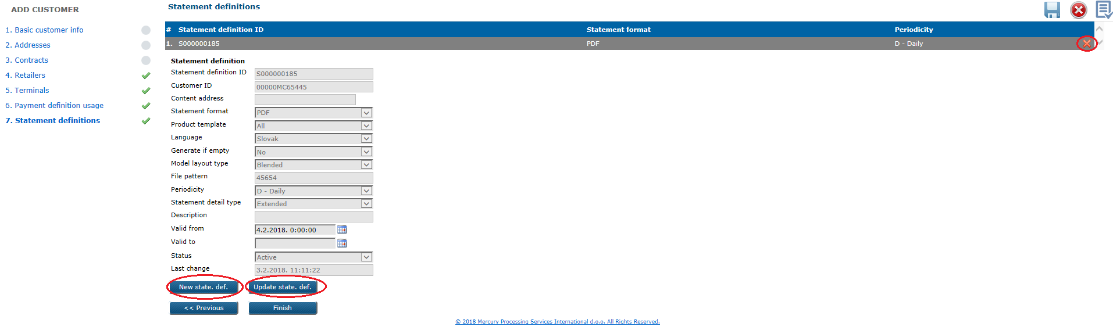

By click on the Finish button at the last new customer wizard step, if you input/selected data correctly, pop-up message will appears with info that new customer successfully added.



2) *Acquiring* module > *Review 2* form > *Customers* level

On this level with Add customer button you can open add customer wizard with only two steps:

1. Basic customer info

2. Addresses.

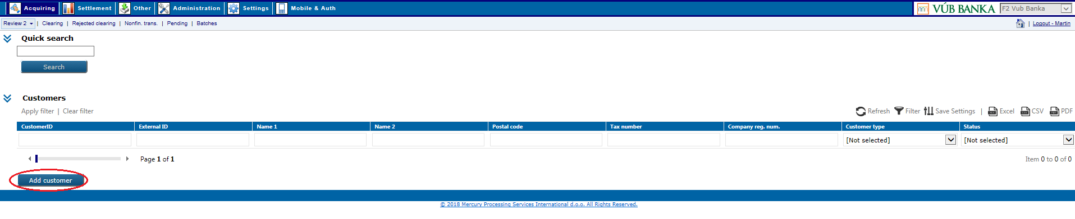

Same wizard you can open if you first list by filter(s) existing customer(s) in the system and then click on one of them, then will be Add customer button available.

**Business & system rules**

*Customer ID* – manual user input till max. 12 digits length and can start with zero, must be

unique per VUB in the system,

*External ID* - VUB internal customer ID is mandatory to input (numeric of max. 15 length), unique per VUB in the system,

- from VUB perspective, when multiple customers (with different External IDs) have the

same Customer ID, only one of those customers should be selected as the one that

will be sent towards eXact, or inputted in External ID field manually on eXact GUI,

- all customer data are replicated in *RAcqCustomer* file from eXact towards VUB

system, in which VUB can distinguish:

a) which customers already have assigned External ID (and at least one active

contract) - indicator means that the customer has „acquiring service“

b) which customers do not have assigned External ID - this indicator enables VUB to

perform customers data updates in eXact

*Customer type* - in web application options for the new customer creation is automatically

‘Merchant’ (type‘Bank’ is not possible to add through web application)*,*

*Cust. tax ID -* must be unique with max. 12 digits length and can start with zeros,

*Company reg. number* – must be unique, max. 100 digits length

*Status* – can be: *Active*/*Inactive* and user cannot change status manually, new added

customerwill be *Active,*

*State register* – possibilities from drop down menu: Y (yes)

N (no)

*Processed from eXact* – possibilities from drop down menu: Y (default)

N (no)

*Phone* – general customer phone number

*Postal code* – filter by number(s) some of possible code(s) for Slovakia, according to which will

system offer relevant places (choose one in the *City* field drop down)

*Responsible person* – possible is to input unlimitted number of persons (by click on ‘+’ sign, new

input field will appears) and contact phone for each responsible person,

*Contact person* – possible is to input unlimitted number of persons (by click on ‘+’ sign, new

input field will appears) and contact phone for each contact person,

*Address ID* – mandatory, autogenerated by system, starting with ‘A’ + followed by ordinal

address number in database,

*Address type* can be:

a) Primary address (permanent - official merchant address as is in the state registry,

replicated in background from the customer basic data) – mandatory fields

for input are: *Address, City, Postal code, Country*

b) Mailing address – only mandatory fields for input will be displayed: *Address, City, Postal code, Country*

c) E-mail – only mandatory field for input will be displayed: *E-mail*

d) InBiz – no input and displayed fields,

*Payment definition ID* - autogenerated by system and unique per VUB, starting with ‘P’ +

followed by ordinal payment definition number in the database

(stuffed to 10 characters with zeros, starting with 1),

*Currency* – drop down menu offers possibilities:

036 AUD – Australian Dollar

124 CAD – Canadian Dollar

203 CZK – Czech Koruna

208 DKK – Danish Krone

826 GBP – Pound Sterling

348 HUF - Forint

756 CHF – Swiss Franc

392 JPY – Japanese Yen

985 PLN - Zloty

643 RUB – Russian Ruble

840 USD – US Dollar

191 HRK – Croatian kuna

946 RON – Romanian New Leu

978 EUR - Euro

*Grouping level* – the way of payments grouping, drop down menu offers:

* + Payment definition level

(payment per customer: for all assigned contracts, retailers and terminals)

* + Retailer-Contract
  + Terminal-Contract,

*Grouping model* - drop down menu offers possibilities:

* + POS-All brands
  + POS-AmexSeparate,

*Settlement model* – drop down menu offers possibilities:

* POS-2-Pay-GROSS
* POS-2-Pay-GROSS-INV
* POS-1-Pay-NET
* POS-2-Pay-NET,

*Status* – mandatory for automatically update, can be *Active*/*Inactive.*

# 5.2. UC POS 003: Get customer data by WS(s)

With two web services is possible to get customer data from the eXact database.

**Preconditions**

* customer(s) which data you would like to get, should exist in eXact database,
* WS(s) should be configured correctly at client side, to achieve successful connection on eXact database,
* WS(s) should be configured correctly at MPSI side, to send response messages successfully to the client side,
* username input in request messages, should exist in eXact database (as service user type), and should be password protected.

**Triggers**

1) *GetCustomerByFilter* WSmethod should contains the following elements:

a) customer's fields allowed to be used in filter expression (CustomerId, Name1,

Name2, TaxNumber, CompanyRegNum, CustomerType),

b) operator type used in filter expression (Equal, Like, GreaterThan,

GreaterThanOrEqual, LessThan, LessThanOrEqual).

2) *GetCustomerChangesFrom* WSmethod should contains date from which will user request customer data changes in database (this date included in search).

Status ‘0’ in response means, that WS was successfully executed.

# 5.2. UC POS 004: Update customer through WS

This case will be used when you have to update some customer’s data

(Case A - the customer is already in VUB customer DB, and immediately during entry of the data on Exact, ExternalId is provided.

Case B - the customer does not already exist in VUB customer DB during the initial definition and entry of the customer in Exact, but is updated at the later stage, when opened in the VUB customer DB and assigned VUB Internal ID.

**Preconditions**

* customer should exist in eXact system,
* WS should be configured correctly at client side, to achieve successful connection on eXact database,
* WS should be configured correctly at MPSI side, to send response messages successfully to the client side,
* username input in request messages, should exist in eXact database (as service user type), and should be password protected.
* GetCustomerByFilter WS method (UC POS 003) can be used for retrieve current customer data from eXact, then by UpdateCustomer WS method is possible to apply changes occured in VUB customers database (DB) on customer’s data in eXact.

**Triggers**

1) *UpdateCustomer* WSmethod allows to update the following data: *CustomerID*, *Name1*,

*Address*, *PostalCode*, *City*, *CountryID*, *CustomerType*, *TaxNumber*.

Updates will be made directly in eXact database and automatically published.

**Business & system rules**

* process of update customer’s data (permanent address included) will be done automatically on VUB side by using WS and providing *Customer ID* as input parameter,
* customer data will be synchronized between eXact and VUB customers DB:

1. when the customer has been entered initially in eXact:

a) data will be initially synchronized by sent *RAcqCustomer* file,

b) or manually entered in VUB customers DB.

2. when the customer has been entered initially in VUB customers DB (with assigned

*External ID*) and assigned *External ID* entered also in eXact, then customer is

consequently received in RAcqCustomer with both IDs (Customer ID, External ID).

3. if customer exist in VUB customers DB and marked as having “acquiring service”, trigger the process of initial data synchronization for the customer towards eXact.

4. when data changed in VUB customers DB and the customer marked as having

“Acquiring service” enabled, the customer is synchronized

towards eXact.

* when WS call for customer update fails, error handling and repeating of failed messages sent to eXact will be implemented on VUB side
* if WS request sent to eXact fails because:

a) of business rules (e.g. uniqueness of the Customer ID, External ID) - VUB should

correct the input message (and perform according underlying data changes in internal

systems) and forward it as corrected message

b) system error/service unavailability on eXact side – VUB should contact MPSI

operations and submit maintenance request for solving the underlying cause on

eXact (all further calls of WSs during the period of service unavailability should be

paused, after correction all sent messages that failed, should be re-sent in sequential

order and all further calls, paused for sending during the service disruption, should be

resumed).

* eXact web services should be called for max. 1 call per 5 seconds,
* initial migration of VUB Internal IDs as External IDs in eXact should be performed as part of the overall migration procedure in eXact where VUB will provide mapping table as one of migration step, for *Customer ID* and *External ID*,
* any change in customer’s data will be reflected to all related interfaces (e.g. *RAcqCustomer* file),
* *Inactive* customers cannot be updated,
* customer changes will be logged for both users. Tehnical and business user who trigerred eRequest.

# 5.2. UC POS 005: Update customer through web application

This case will be used when you have to update some customer’s data through the web application option.

**Preconditions**

* customer should exist in eXact system and be *Active*.

**Trigger**

*Acquiring* module > *Review 2* form > *Customers* level

Search first by filter(s) for existing customer which you want to modify, then click on it so that Customer update button appears:

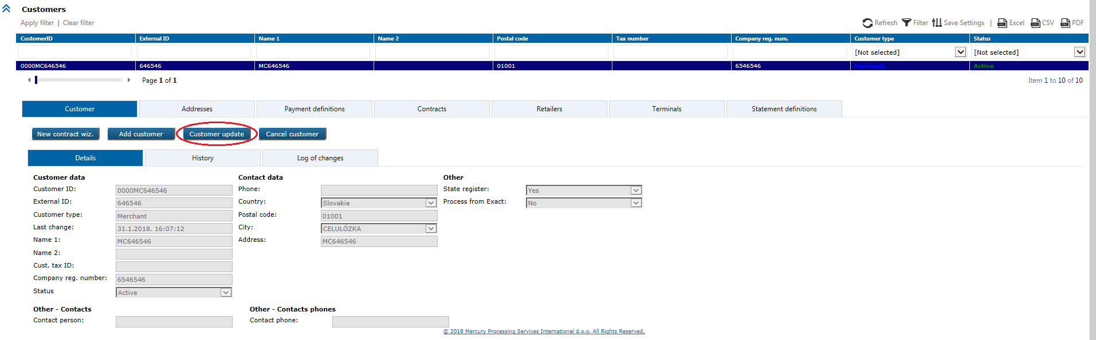

Customer update wizard will open with the following two steps, you can change undimmed fields and then confirm changes with *OK* button.

a) Basic customer info:

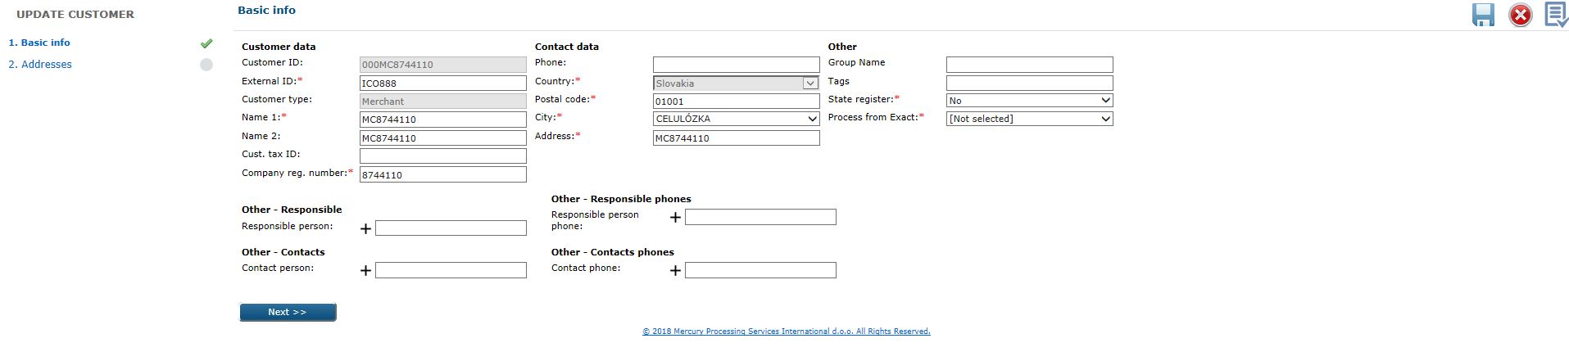

b) Addresses:

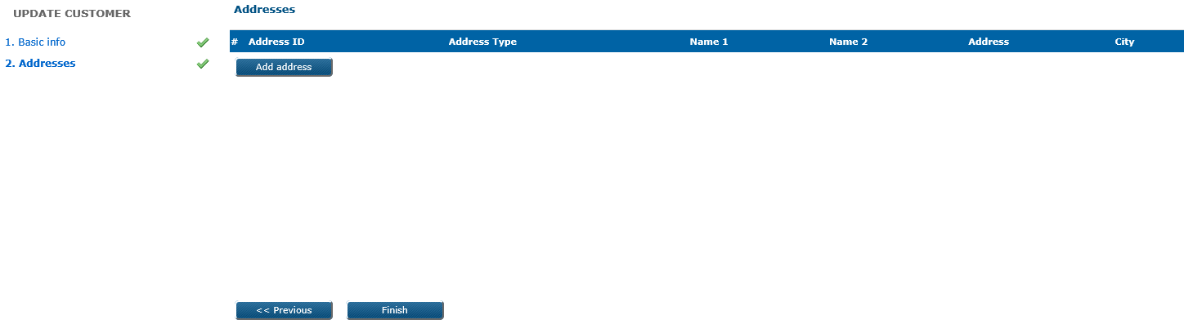

**Business & system rules**

* explained in UC POS 002.

# 5.2. UC POS 006: Cancel customer

Customer cancellation will cause deactivation/cancellation of the following customer’s

associated subentities:contract(s), retailer(s), terminal(s), product(s). On statement definition and payment definitions value for Valid to will be set to current date. Fees/discounts will remain acitive till end of month of cancelation, at that date Valid to will be changed.

Customer can be cancelled temporary or permanent, through the web application.

**Preconditions**

* customer must exist in eXact system and be in *Active* status.

**Trigger**

*Acquiring* module > *Review 2* form > *Customers* level

Search first for the active customer which you want to cancel, then click on it to open details:

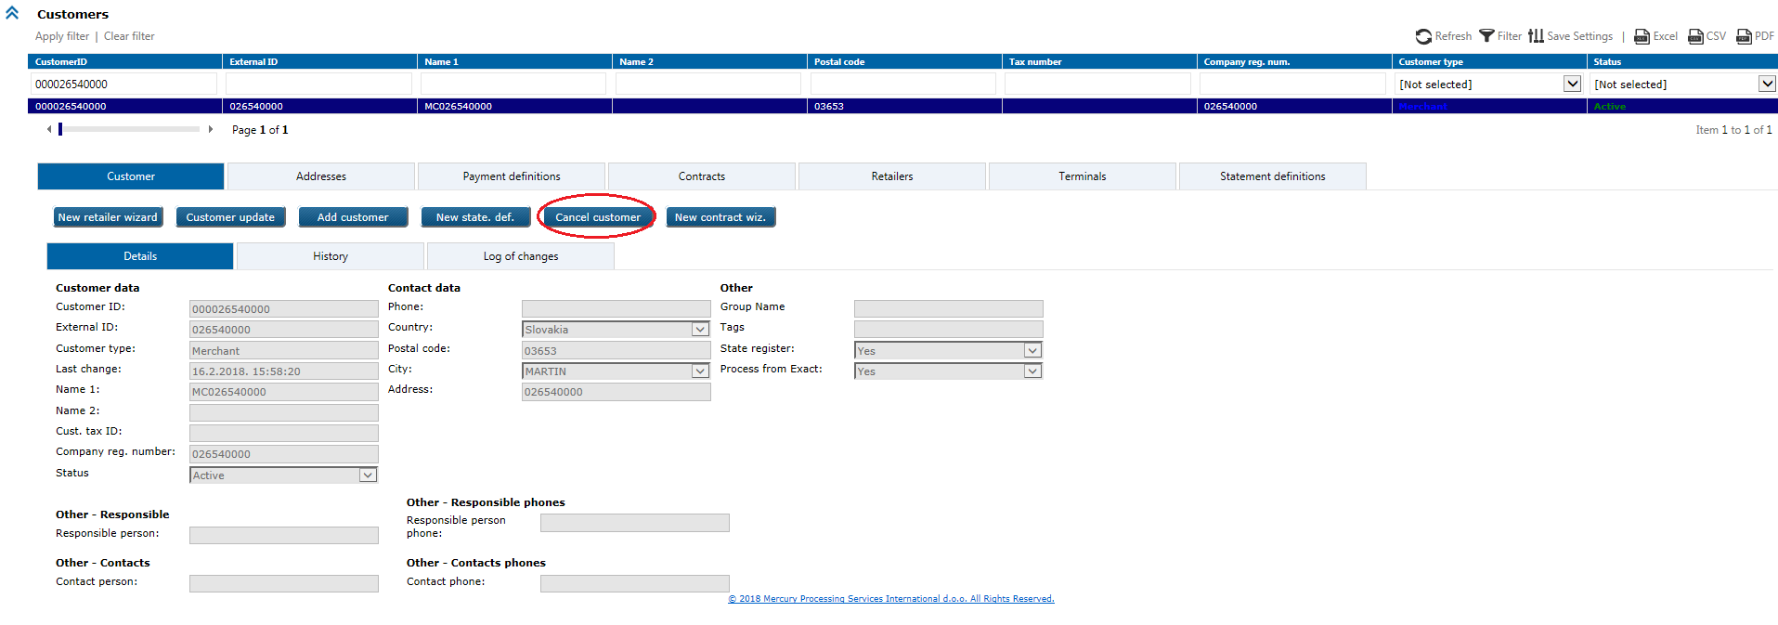

By click on the Cancel customerbutton, pop-up window will appears where you should choose cancellation reason and confirm your choice on OK button:

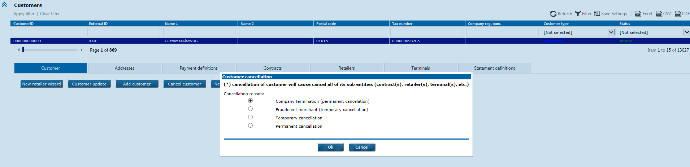

**Business & system rules**

* *Cancellation reasons* are:

Company termination (permanent cancellation)

Permanent cancellation

Fraudulent merchant (temporary cancellation)

Temporary cancellation

* after cancellation, customer status will be changed to *Inactive*,
* customer status change will be reflected in all related interfaces

(e.g. *RAcqCustomer* file),

* temporary cancelled customer will be possible to reactivate again,
* permanent cancelled customer will not be possible to reactivate again,
* this changes will be logged.

# 5.2. UC POS 007: Reactivate customer

Temporary cancelled customer can be reactivate again in the system through web application, permanent cancelled customer cannot.

By customer reactivation, the following associated subentities should be reactivated manually

(message will inform user): contract(s), retailer(s), terminal(s), product(s) , statement definition(s), payment definition(s) and fees&discounts assignment.

**Preconditions**

* customer must exist in eXact system and be in *Inactive* status,
* customer should have temporary type of cancellation reason (fraudulent merchant/temporary cancellation).

**Trigger**

*Acquiring* module > *Review 2* form > *Customers* level

Search first for the temporary cancelled customer which you want to reactivate again, then click on it to open details:

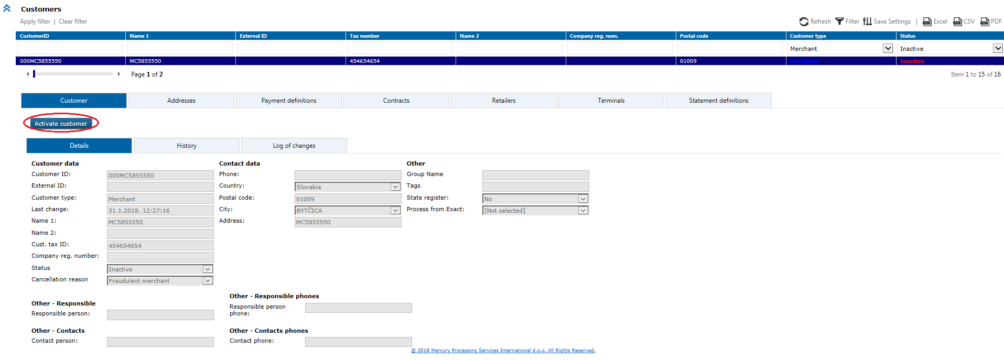

Click on the Activate customer button and pop-up window will appears, user should confirm that he want this customer reactivation:

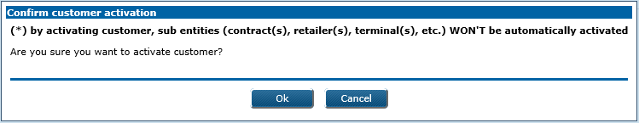

**Business & system rules**

* e.g. of business cases for cancelled customer reactivation:

a) company has been re-opened again

b) fraud suspicion has been lifted,

* customer status change will be reflected in all interfaces (e.g. *RAcqCustomer* file),
* *Cancellation reason* code will be annulled in database,
* reactivated customer and it’s associated manually reactivated subentities ill have *Active* status again,
* this changes will be logged forever.

# 5.2. UC POS 008: Retrieve customer(s)

Retrieval of existing customer(s) data in web application by using search parameters for filtering: *CustomerID*, *External ID*, *Name 1*, *Name 2*, *Tax number*, *Company registration number*, *Customer type, Status, Postal code*.

User can select by click with the right mouse button on grid column names line, from the columns submenu, which columns he want to see.

Retrieved will be: customer data, addresses, payment definitions, contracts, retailers, terminals, statement definitions, details, history and log of changes data.

Preconditions

* customer(s) must exist in the system.

**Trigger**

*Acquiring* module *> Review2* form *> Customers* level

Search can be performedby applying different search filter(s) on the screen. When the particular customer found, customer details will be display by click on retrieved record.

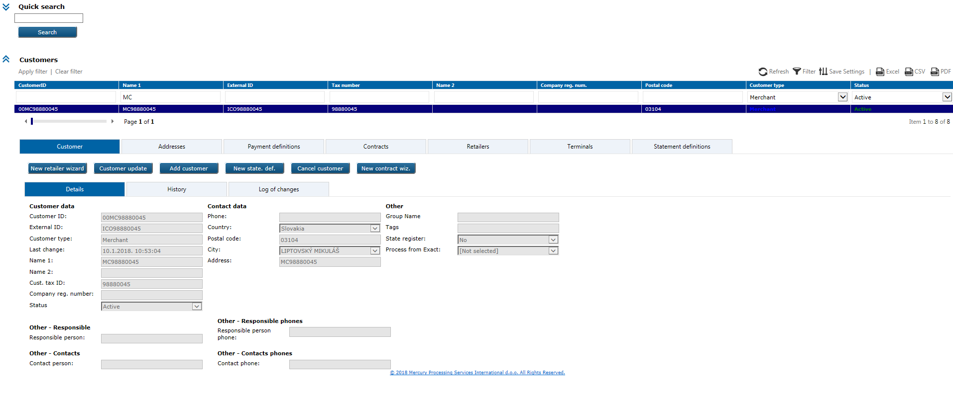

# 5.2. UC POS 009: Add new address & Statement definition

This option allows to add new additional address for the merchant in web application (e. g. merchant have to send statements on the new address, or he must create new statement definition for new address).

Primary (permanent) address is possible to enter only during the new customer creation, and can be changed only with customer update wizard. Explained in UC POS 010.

**Preconditions**

* additional address which you want to add, should not exist in eXact system.

**Triggers**

*Acquiring* module > *Review 2* form > *Addresses* level

Review first existing address(es) in the system, then click on one of them to open details: 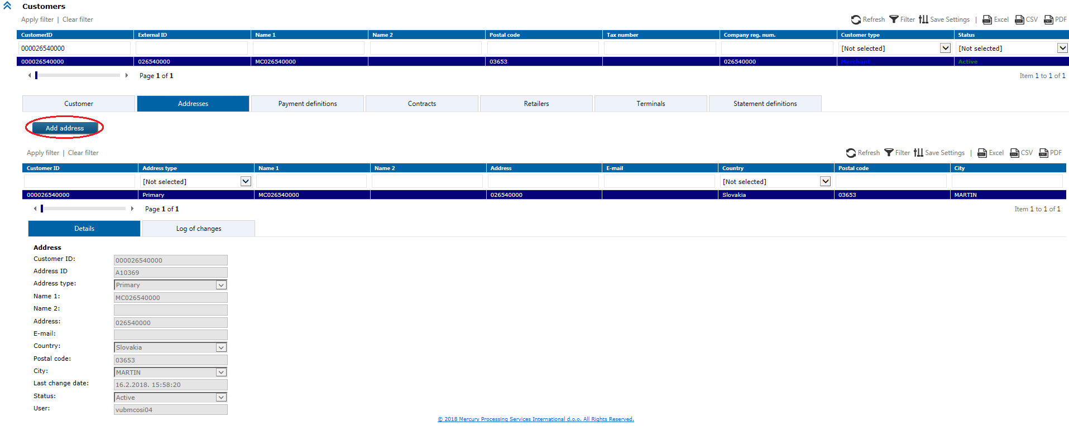

Click on Add addressbutton to open the following wizard (mandatory fields marked with red asterix):

a) Address - depends of selected *Address type*, fileds will be visible and ready to input/select:

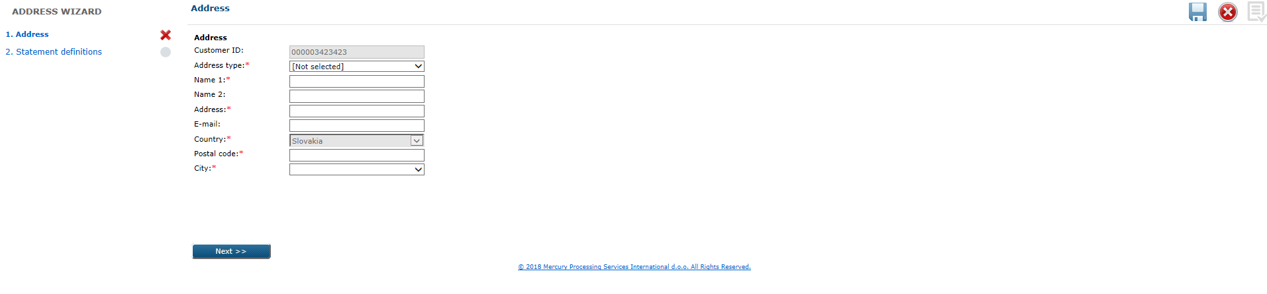

Depends of selected Address type, relevant fields will be dynamically displayed.   
(explained in UC POS 002)

b) Statement definitions:

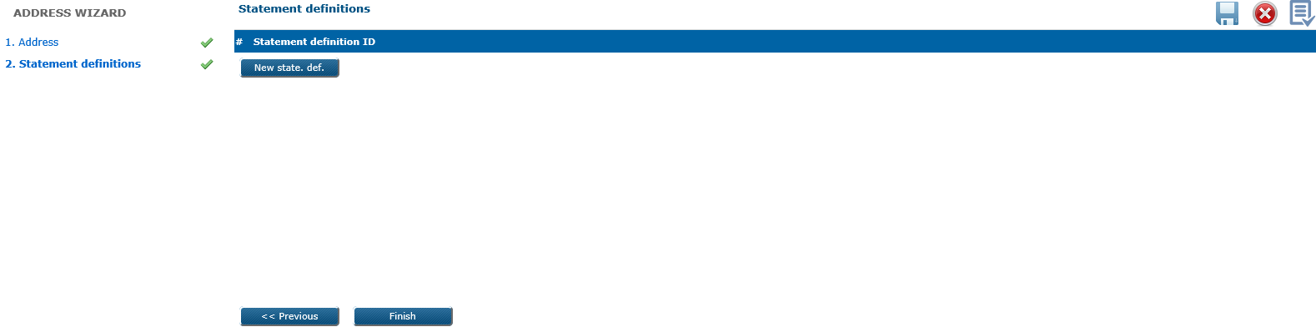

Click on the New state. def. button if you want to add new statement definition for the new address which you created in this wizard.

New statement definition wizard will open the following steps

1. Basic statement definition data

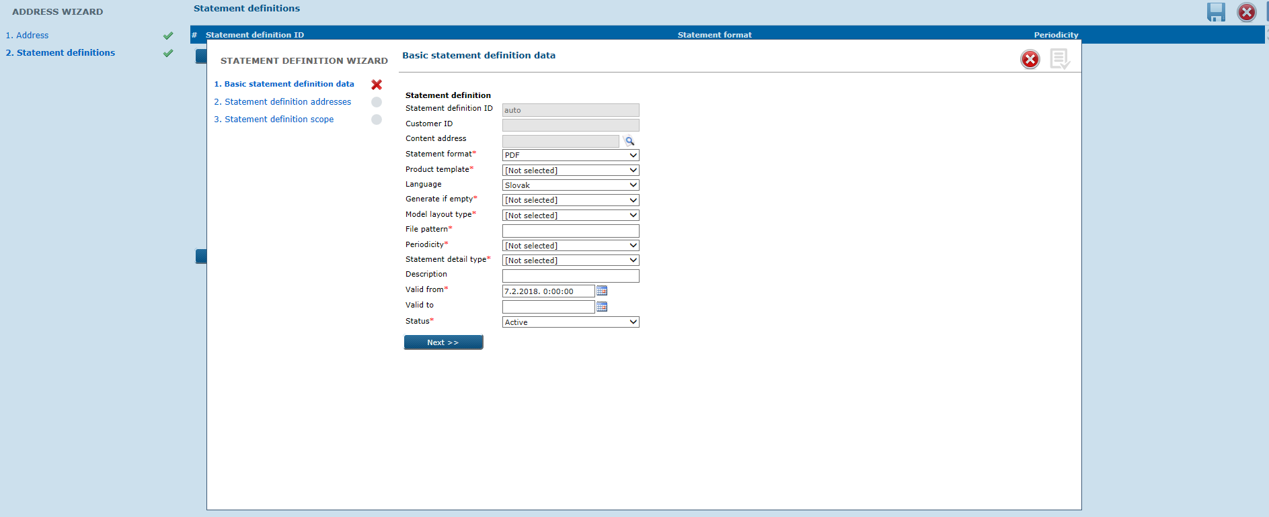

2. Statement definition addresses

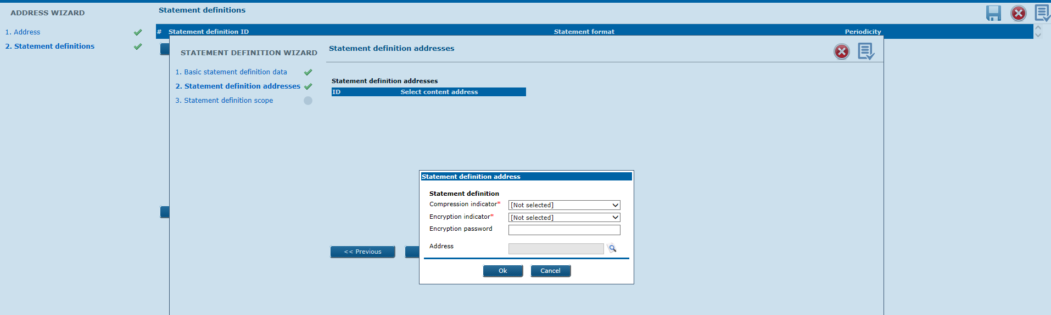

Search and select previously entered address

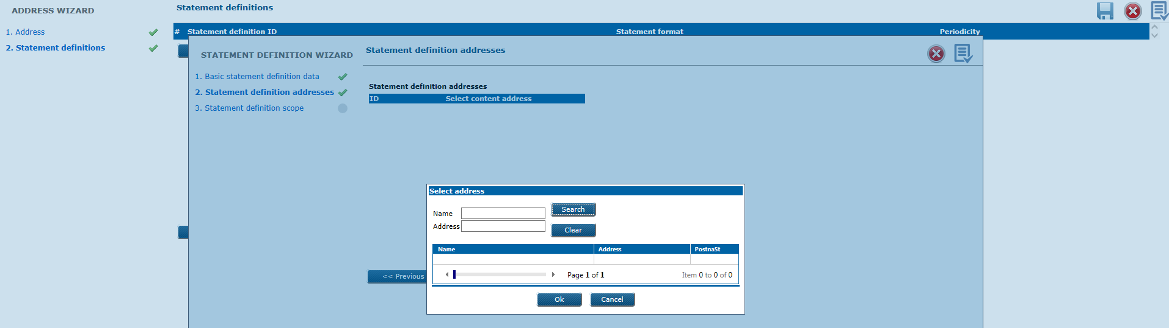

3. Statement definition scope

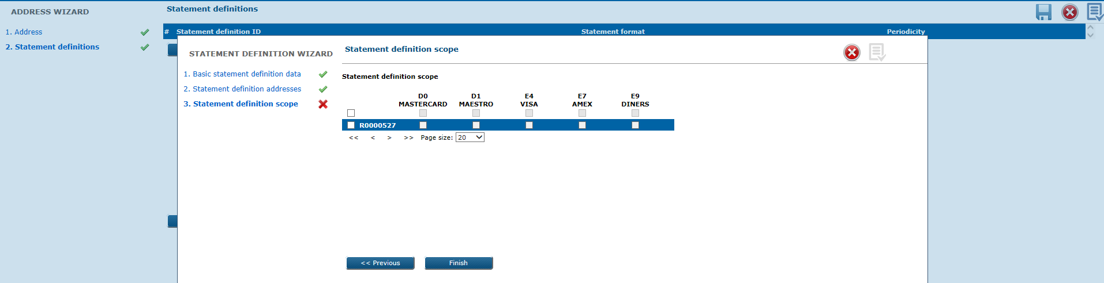

On the following screen you can delete added Statement definition, by click on the right positioned orange X sign related to statement definition data in that line, you can modify entered data, add more statement definitions.

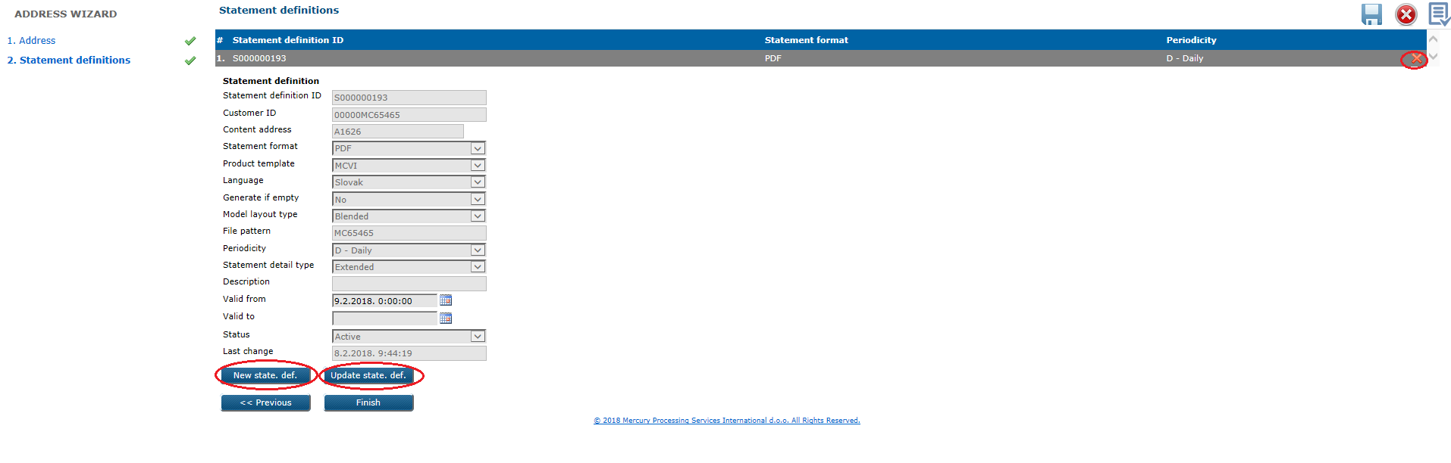

By click on the Finish button at the last new address wizard step, if you input/selected data correctly, pop-up message will appears with info that new address successfully added.

**Business & system rules for address**

*Address type* – possible is to select the following types of additional addresses from the drop

down menu:

* Mailing address
* E-mail
* InBiz.

*Address* – max. 100 characters length (mandatory filed if address type = ‘Mailing address’)

*E-mail* – max. 100 characters length (mandatory filed if address type = ‘E-mail’)

*Postal code* – select from drop down menu, or you can input number(s) and postal codes list

will be automatically filtered according to that

*City* – will offer automatically place(s) related to selected postal code.

* address cannot be “moved” from one customer to another,
* if you add new statement definition through the Add address wizard, isn’t possible to change *Content address*,
* address changes will be logged.

**Business & system rules for statement definition**

explained in UC POS 047

# 5.2. UC POS 010: Update address (additional / permanent)

1. **Update additional address**

This option in web application allows to update merchant’s additional address data.

**Preconditions**

* additional address which you want to update, should exist in eXact system.

**Trigger**

*Acquiring* module > *Review 2* form > *Addresses* level

Review first by filter(s) existing addresses in the system, then click on one of them so that Update address button appears:

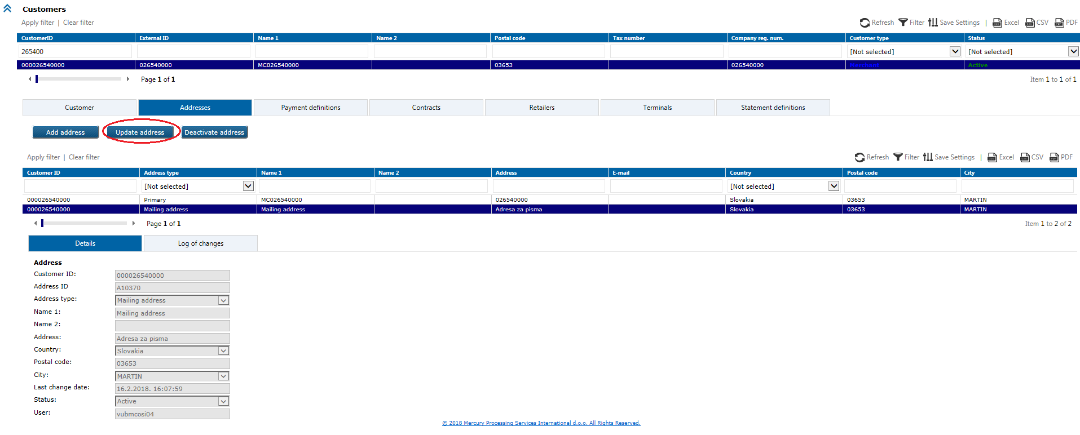

Action will open new window prepopulated with current address data, some of them (undimmed) can be changed:

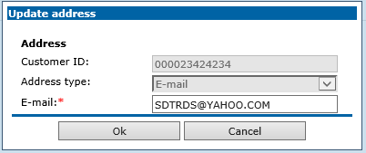

Depends of selected Address type, relevant fields will be dynamically displayed.   
(explained in UC POS 002)

**Business & system rules**

* address changes will be logged,
* it is not allowed to update merchant’s permanent address with this option (it can be changed with customer update wizard).

1. **Update permanent address**

**Trigger**

*Acquiring* module > *Review 2* form > *Customers* level

Search first by filter(s) for existing customer which you want to modify, then click on it so that Customer update button appears:



Customer update wizard will open two steps, focus on Basic customer info.

a) Basic customer info:



Change Address fields and finish wizard without step2.

**Business & system rules**

* address changes will be logged

5.2. UC POS 011: Deactivate address

This is option in web application for additional address deactivation, address’s status will be changed to *Inactive*.

**Preconditions**

* address which you want to deactivate must exist in the system and be in *Active* status.

**Trigger**

*Acquiring* module > *Review 2* form > *Addresses* level

Review first by filter(s) existing address(es) in the system, then click on one of them so that Deactivate addressbutton appears:

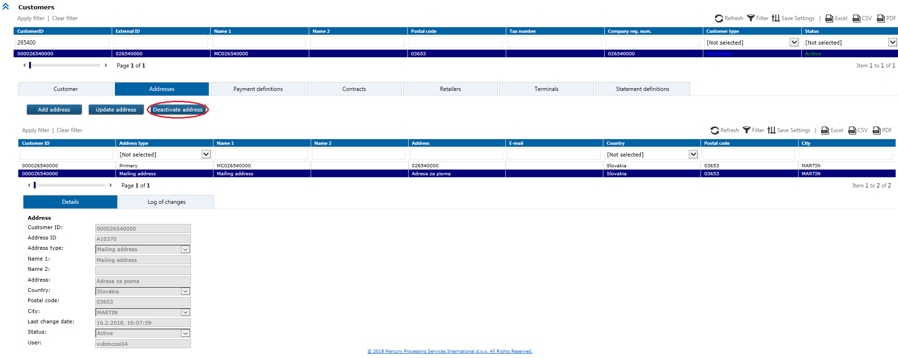

Click on it and confirm in the new pop-up window that you want to deactivate it.

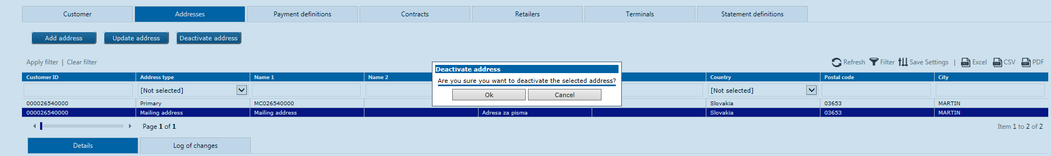

**Business & system rules**

* permanent address cannot be deactivated if customer is *Active*,
* address cannot be deactivated if there is active statement definition or payment definition which using this address (pop-up message will appeared),
* deactivated address has *Inactive* status,
* address changes have been logged.

# 5.2. UC POS 012: Retrieve address(es)

Retrieval of existing address(es) can be done by web service or web application. In web application address(es) can be retrieved by using search parameters for filtering: *Customer ID*, *Address type*, *Name 1*, *Name 2*, *Address*, *E-mail*, *Country*, *Postal code*, *City*.

User can select by click with the right mouse button on grid column names line, from the columns submenu, which columns he want to see.

Retrieved will be: address data, history data.

Preconditions

* address(es) must exist in eXact system.

**Triggers**

1) WS: *GetAddressesByFilter* method will retrieve address(es) data, it can be used

separately or as wizard sequence scenario.

*2)* Web: *Acquiring* modul *> Review 2* form *> Addresses* level

Search can be performedby apply different search filter(s) on the screen. When the particular address found, address details can be displayed by click on the retrieved record.

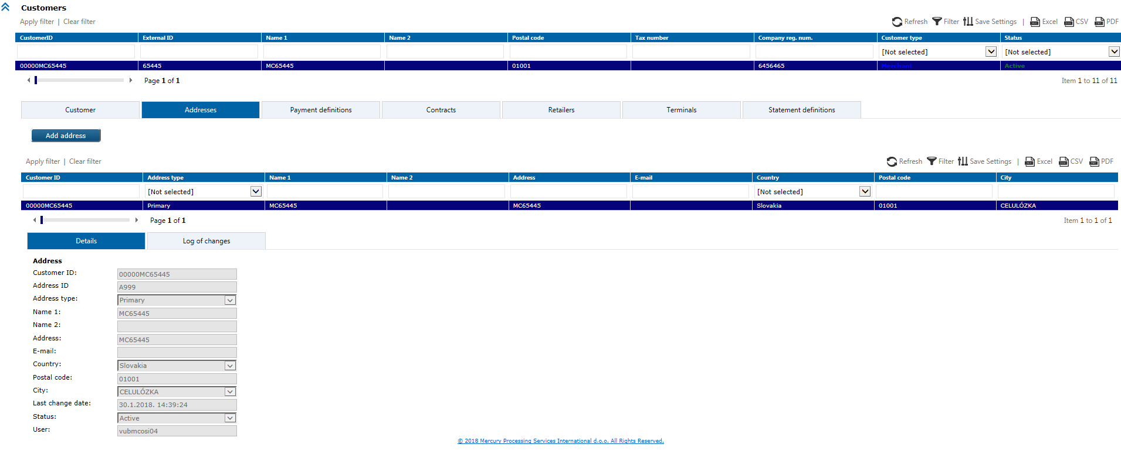

# 5.2. UC POS 013: Add new contract through WS(s)

Entry of new contract by web services, for the new or existing customer in eXact.

**Preconditions**

* customer for which you want to add new contract, should exist in the system and be *Active*,
* contract which you want to add should not exist in the system,

**Triggers**

1) *AddContract* WS method with contract data as elements. New contract added on this way

will be directly inserted in the database and automatically published.

2) Add new contract per sequences (to create unfinished wizard case in web application),

possible WS methods are:

*StartWizardSequence* – *UseCaseTemplateID* should have value ‘700’ (New contract

wizard)

*-* if will be successfully executed, user will receive *SequenceID* in response

message

*AddPaymentDefinition* (by sequence, 1st, 2nd… )

*AddContract* (by sequence)

*GetRetailerByFilter*

*AssignRetailerTerms* (by sequence)

*AssignRetailerProducts*

*GetAddressByFilter*

*AddAddress* (by sequence)

*AddStatementDefinition* (by sequence, 1st, 2nd… )

*GetTerminalByFilter*

*AssignTerminalFees* (by sequence)

*FinishWizardSequence -* in request message should be input the same *SequenceID*

which you got in response for *StartWizardSequence* method.

Appendix B - UML sequence diagram

Successfully added new contract in the system by WS-es per sequence, you can open like

unfinished *New contract* wizard case in web application:

*Acquiring* module > *Review2* form > *Unfinished wizard cases*

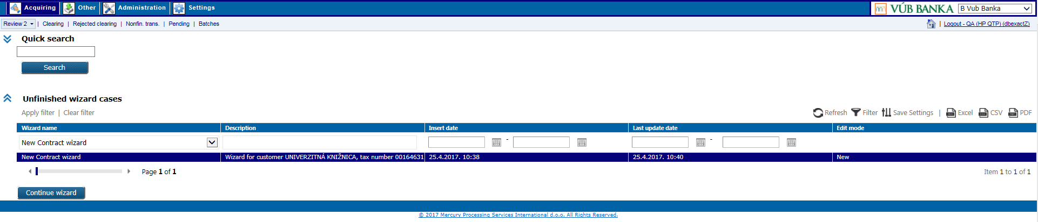

Search first on this level for the certain unfinished wizard case and select it, then click on Continue wizard button which will open wizard and you can continue to work on case. Each wizard step must be populated with valid data in order to publish case or save it temporary.

By click on the Finish button at the last wizard step, contract will be published.

**Business & system rules**

* validity contract date must be in future,
* at least one product on contract must be active,
* contract for MCVI, Diners and JCB will be separate from the contract for AMEX,
* products on retailer and terminal level are set of products defined on all contracts level for the customer,
* *c*ustomer can have one or more active contracts, but two contracts with the same products cannot be assigned to one terminal because of overlapping (they can overlapped in the case of eCommerce contract and POS contract),
* explained in UC POS 014,
* this actions will be logged.

# 5.2. UC POS 014: Add new contract through web application

Entry of new contract in eXact web application, for the new or existing customer. It is possible through two options on two system levels.

**Preconditions**

* customer for which you want to add contract, must exist in eXact and be *Active*.

**Triggers**

1) option:

*Acquiring* module > *Review 2* form > *New contract* wizard

Wizard will open with the following steps, insert/select all mandatory (marked with red asterix) and optional fields in all wizard steps, with Finish button at the last step user can finish new contract creation.

a) Customer info – if you want to add new contract for the new customer:

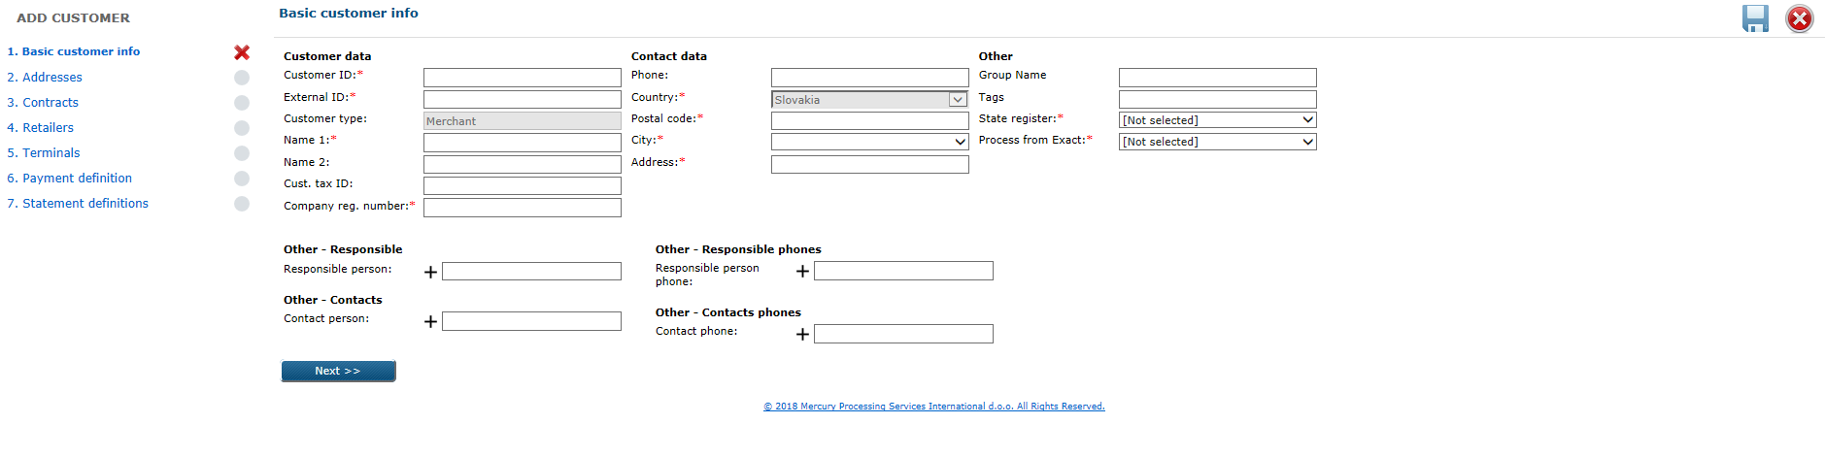

or for the existing customer:

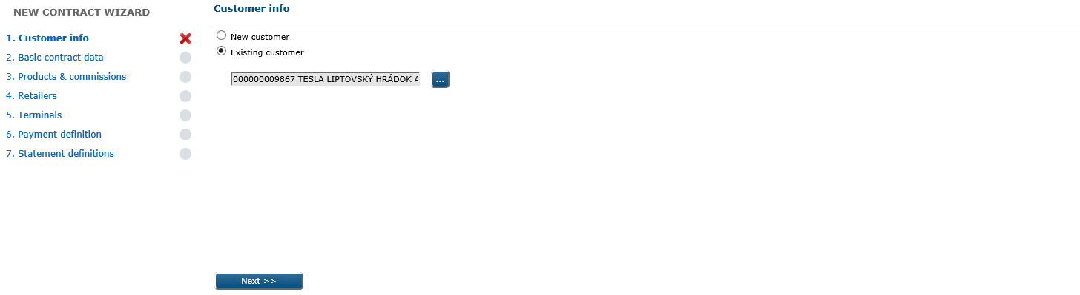

b) Basic contract data:

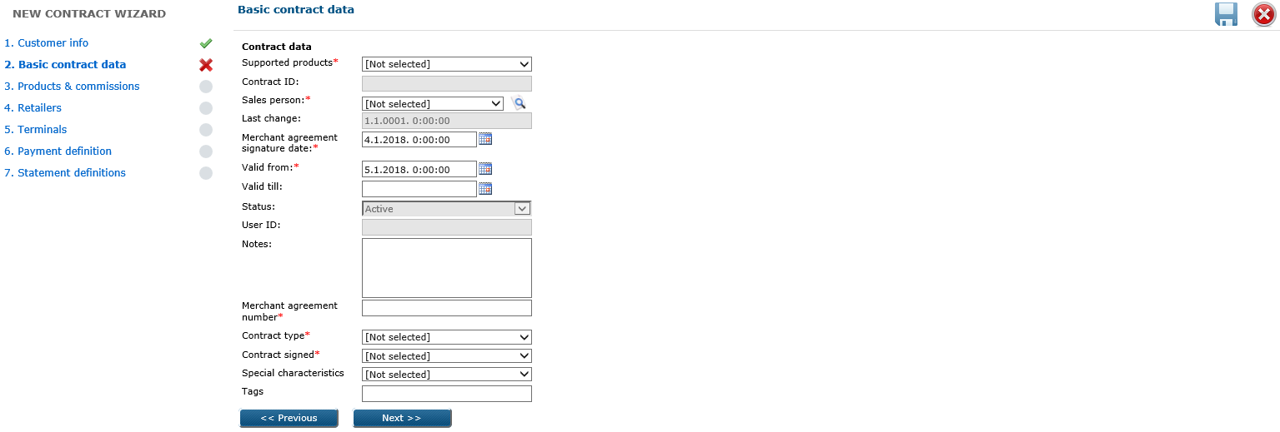

c) Products & commissions - only defined supported products for contract should be offered on

this screen, commission model which you want to apply per product should exist in

database:

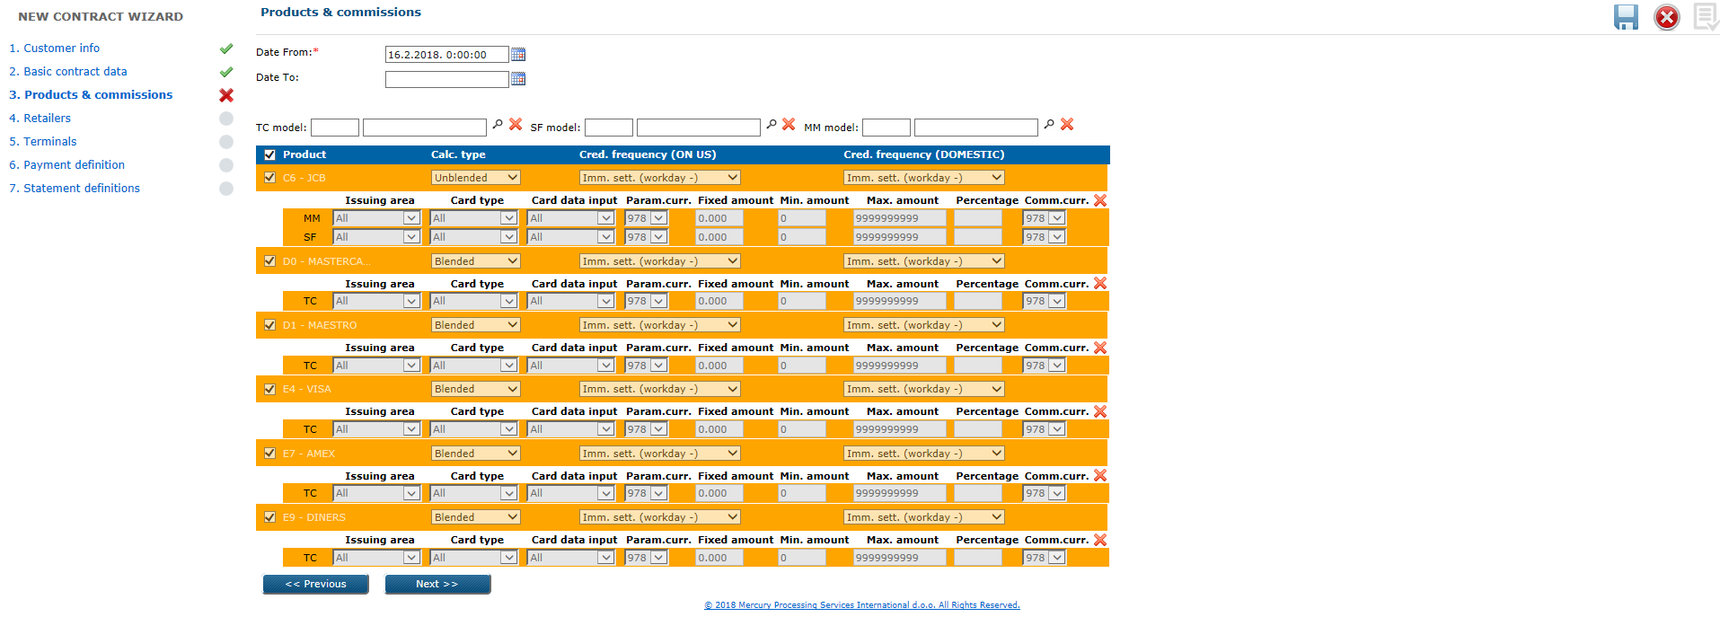

d) Retailers – optional is possible to add (explained in UC POS 027):

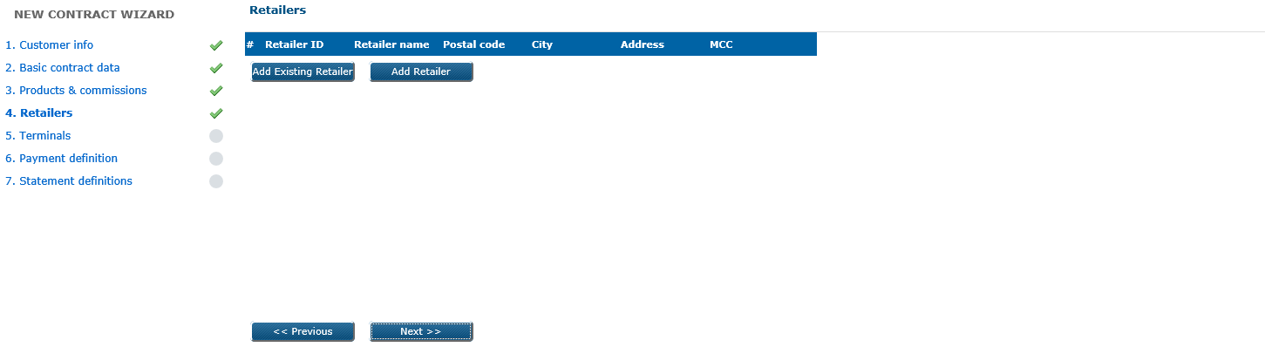

e) Terminals – optional is possible to add (explained in UC POS 034 and UC POS 035):

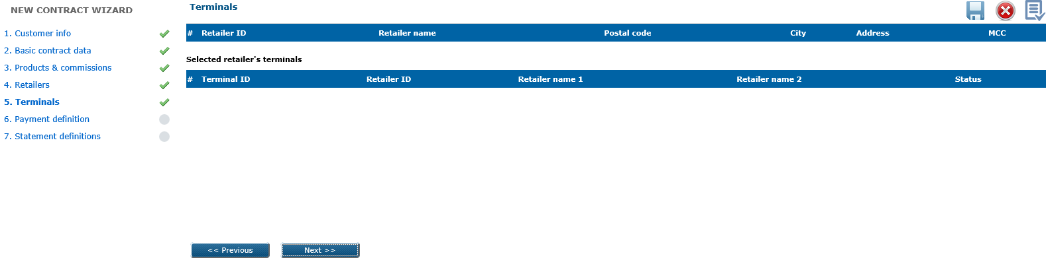

f) Payment definitions – At least one payment definition on contract must be added.

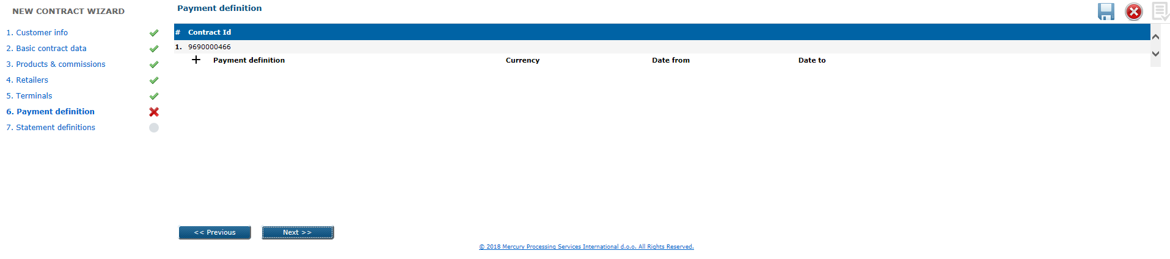

Click on the plus sign (+) left from ‘Payment definition’ and pop-up window will appears, where user can:

a) select previously entered payment definition

b) add new payment definition.

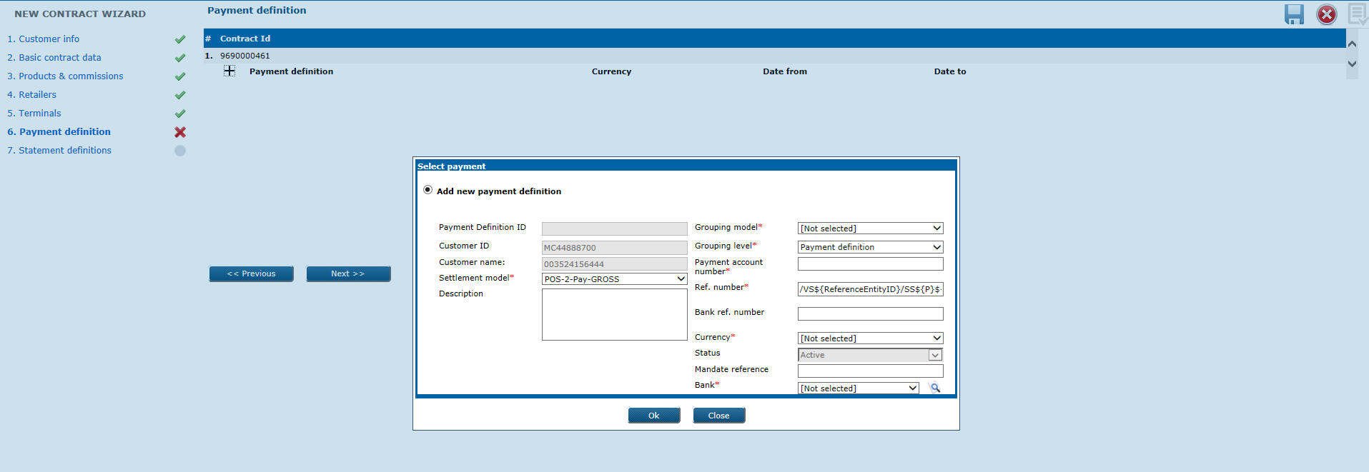

You can add *n* different payment definitions for one customer, but validity period between payment definitions cannot overlapped.

g) Statement definitions – optional is possible to add (explained in UC POS 046):

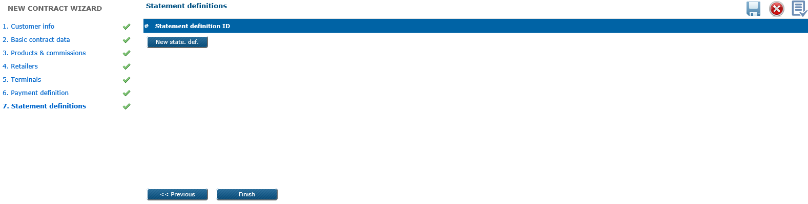

2) *Acquiring* module > *Review 2* form > *Customers* level

Search first for existing customer for which you want to add new contract, click on it to open details and then launch wizard with New contract button.

Wizard has the following steps:

1. Basic contract data

2. Products & commissions

3. Retailers

4. Terminals

5. Payment definitions

6. Statement definitions.

**Business & system rules**

*Contract ID* – autogenerated by system (MCVI and Joint contract type has same sequence

numbers range)

* + - MCVI – prefix ‘505’ + MCVI-sequence
    - Joint (mixed) – prefix ‘5051’ + MCVI-sequence
    - AMEX – prefix ‘969’ + AMEX-sequence

*Supported products* – drop down menu offers possibilities:

* + - * MCVI
      * AX
      * Joint

*Status* – can be *Active*/*Inactive*, cannot be managed manually by user, new added contract

will be *Active*

*Contract type* – possibilities from the drop down menu:

* + - e-Commerce
    - POS VUB
    - POS foreign
    - Top-up (ATM)
    - Cash advance
    - MOTO
    - Imprinter
    - Unattended

*Valid From:* default set to current date as a with possibility to be overidden to the future

*Special characteristics* – offered from drop down menu:

* BMK

*Contract signed* – drop down menu offers:

* + - * Y (default)
      * N

*Merchant agreement number*:

a) autogenerated on VUB side and send via WS for customers with MOTO, POS

purchase, AMEX only and e-Commerce contracts:

* AMEX only contract:

A + CustomerID + YY (last two digits of year) + two digit number (counter)

* Ecommerce contract:

E + CustomerID + YY (last two digits of year) + two digit number (counter)

* Rest type of contracts (including joint):

P + CustomerID + YY (last two digits of year) + two digit number (counter)

b) in case of contract manual entry directly in eXact web application:

* AMEX only contract:

A + CustomerID + YY (last two digits of year) + E + 1 digit number (counter)

* Ecommerce contract:

E + CustomerID + YY (last two digits of year) + E + 1 digit number (counter)

* Rest type of contracts (including joint):

P + CustomerID + YY (last two digits of year) + E + 1 digit number (counter)

*Calculation type* – depending on selected calculation type from this drop down menu, will be

offered commission models:

* Blended (lookup yust for TC model)
* Unblended (lookup for MM model and SF model)

- some rules explained in UC POS 015.

# 5.2. UC POS 015: Update contract

Update of some contract data through the web application.

**Preconditions**

* contract which you want to update should exist in eXact and be *Active*.

**Trigger**

*Acquiring* module > *Review 2* form > *Contracts* level,

Search first for the contract which you want to update, then click on it to open details:

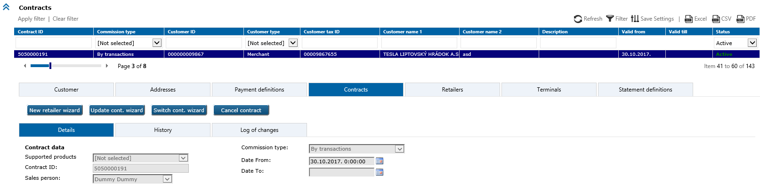

Click on the Update cont. wizard button to open the following wizard:

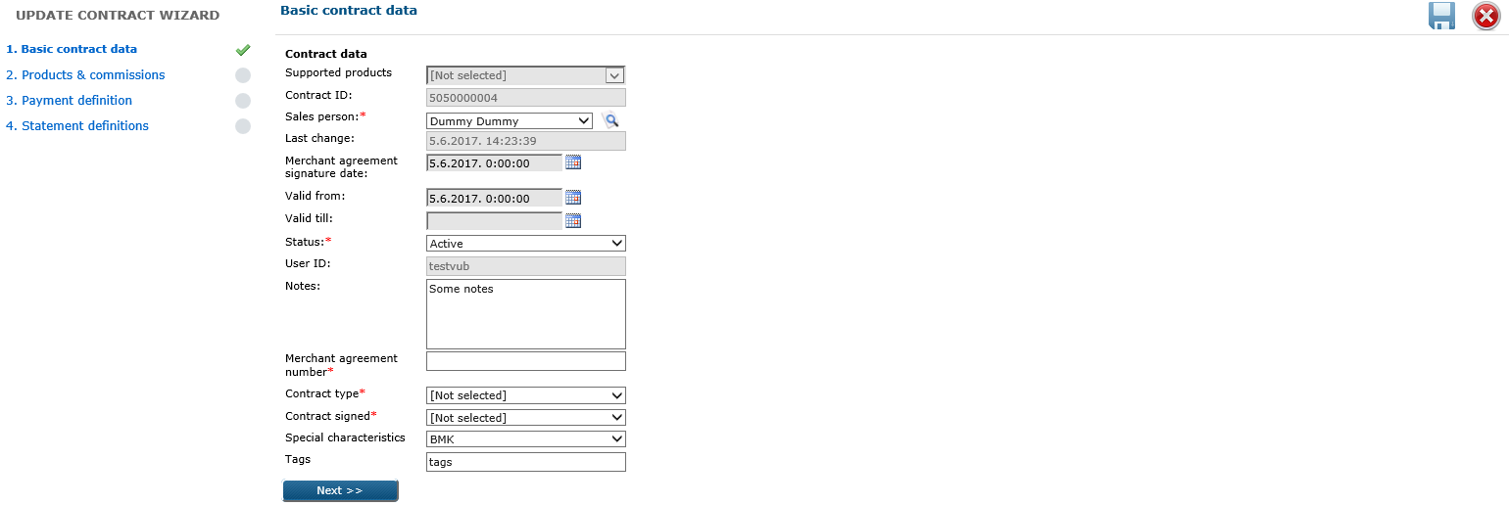

User can change only undimmed fields in wizard, with Finishbutton at the last wizard step data will be updated if all validations passed OK.

**Business & system rules**

* explained in UC POS 013 and UC POS 014,
* supported products on contract are possible to change by update (e.g. merchant signs the Annex to contract when he wants additionally to accept Diners or JCB),
* Valid till – can me updated with date in future as a date to which transactions will be accepted for processing (including that day)
* contract update will be logged.

# 5.2 UC POS 016: Update contract basic data

Update of basic contract data through the web application.

**Preconditions**

* contract which you want to update should exist in eXact and be *Active*.

**Trigger**

*Acquiring* module > *Review 2* form > *Contracts* level,

Search first for the contract which you want to update, then click on it to open details:

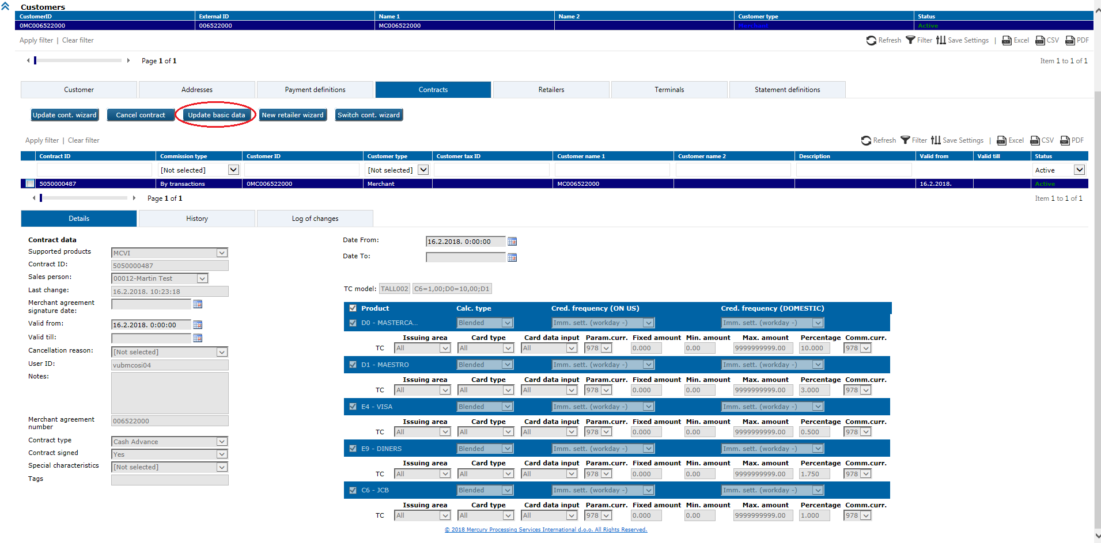

Click on the Update basic data button to open update contract wizard:

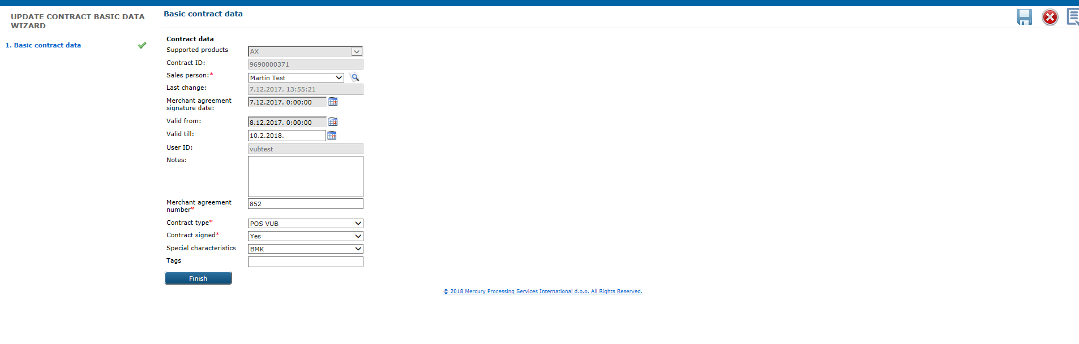

User can change only undimmed fields, with Finishbutton data will be updated if all validations passed OK.

**Business & system rules**

* Valid till – can me updated with date in future as a date to which transactions will be accepted for processing (including that day) and as a date contract and all sublevels will be automatically deactivated.

# 5.2. UC POS 017: Cancel contract

Contract cancellation through the web application will change contract status to *Cancelled,* and supported products will be deactivated on all subordinate entities which derive products from this contract. On statement definition and payment definitions value for Valid to will be set to current date. Fees/discounts will remain acitive till end of month of cancelation, at that date Valid to will be changed. Validity of the contract will be changed as well.

**Preconditions**

* contract which you want to cancel must exist in system and be in *Active* status.

**Trigger**

*Acquiring* module > *Review 2* form > *Contracts* level

Search first for the contract which you want to cancel, then click on it to open details.

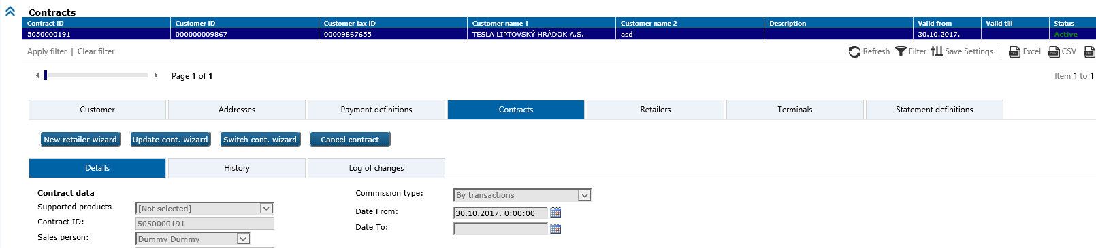

Click on the Cancel contract button to open pop-up window where you can optional select contract cancellation reason from the possibilities

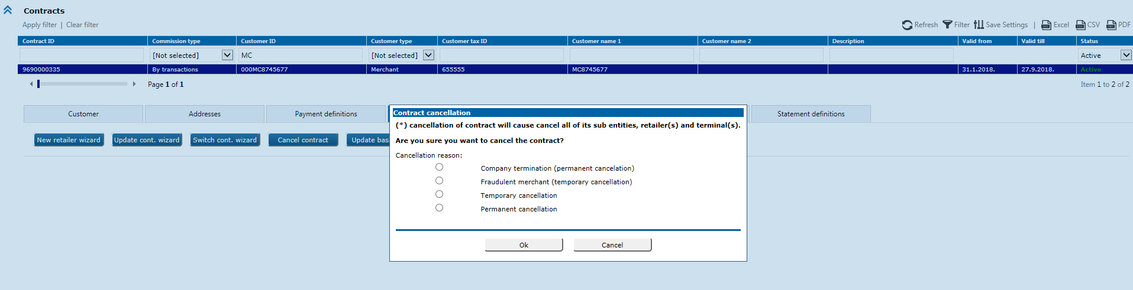

* *Cancellation reasons* are:

Company termination (permanent cancellation)

Permanent cancellation

Fraudulent merchant (temporary cancellation)

Temporary cancellation

Contract cancellation you should confirm by *OK* button.

**Business & system rules**

* contract cancellation will deactivate supported products on the contract level and on all subordinate entities which derive their products from the cancelled contract:

- retailer products have been cancelled where retailer products are derived from the

cancelled contract,

- terminal products have been cancelled where terminal products are derived from

the cancelled retailer products,

* *Valid* *to* will be set to the date of status change (current day),
* this changes will be logged.

# 5.2. UC POS 018: Reactivate contract

Contract reactivation can be done through the web application, it refers to change contract status, validity and activation set of products.

**Preconditions**

* contract which you want to reactivate must exist in the system and be in *Cancelled* status.

**Trigger**

*Acquiring* module > *Review 2* form > *Contracts* level

Search first for the temporary cancelled contract which you want to reactivate again, then click on it to open details.

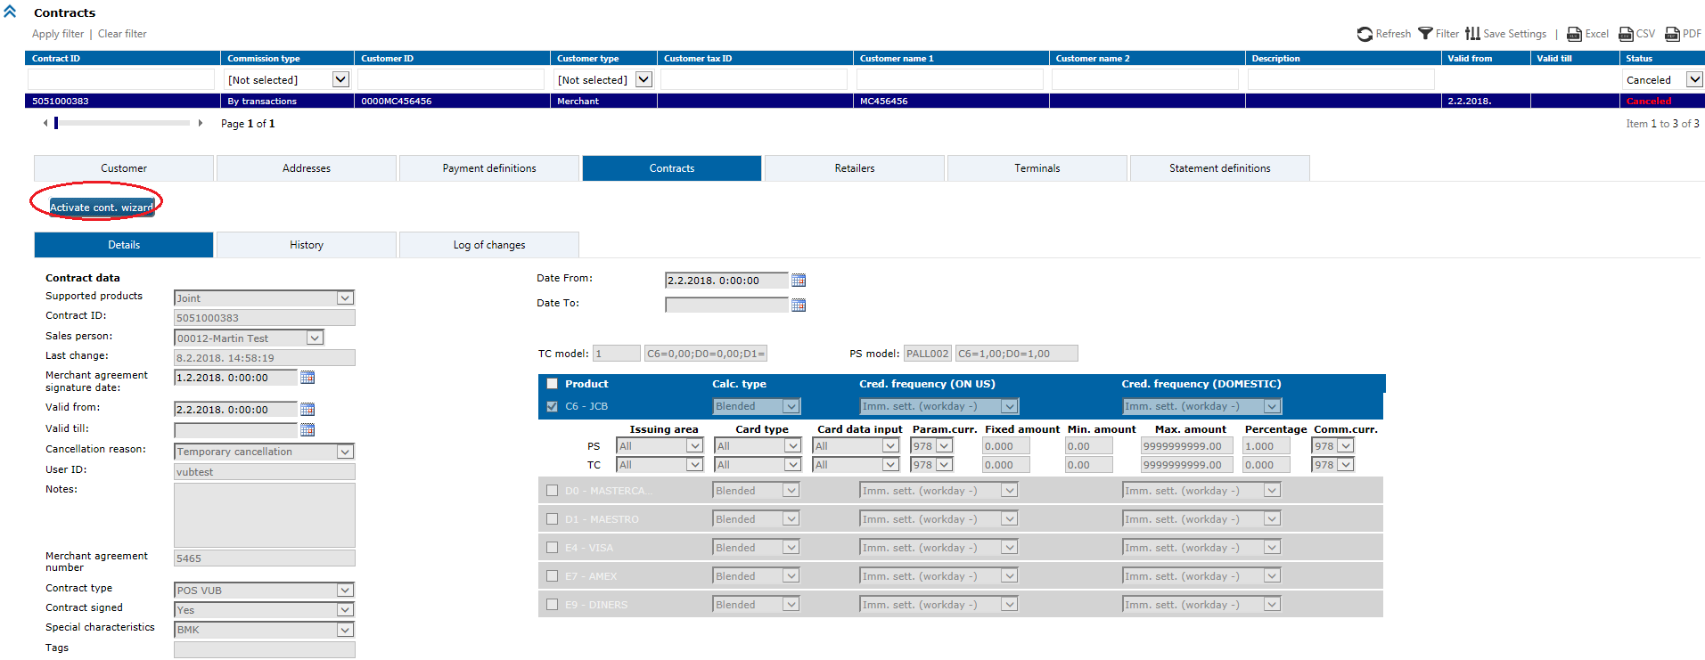

By click on the Activate cont. wizard button, the following wizard will open and you can activate contract again:

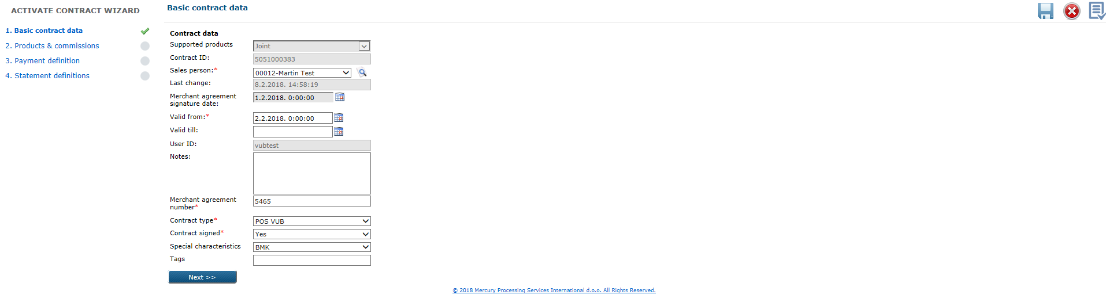

**Business & system rules**

* validity of contract will be updated (must be current date od later) ~~(must be in future)~~,
* contract status will be changed to *Active* again
* explained in UC POS 013 and UC POS 014.

# 5.2. UC POS 019: Contract transfer to same or different customer

With this option in web application is possible to transfer all entities from one contract to another contract. Payment definition and statement definition can be also transferred in case targeting customer don’t change. If transfer is on new customer - Payment definition and statement definition cannot be transferred.

**Preconditions**

* contract which you want to switch, should exist in system and be active,
* customer to which you want contract switch, should exist in system and be Active.

**Triggers**

*Acquiring* module > *Review 2* form > *Contracts* level

Search first for contract which you want to switch, then click on the Switch cont. wizard button:

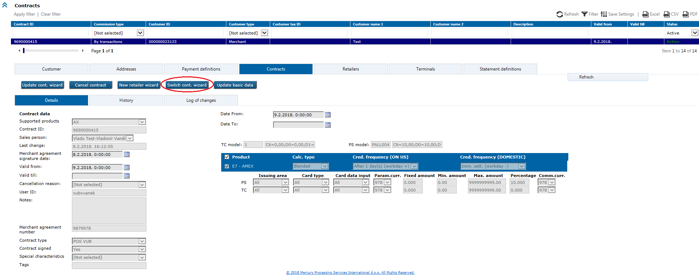

The following wizard will open:

a) Select current or other customer in the system:

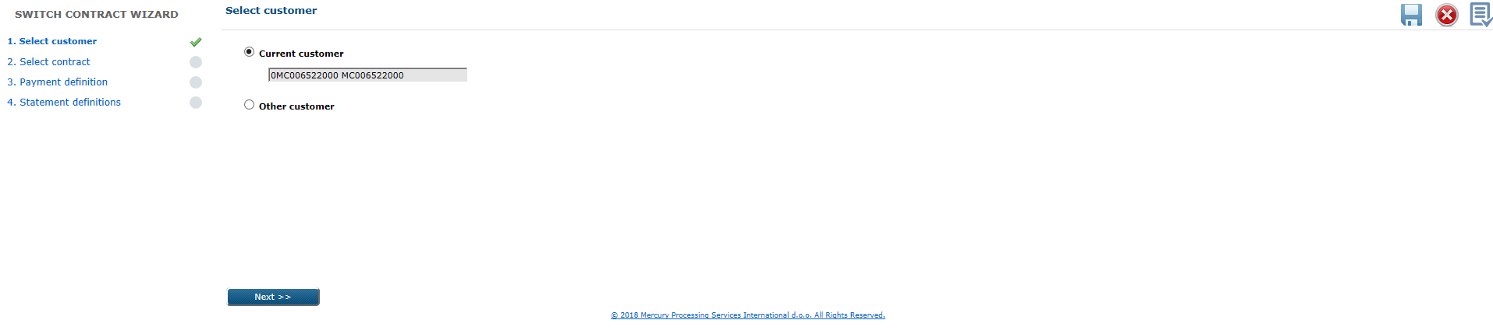

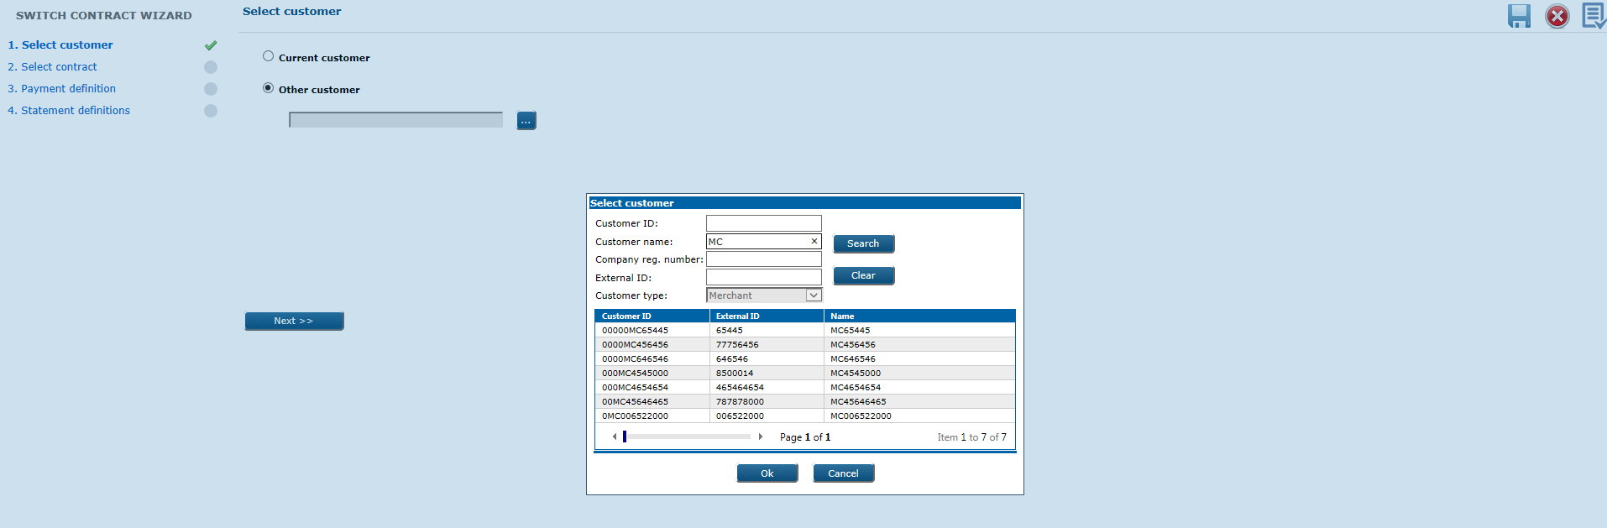

b) Select contract

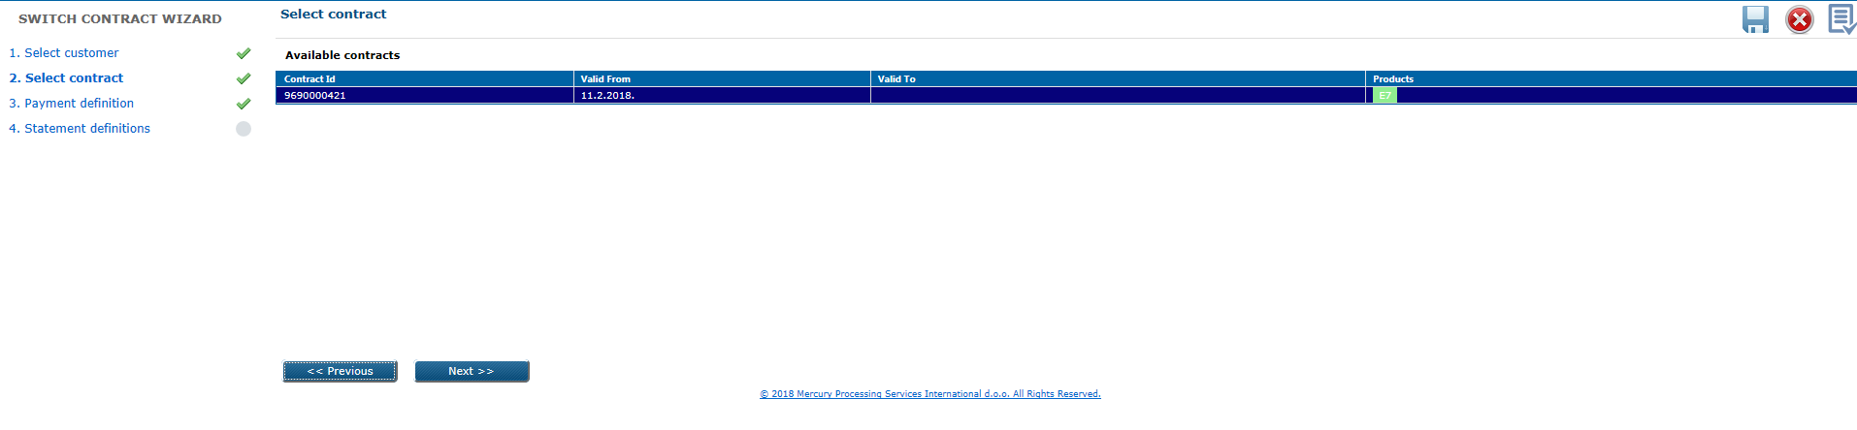

c) Payment definition

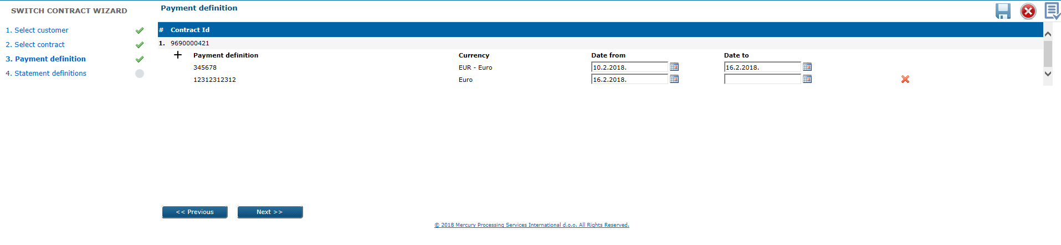

Here is listed existing Payment definition of new customer with possibillity to add new

d) Statement definition

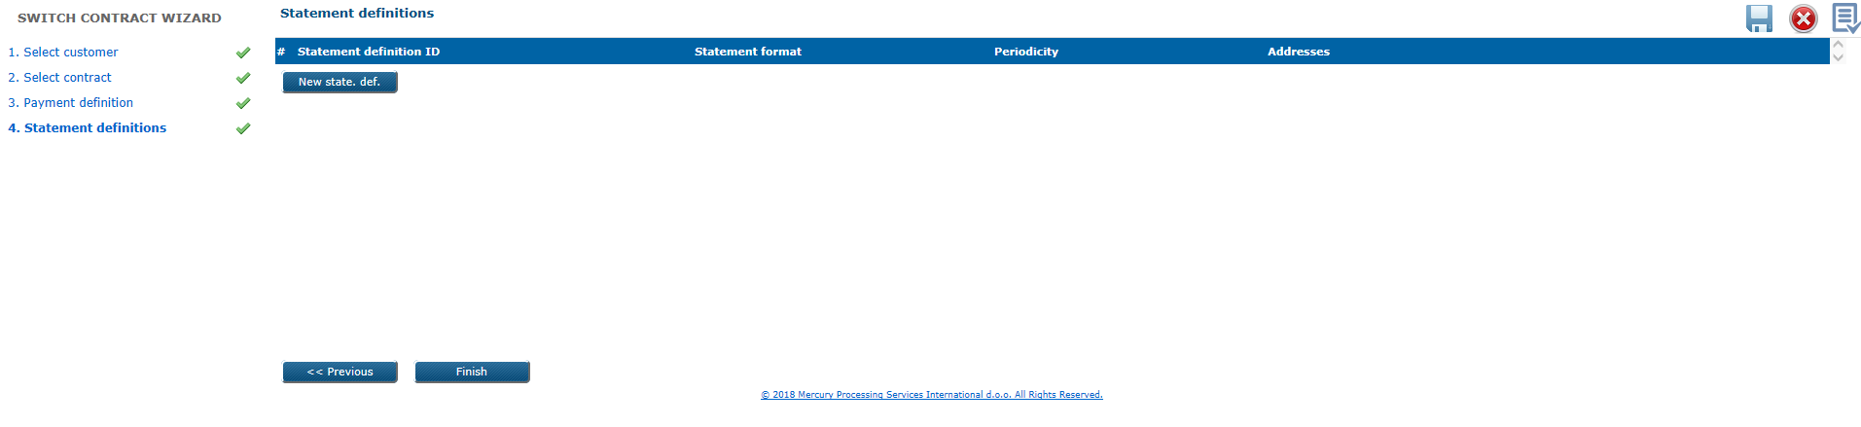

* in case of new customer – user is prompted to create new payment definition and statement definition
* all level down entities should be moved to target contract (there are no automatic

activation),

* products list on target contract is the same as on old contract,
* old contract should end up in status *Changed*,
* if you are moving contract to the different customer, all retailer connections with other contracts from previous contract/customer relation should be deleted.
* Possible statuses for Contract: Active,Updated,Changed,Canceled

# 5.2. UC POS 020: Retrieve contract(s)

Retrieval of existing contract(s) in web application by using search parameters: *Contract ID*, *Commisssion type*, *Customer ID*, *External ID*, *Customer type*, *Customer tax ID*, *Customer name 1*, *Customer name 2*, *Postal code*, *City*, *Description*, *Status*.

User can select by click with the right mouse button on grid column names line, from the columns submenu, which columns he want to see.

Retrieved will be: contract data, account number, commission data, history data.

Preconditions

* contract(s) must exist in the system.

**Triggers**

*Acquiring* module *> Review 2* form *> Contracts* level

Search can be performedby applying different search filter(s) on the screen. When the particular contract found, details can be displayed by click on retrieved record.

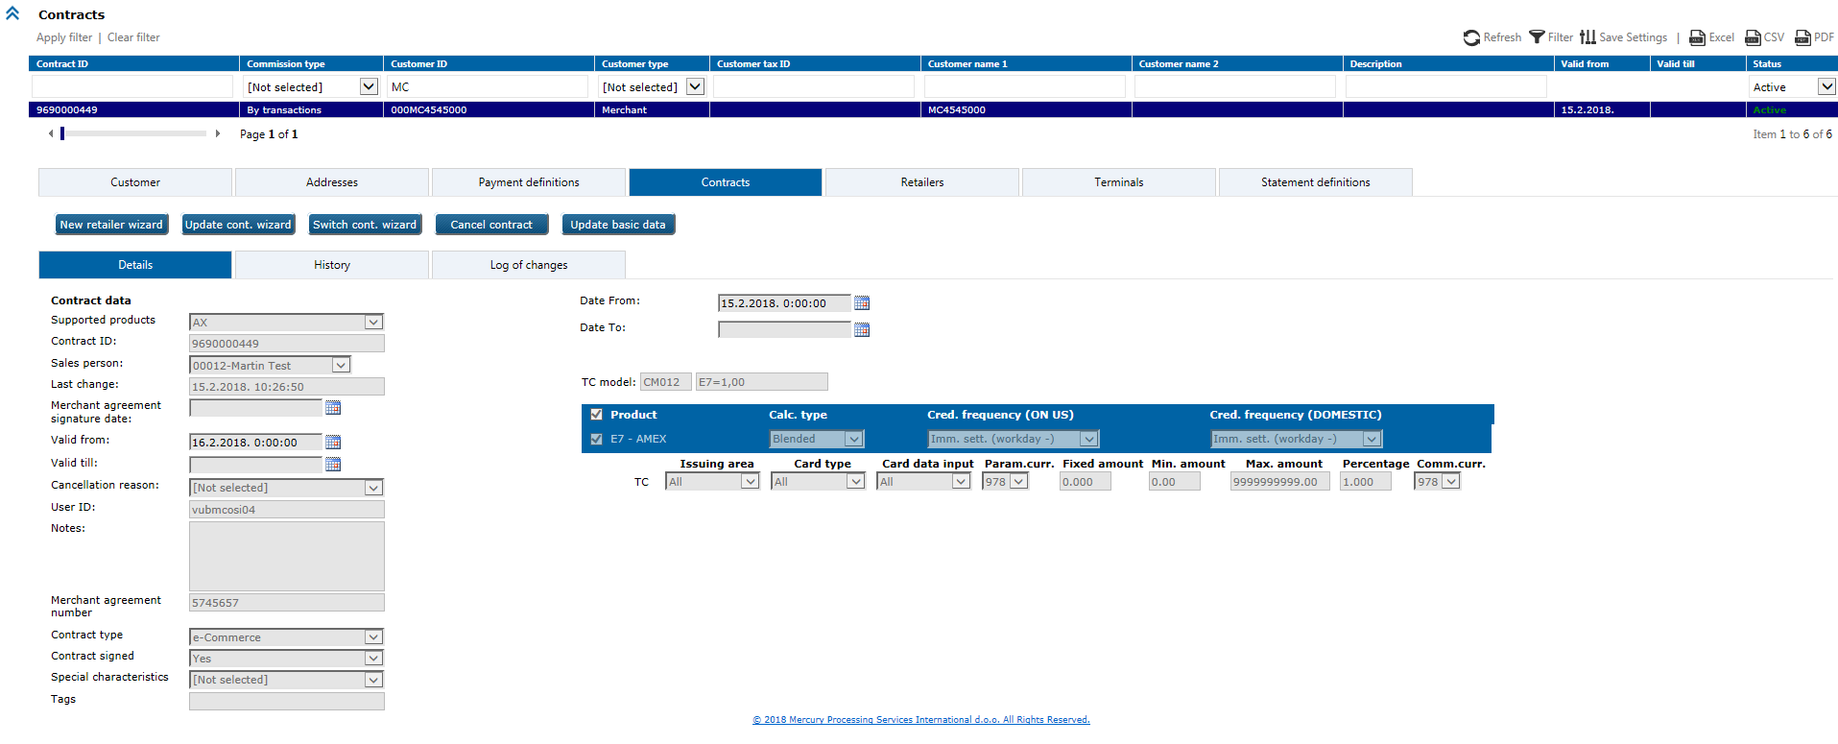

**Business & system rules**

* contract can be in *Active* or *Canceled* status (or Updated / Changed used only for system – not used by end user)

# 5.2. UC POS 021: Update payment definiton

Payment definition data is possible to change in web application.

**Preconditions**

* payment definition should exist in the system.

**Trigger**

*Acquiring* module > *Review 2* form > *Payment definitions* level

Search first for existing payment definition which you want to change, then click on it to open details:

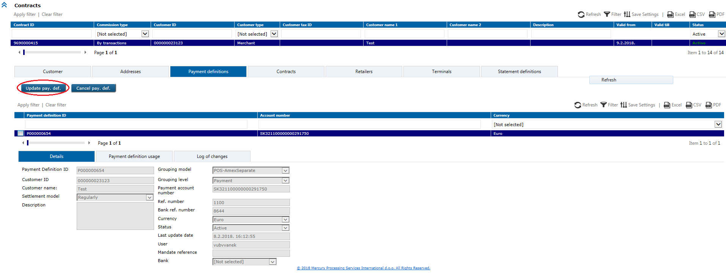

Click on the Update payment def. button, the following window appears where user can change undimmed fields and confirm changes by *OK* button:

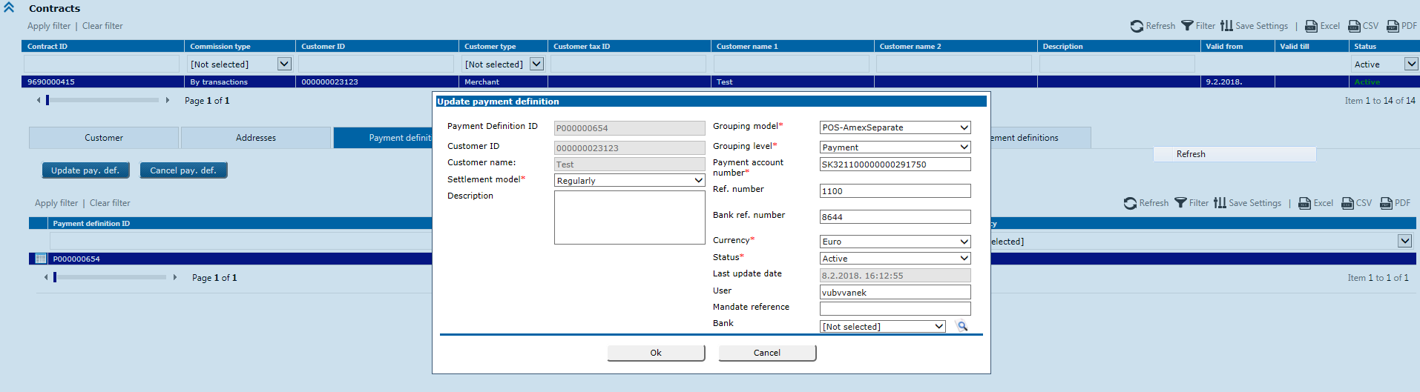

# 5.2. UC POS 022: Update payment definition validity

Payment definition validity is possible to change in web application.

**Preconditions**

* payment definition should exist in the system.

**Trigger**

Search first for existing entity for which you want to change validity of Payment definition

1. for Contract

on selected Contract click on Update cont. wizard

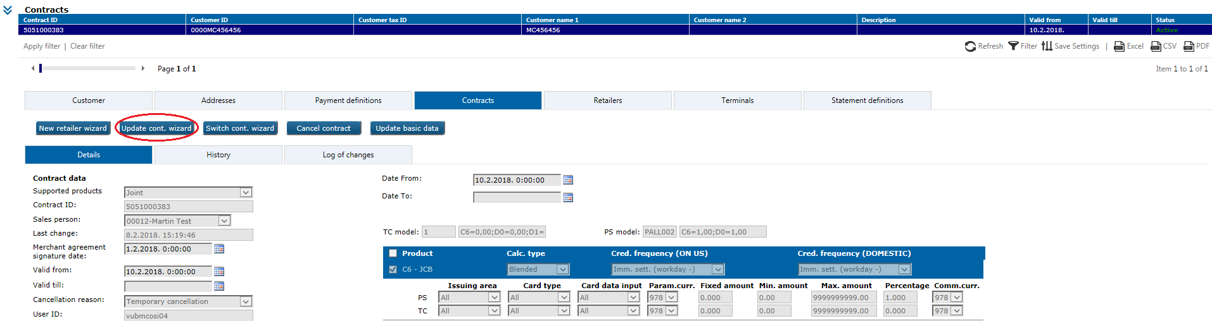

And go to step 3.Payment definition to change Date to.

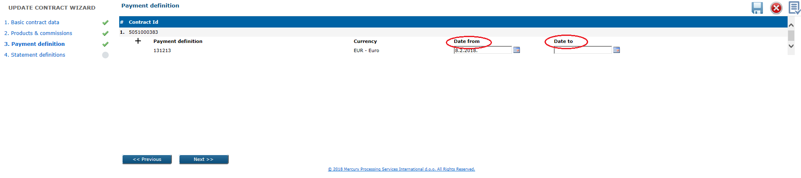

1. for Retailer

on selected Retailer click on Update ret. wizard

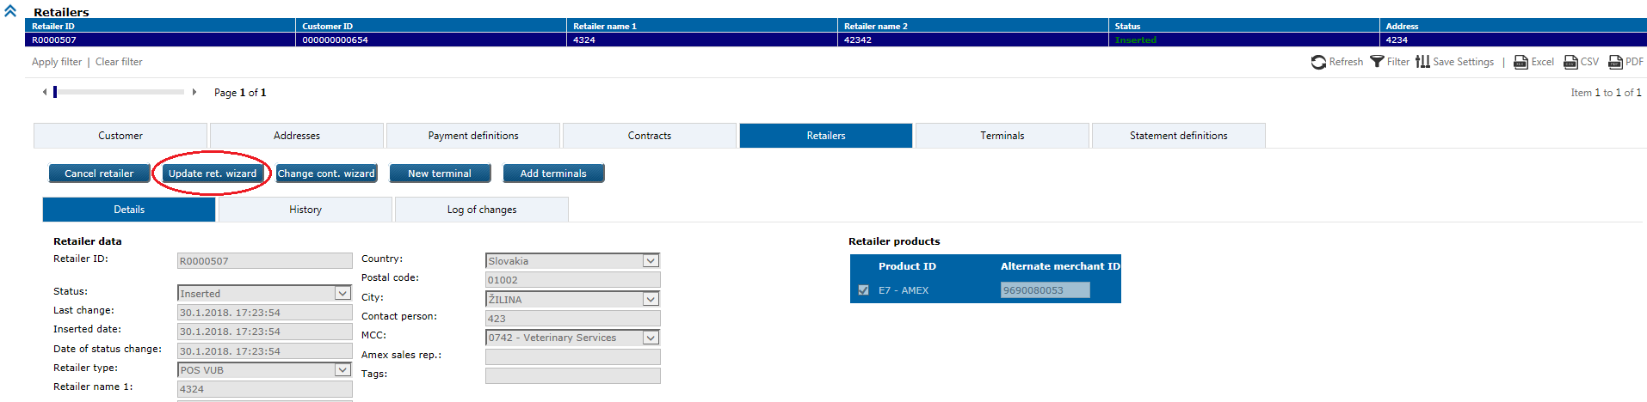

And go to step 3.Payment definition to change Date to.

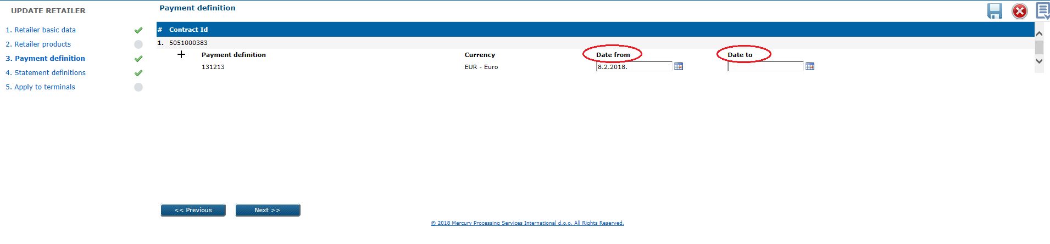

1. for Terminal

on selected Terminal click on Update terminal

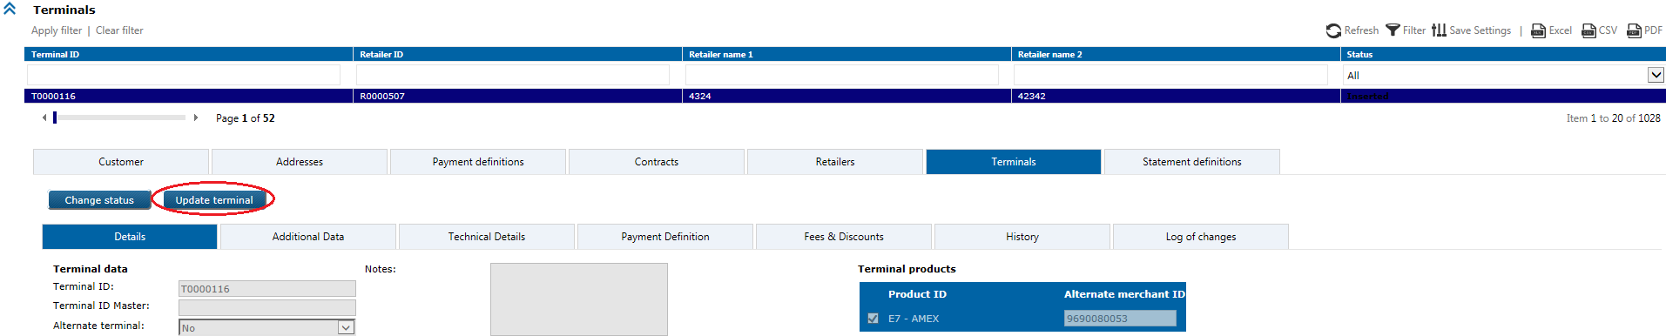

And go to step 6.Payment definition to change Date to.

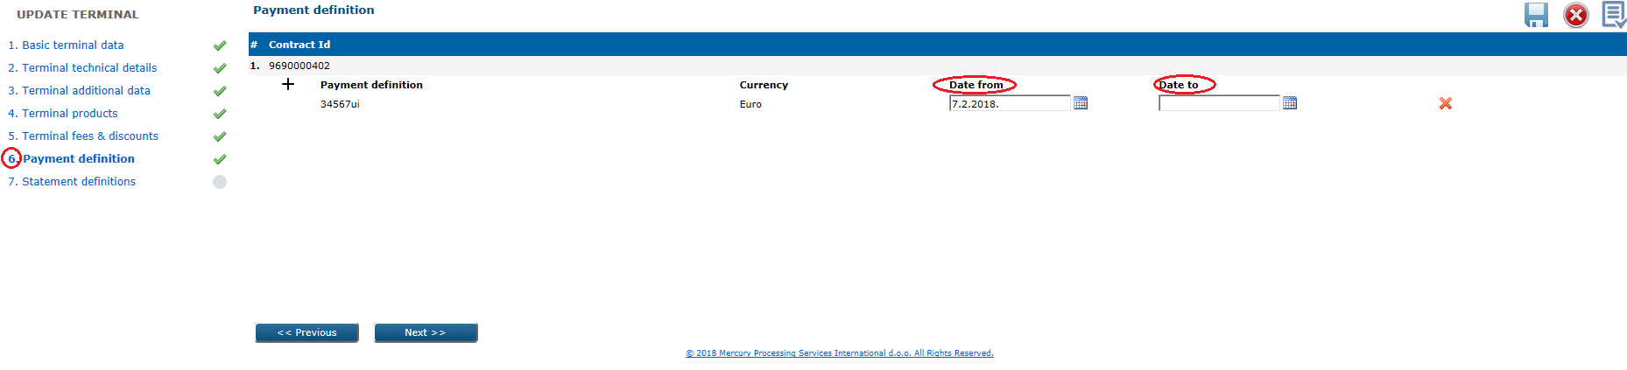

# 5.2. UC POS 023: Cancel payment definiton

Payment definition data is possible to cancel in web application.

**Preconditions**

* payment definition should exist in the system and be active.

**Trigger**

*Acquiring* module > *Review 2* form > *Payment definitions* level

Search first for existing payment definition you want to cancel, then click on it to open details:

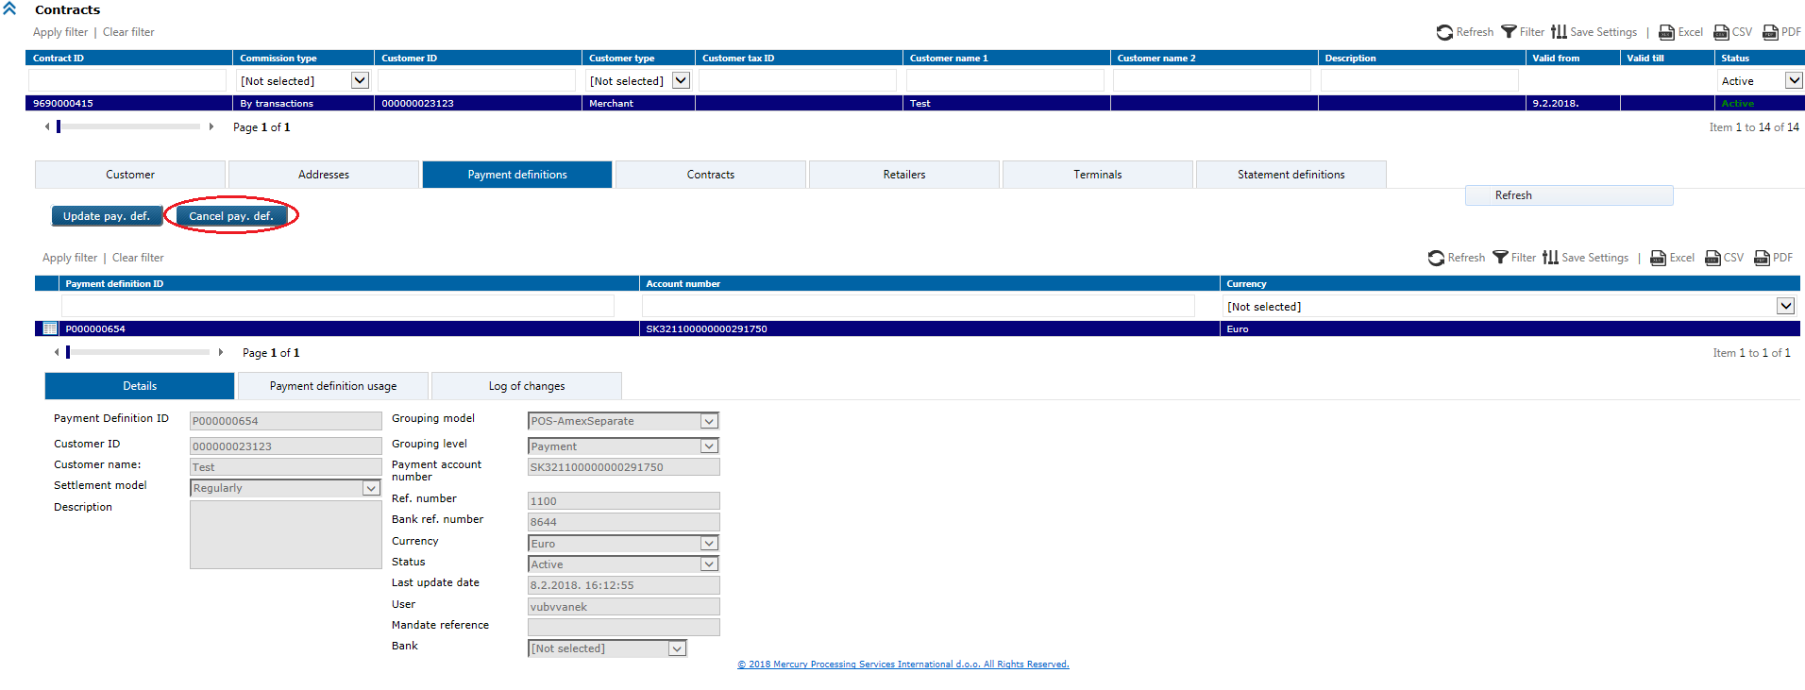

Click on the button Cancel payment definition to launch this action and confirm cancellation with *OK* button:

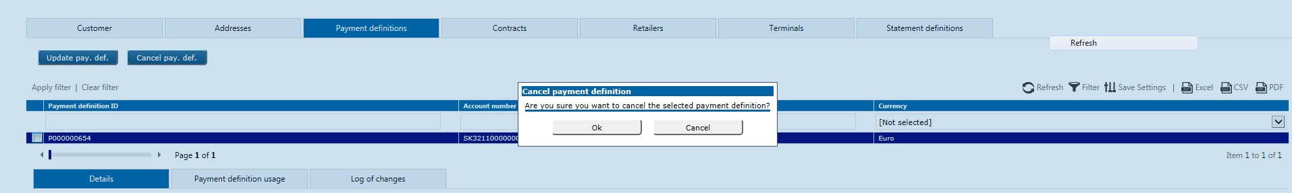

Popup message appears with information about cancelation.

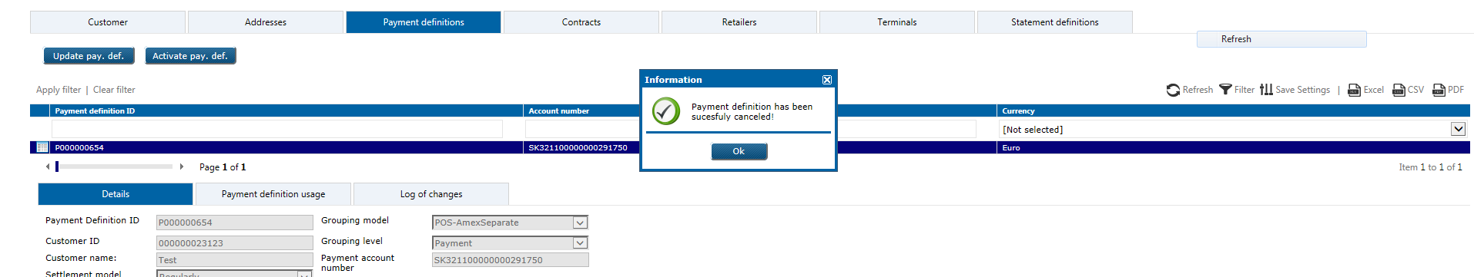

# 5.2. UC POS 024: Reactivate payment definiton

Cancelled payment definition is possible to reactivate again in web application.

**Preconditions**

* payment definition should exist in the system and be cancelled.

**Trigger**

*Acquiring* module > *Review 2* form > *Payment definitions* level

Search first for cancelled payment definition you want to reactivate again, then click on it to open details:

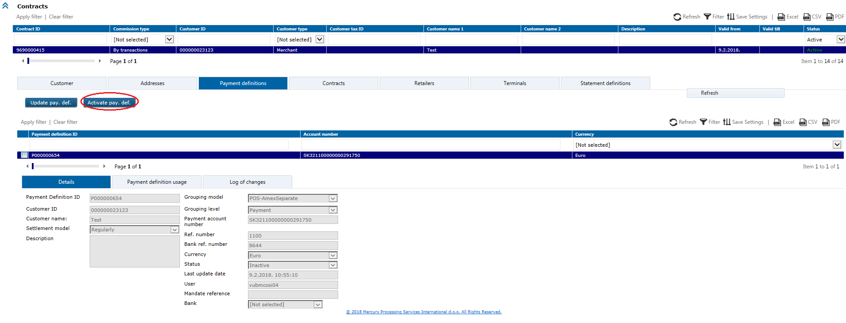

Click on the Activate pay. def. button and confirm reactivation by *OK* button:

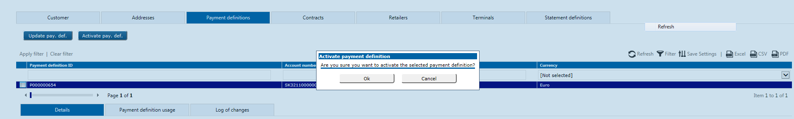

Popup message appears with information about reactivation.

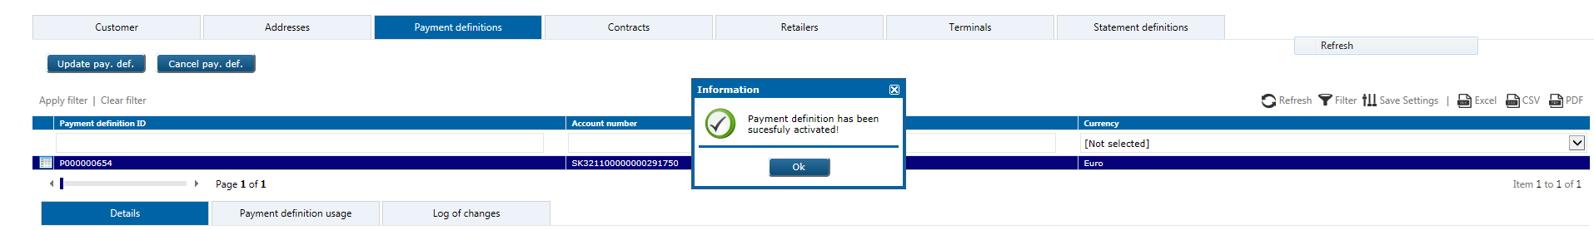

# 5.2. UC POS 025: Retrieve payment definition(s)

Retrieval of existing payment definition(s) in web application by using possible search parameters: *Payment definition ID*, *Account number*, *Currency*.

User can select by click with the right mouse button on grid column names line, from the columns submenu, which columns he want to see.

Retrieved will be: basic customer data, payment definition data, history data.

Preconditions

* payment definition(s) must exist in the system.

**Trigger**

*Acquiring* module *> Review 2* form *> Payment definitions* level

Search can be performedby applying different search filter(s) on the screen. When the particular payment definition found, details can be displayed by click on retrieved record.

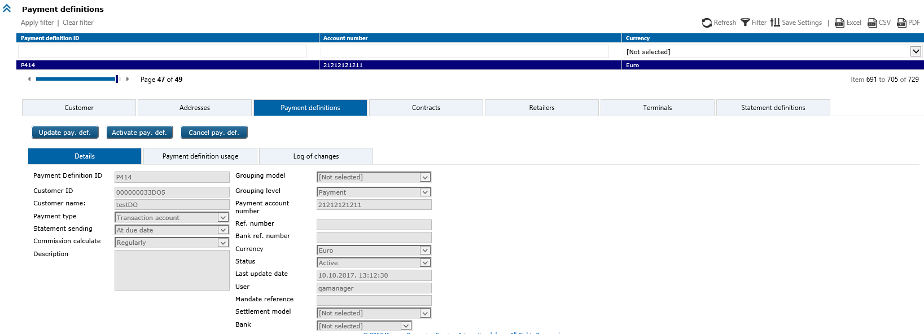

Under payment definition usage tab user can see to which entities is the paydef is assigned.

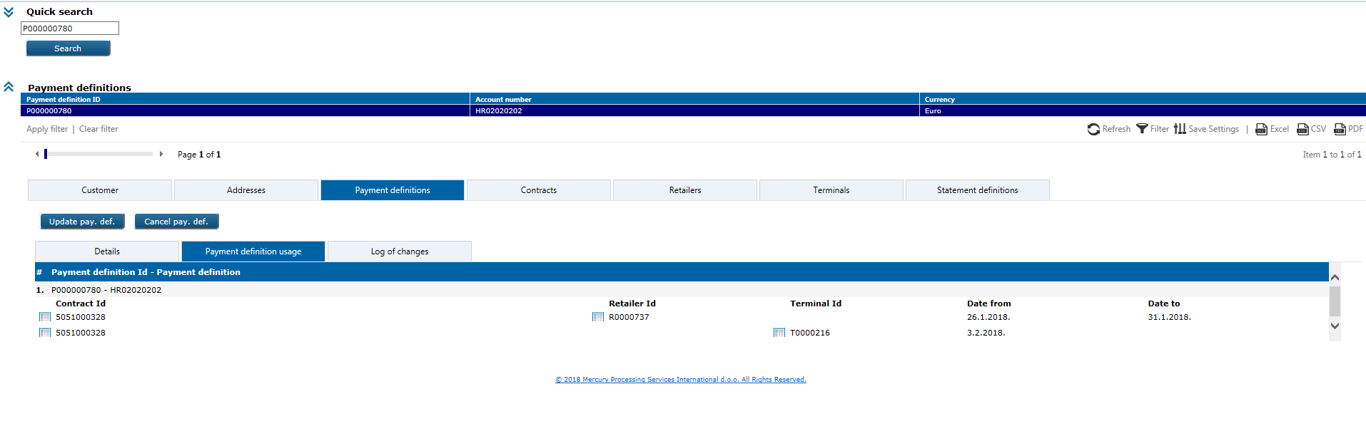

**Business & system rules**

* payment defintion can be in *Active* or *Inactive* status.

# 5.2. UC POS 026: Add new retailer through WS(es)

This option allows to add new retailer in system, through the web services.

**Preconditions**

* customer exist or not in the system, if doesn’t it should be created (UC POS 001) before adding new retailer and contract,
* retailer which you want to add should not exist in the system.

**Triggers**

*AddRetailer* WS methods and/or *AddTerminal* WS methods – to create new retailer(s) and/or terminal(s) and publish it automatically in eXact database.

Successfully input data in eXact database, possible are to use in web application:

*Acquiring* module > *Review2* form > *Unfinished wizard cases* option

Detailed explained in US POS 052

Appendix B - UML sequence diagram

**Business & system rules**

*Retailer ID* – autogenerated by system, unique per VUB and total 10 digits in length:

prefix ‘5052’ + sequence starting from ‘000001’

*Retailer type* – from drop down menu:

* 1-POS VUB
* 14-POS foreign
* 8-MOTO
* 7-e-Commerce
* 633-Imprinter
* 625-Cash Advance
* 626-Top-up (ATM)

*Contact person* – possible is to input unlimitted number of persons and *Contact phone* and *Contact e-mail* for each contact person,

*Alternate merchant ID* - for AMEX should be autogenerate in background on the retailer level

and visible in web (VUB use it for merchant disputes and send it to other

partner banks for assigning on the terminal level):

prefix 969DD8DDD% followed by sequence number, 10 characters in total

(DD8DDD% - sequence with constant '8' on the third position)

* status of new added retailer will be *Inserted,*
* status of products on retailer level will be *Active*,
* new retailer will be propagated automatically to the authorisation system.

# 5.2. UC POS 027: Add new retailer through web application

This option allows to add new retailer in eXact system, through the web application.

**Preconditions**

* customer should exist in the system,
* contract on which you want to add retailer must exist in system and be *Active*,
* retailer which you want to add should not exist in the system.

**Triggers**

a) option:

*Acquiring* module > *Review 2* form > *Customers* level

Retailer entry starts with search for particular customer to which you want to add retailer,

click on customer to open details.

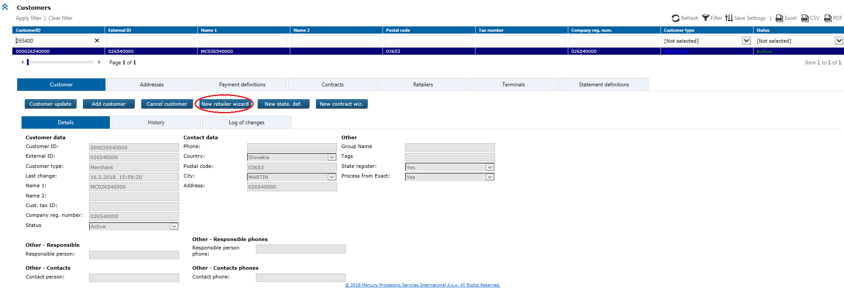

Click on New retailer wizard button to open wizard, where each step must be populated with valid data:

1. contract data

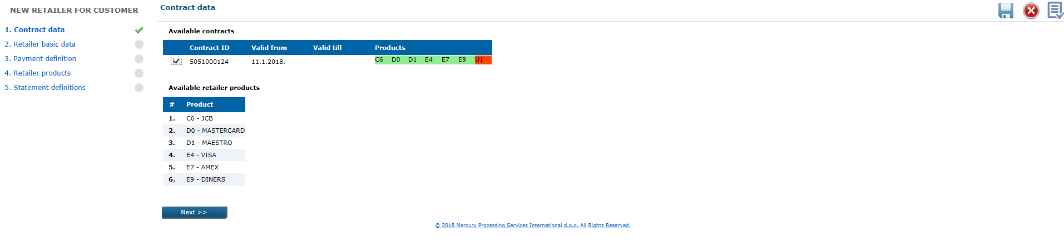

1. Retailer basic data

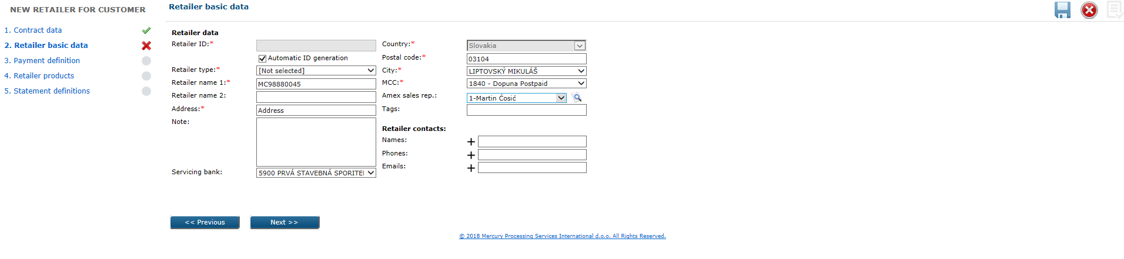

3. Payment definition

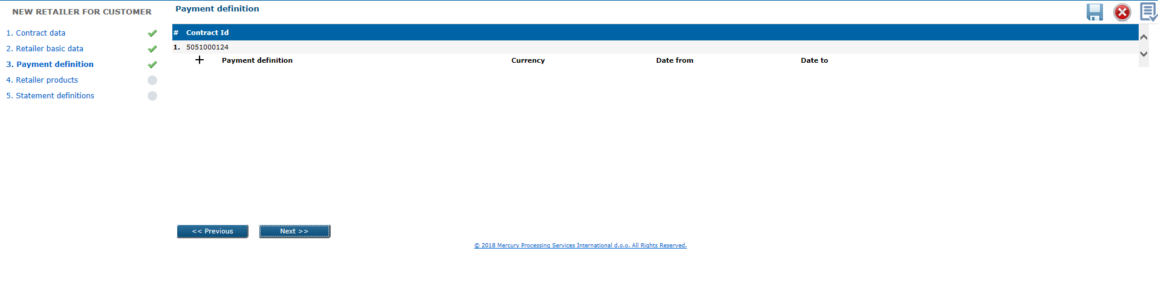

On the following screen you can select existing Payment definition from that customer or enter new one.

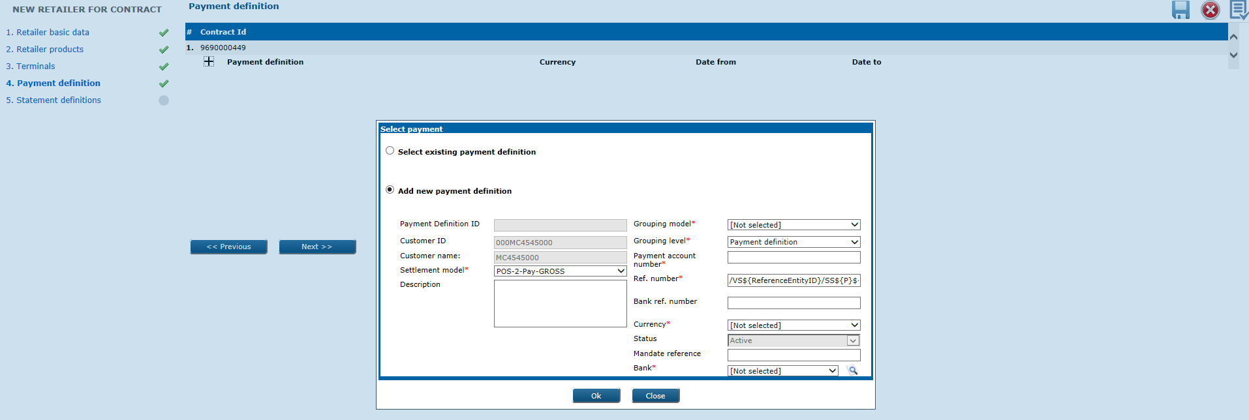

On the following screen you can delete added Payment definition, by click on the right positioned orange X sign related to data in that line.

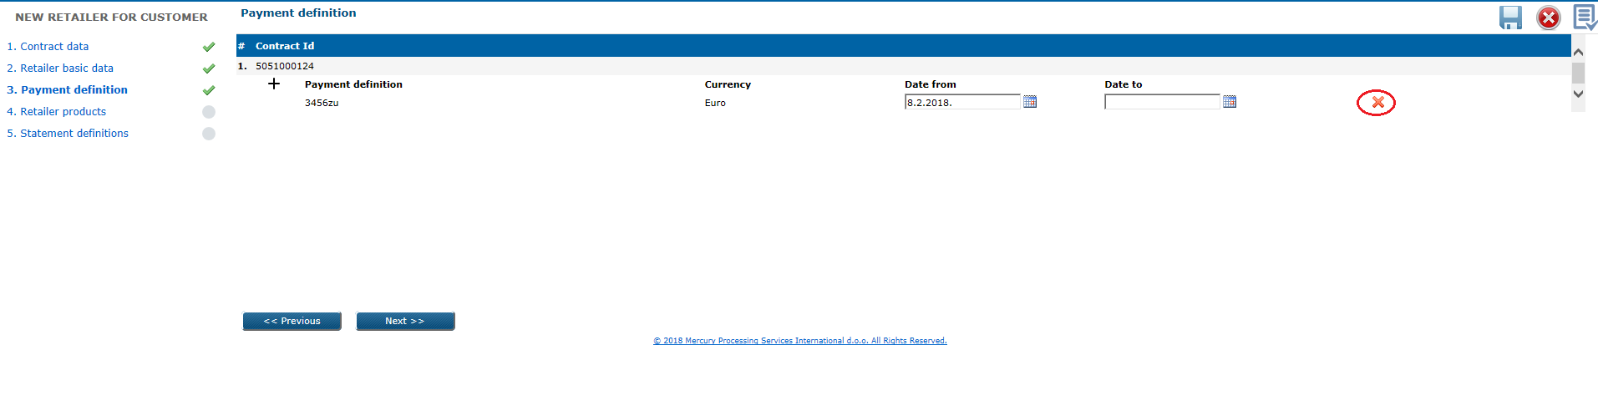

1. Retailer products

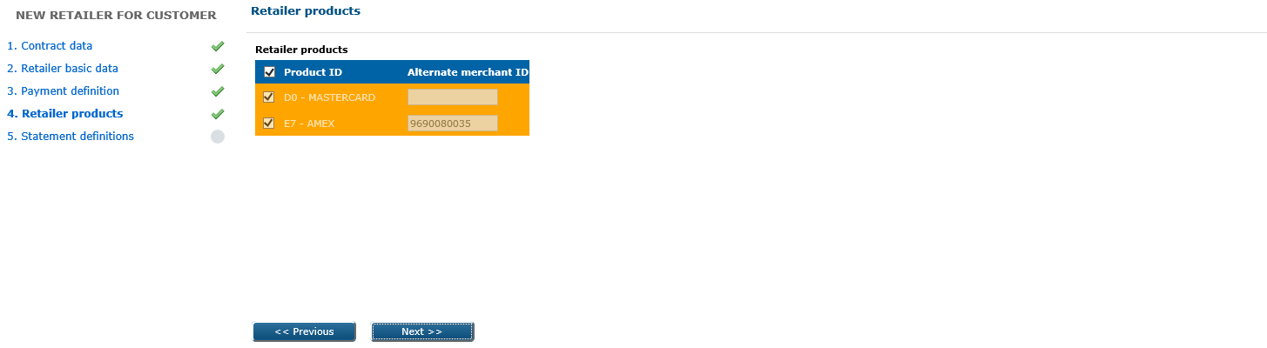

1. Statement definitions

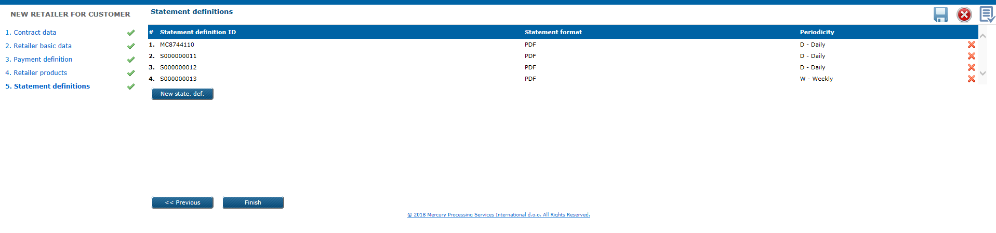

On the following screen you can delete added Statement definition, by click on the right positioned orange X sign related to data in that line, modify entered data or add new.

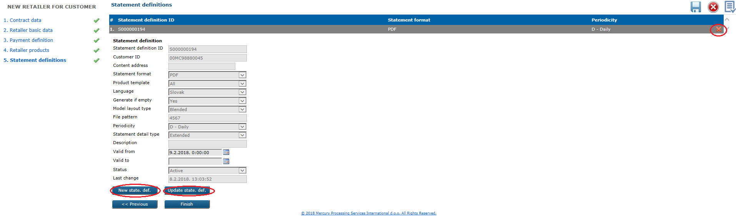

By click on the Finish button, retailer will be published.

b) option:

*Acquiring* module > *Review 2* form > *Contracts level*

Search first for existing contract to which you want to add retailer, then click on it to open details.

Click on New retailer button and wizard will open with the following 5 steps:

1. Retailer basic data

2. Retailer products

3. Terminals

4. Payment definitions

5. Statement definitions.

**Business & system rules**

* explained in UC POS 029.

# 5.2. UC POS 028: Update retailer

This is option in web application for retailer’s data changes, which will be applied to selected terminals of updated retailer.

**Preconditions**

* retailer which you want to change, should exist in the system.

**Triggers**

*Acquiring* module > *Review 2* form > *Retailers* level

Search first for retailer which you want to change, then click on it to show details:

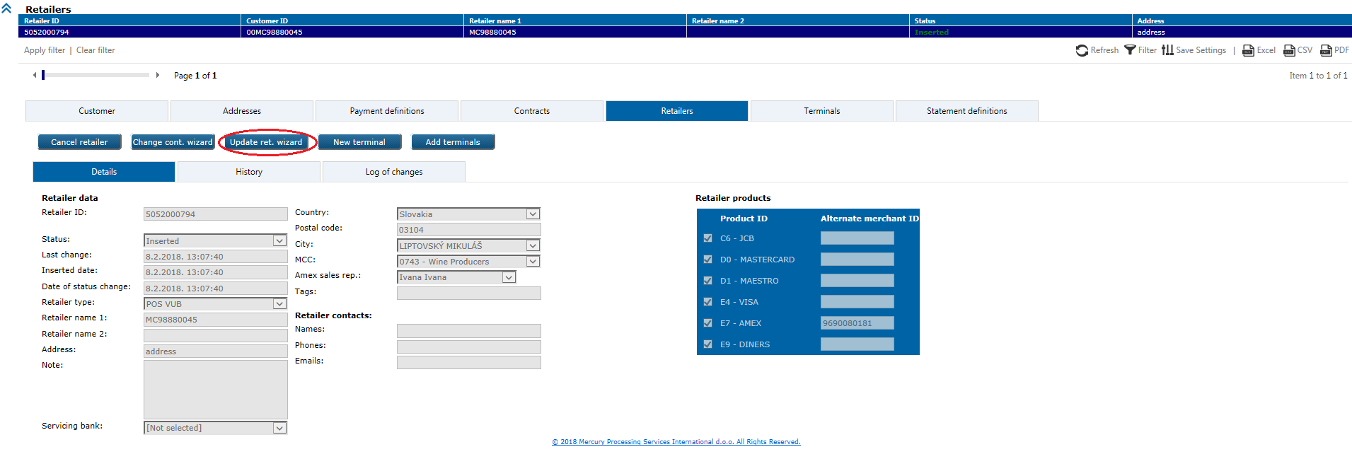

Click on the Update ret. wizardbutton to open wizard, each step prepopulated with current data and undimmed fields can be changed (some fields are mandatory and validations will be performed prior to update):

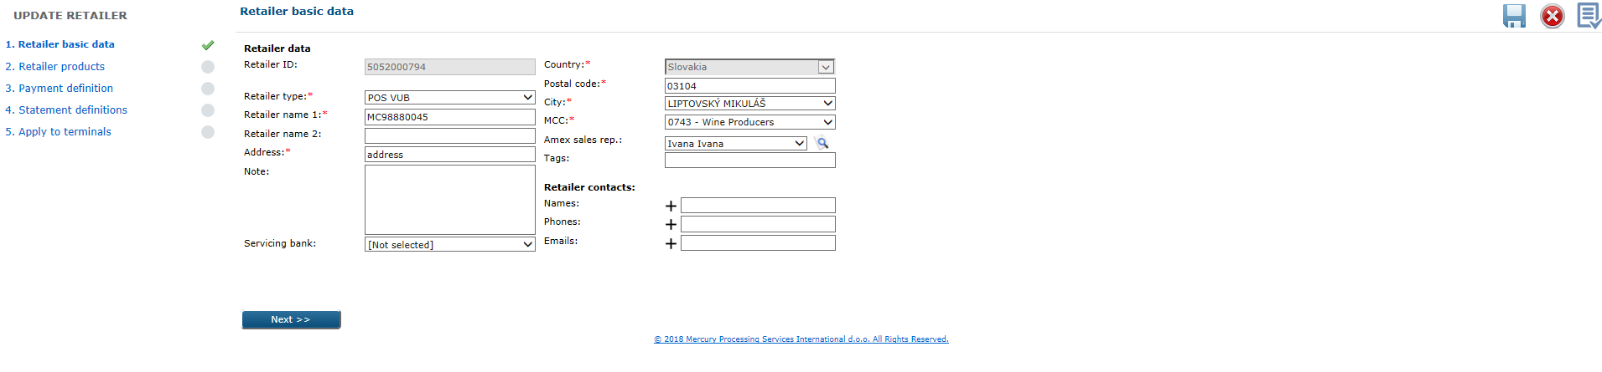

Changes in retailer products will be propagated to terminals

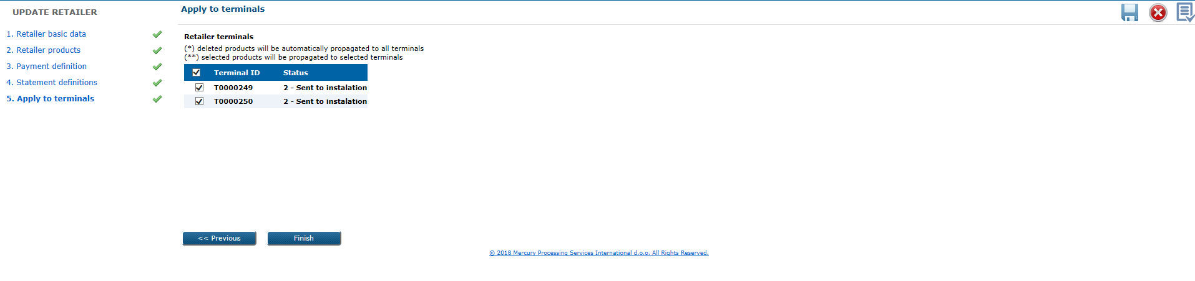

By click on Finish button, retailer will be updated if all validations passed OK.

**Business & system rules**

* changes in retailer products will be reflected in all subordinate entities (e.g. revoking product on retailer level will revoke the same active product on all retailer terminals), selected products will be propagated only to selected terminals,
* active retailer should have at least one active product,
* retailer status can be *Inserted* or *Canceled,*
* for retailers in status *Canceled* only basic retailer data can be updated,
* for retailers in status *Inserted* updated can be basic retailer data, retailer products and affected terminals,
* retailer changes will be logged,
* retailer updates will be propagated automatically to the authorisation system.

# 5.2. UC POS 029: Cancel retailer

This is option in web application for retailer cancellation, and also it’s products, terminals and terminal products.

Preconditions

* retailer must exist in the system and be in *Inserted* status.

**Triggers**

*Acquiring* module > *Review 2* form > *Retailers* level

Search first for retailer which you want to cancel, then click on Cancel retailerbutton:

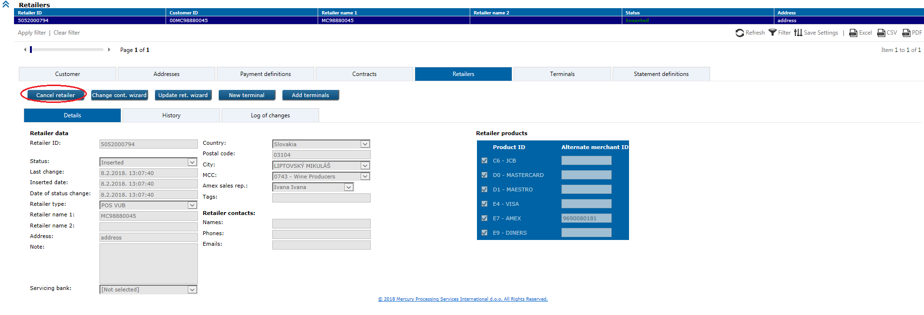

Choose temporary or permanent cancellation reason, and confirm your choice by *OK*:

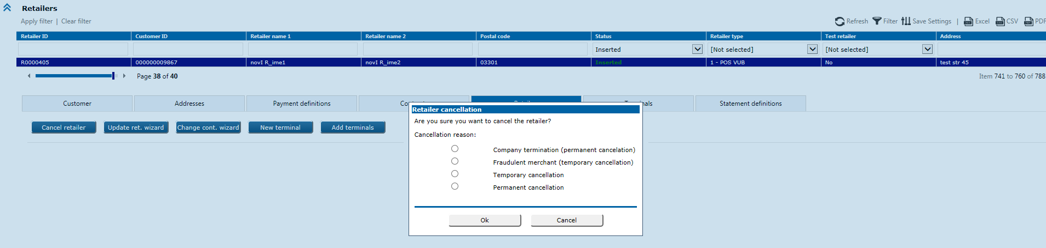

List of automatically deactivated terminals of that retailer will be provided to user in pop-up window on the screen.

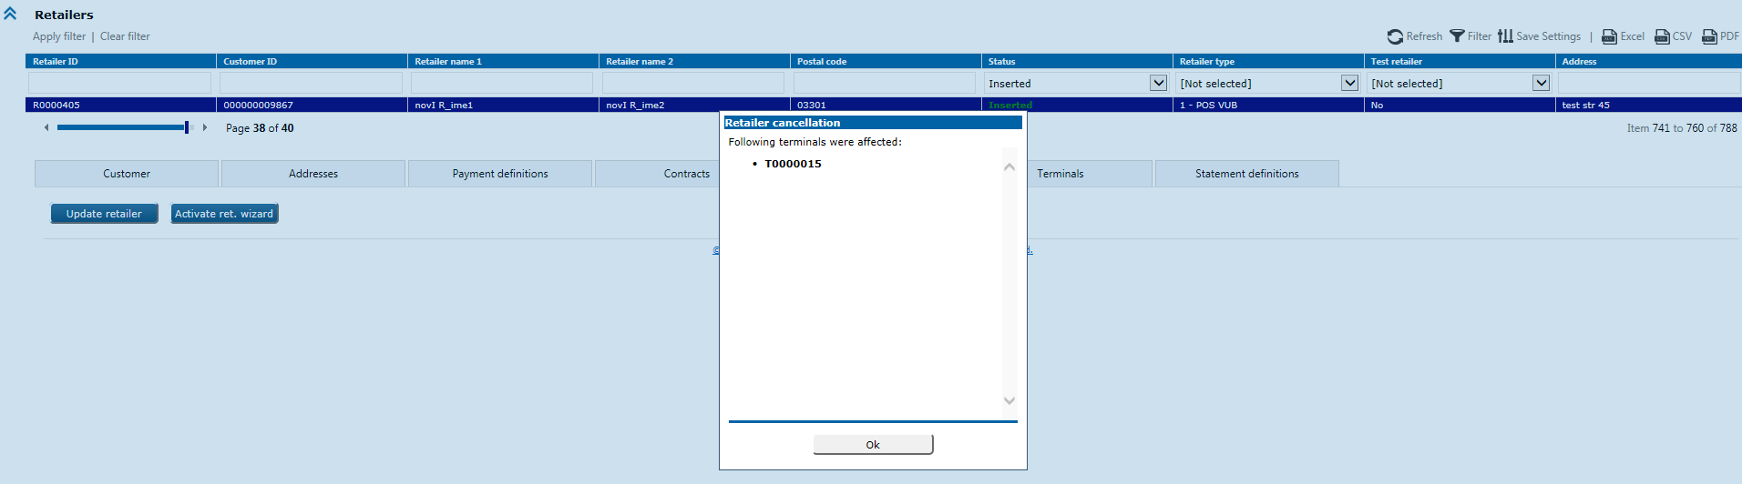

**Business & system rules**

* + temporary cancellation:

- retailer status will be changed to *Canceled*,

- related terminal with status 3 (*Installed*) will be moved to status C (*Cancelled*),

- related terminal with all other statuses will be moved to D (*De-Installed*)

- in case of re-activation, only status C will be re-activated to 3

* + permanent cancellation:

- all related terminals will be moved to D (*De-Installed*)

* + in both cancellation cases, previous product(s) is cancelled (*Inactive*) and will not be reverted automatically in case of re-activation (levelup product will be used as reference),
  + all changes have been logged,
  + all transactions imported after retailer cancellation will be rejected (unprocessed).

Cancellation of retailer will be propagated automatically to the authorisation system (retailer changes synchronized to B24 in real-time manner or 15 minute intervals).

# 5.2. UC POS 030: Reactivate retailer

This is option in web application for reactivation of temporary cancelled retailer, it’s products, terminals and terminal products.

Permanent cancelled retailer is not possible to reactivate again.

Preconditions

* retailer must exist in the system, and be temporary cancelled.

**Triggers**

*Acquiring* module > *Review 2* form > *Retailers* level

Search first for temporary cancelled retailer which you want to reactivate:

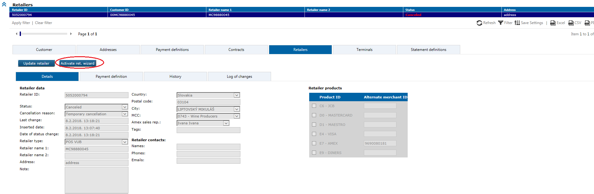

Then click on Activate ret. wizardbutton which will open the following wizard, populate necessary data to publish reactivation correctly:

Retailer basic data

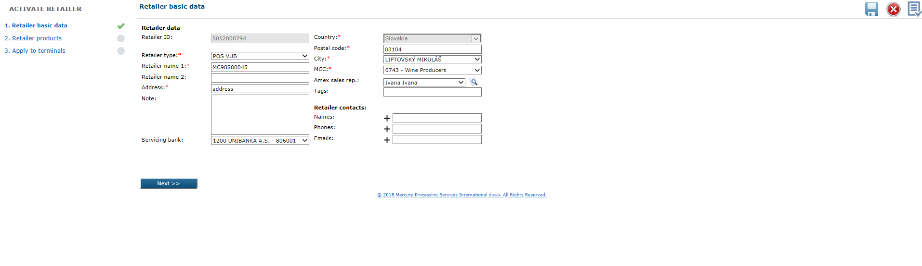

Retailer products

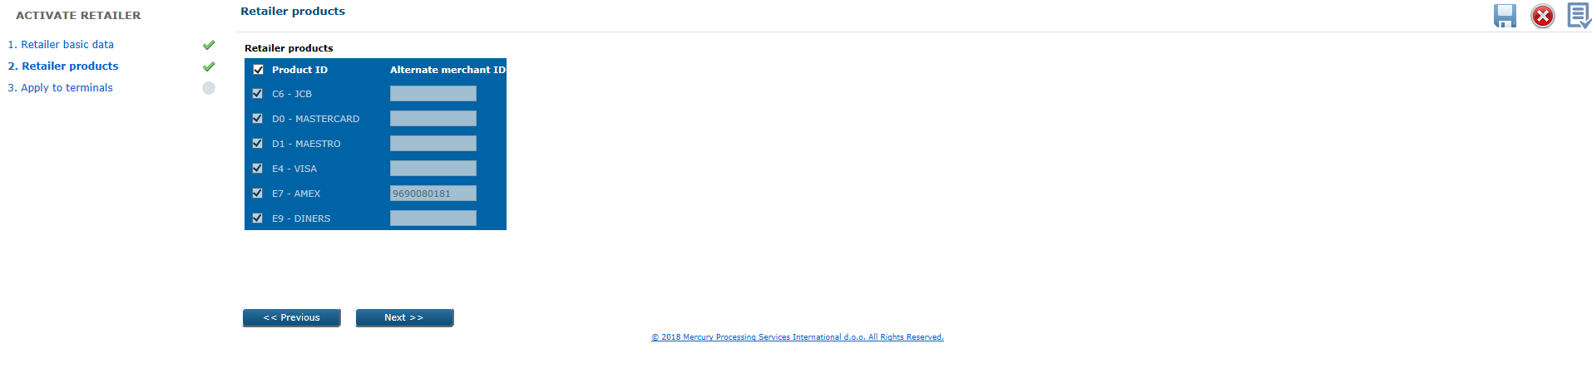

Apply to terminals

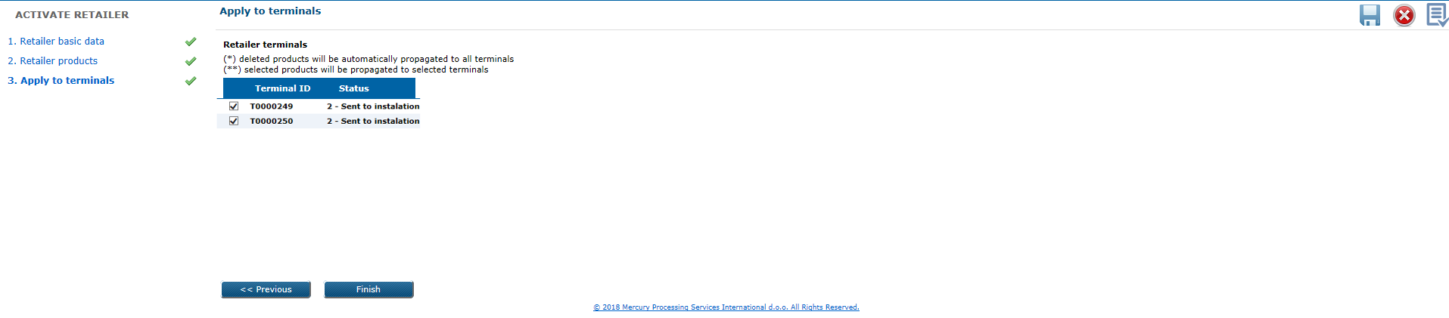

List of automatically activated terminals of that retailer will be provided to user in pop-up window on the screen.

# 5.2. UC POS 031: Assign retailer to second contract

With this option in web application is possible to assign existing retailer to second contract, within the same customer (e.g. retailer has MCVI contract, and with this option you want to assign also AX contract to this retailer).

Also is possible with this option to add contract to retailer for supported product(s) which is(are) not already included in existing contract(s).

**Preconditions**

* retailer must exist in the system and be active (*Inserted* status),
* contract which you want to assign/add, should exist and be active in the system.

**Triggers**

*Acquiring* module > *Review 2* form > *Retailers* level

Search first for retailer to which you want to change or add contract, then click on the Change cont. wizard button:

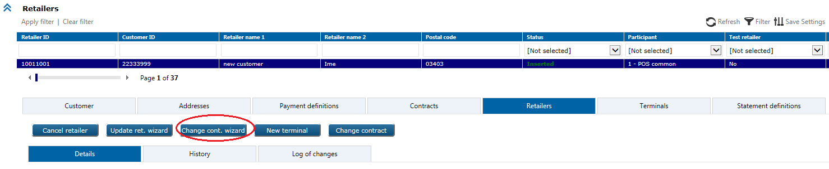

Following wizard will open and on the first step user should indicate another contract for customer, which he want to assign or to add for retailer (available products from all indicated contracts will be visible in green):

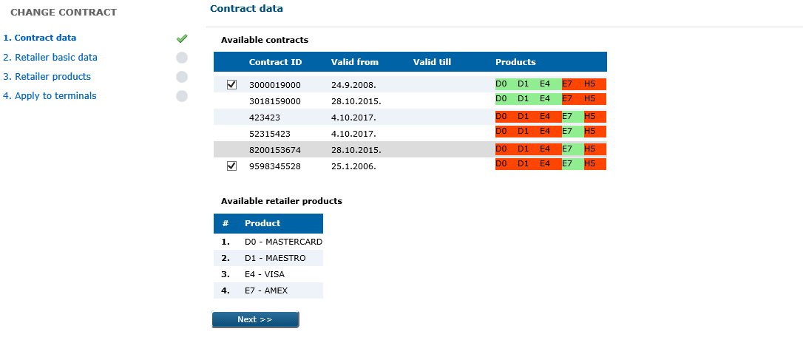

Retailer can have only 1 contract for product (e. g. not possible to have more then 1 contract for MC/VS), only contracts within non-overlapped products will be offered in wizard for selection.

With this option user can also change some (undimmed) of retailer basic data, retailer products and terminals data which are applied to retailer.

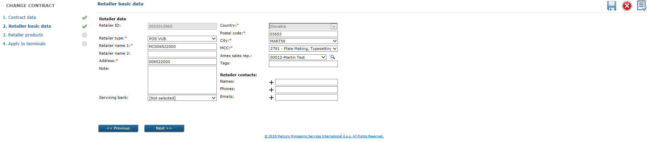

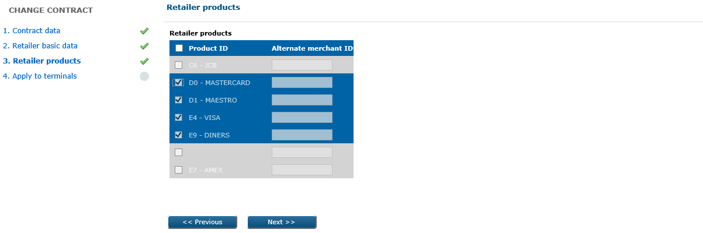

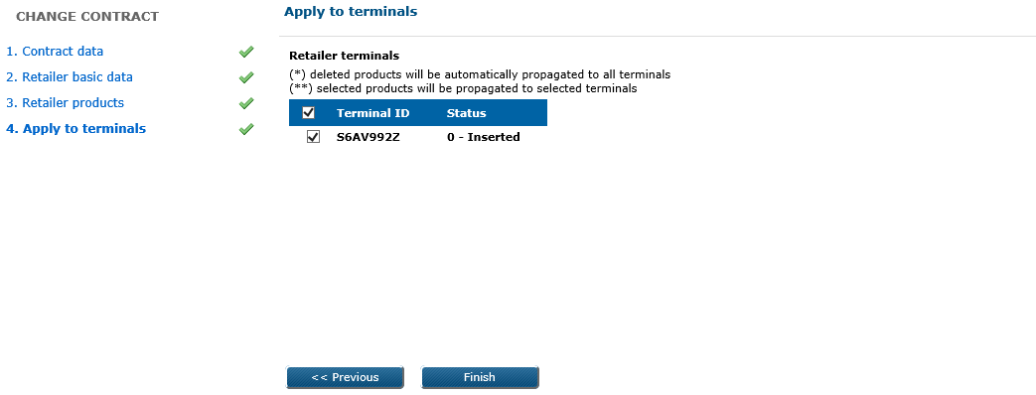

**Business & system rules**

* moving existing retailer to new contract which can have different commissions per product(s),
* moved retailer are not activated automatically,
* existing retailer connections with other contracts will be saved,
* old (replaced) contract will end up in status *Changed*,
* contract in eXact can have the following statuses:

a) *Active* (visible in current data grid)

b) *Cancelled* (visible in current data grid)

c) *Changed* (visible in history)

d) *Updated* (visible in history),

* change will be logged.

5.2. UC POS 032: Retrieve retailer(s)

Retrieval of existing retailer(s) can be done by web service or web application. In web application by using search parameters: *Retailer ID*, *Customer ID*, *Retailer name 1*, *Retailer name 2*, *Postal code*, *Status*, *Retailer type*, *Alternate retailer ID* (for AMEX), *Address*.

User can select by click with the right mouse button on grid column names line, from the columns submenu, which columns he want to see.

Retrieved will be: retailer data, payment definition data, retailer products data, history data.

Preconditions

* retailer must exist in the system.

**Triggers**1)WS: *GetRetailerByFilter* method will retrieve retailer(es) data

2) WEB: *Acquiring* module *> Review 2* form *> Retailers* level

Search can be performedby applying different search filter(s) on the screen. When the particular retailer found, details can be displayed by click on the retrieved record.

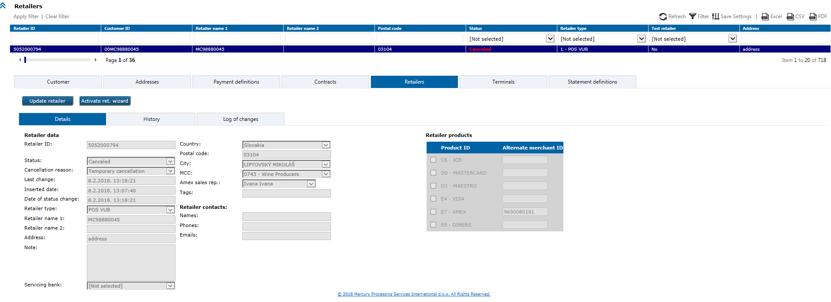

# 5.2. UC POS 033: Add new terminal through WS(s)

This is option for new terminal entry, through the web service(s).

Preconditions

* terminal which you want to add, should not exist in the system,
* retailer must exist and be in status *Inserted*.

**Triggers**

1) *AddTerminal* WS method with terminal data as elements. New terminal added on this way

will be directly inserted in the database and automatically published.

2) Add new terminal per sequences (to create unfinished wizard case in web application),

possible WS methods are:

*StartWizardSequence*

*AddRetailer* (by sequence, 1st, 2nd … )

*AddTerminal* (by sequence, 1st, 2nd … )

*FinishWizardSequence.*

Status ‘0’ in response means, that WS was successfully executed.

Appendix B - UML sequence diagram

Successfully input terminal’s data in database, possible are to use in web application:

*Acquiring* module > *Review2* form > *Unfinished wizard cases* option

First apply filter to list existing unfinished wizard cases visible under logged web user, then select yours wizard and click on the Continue wizard button which will open unfinished wizard case and you can continue to work on it.

Each wizard step must be populated with valid data in order to publish case by click on the Finish button at the last wizard step.

**Business & system rules**

* explained in UC POS 034 and UC POS 035.

# 5.2. UC POS 034: Add new terminal (POS) through web application

This is option for new POS terminal entry through web application, where under POS we consider the following terminal types: POS VUB, POS foreign, MOTO, Cash advance, Imprinter, Unattended

Preconditions

* terminal which you want to add, should not exist in eXact system,
* retailer Participant should be POS VUB / POS foreign / Imprinter / MOTO / CASH advance / Unattended
* retailer must exist and be in status *Inserted*.

**Triggers**

*Acquiring* module > *Review 2* form > *Retailers* level

Search first for retailer to which you want to add new terminal, click on it to open details:

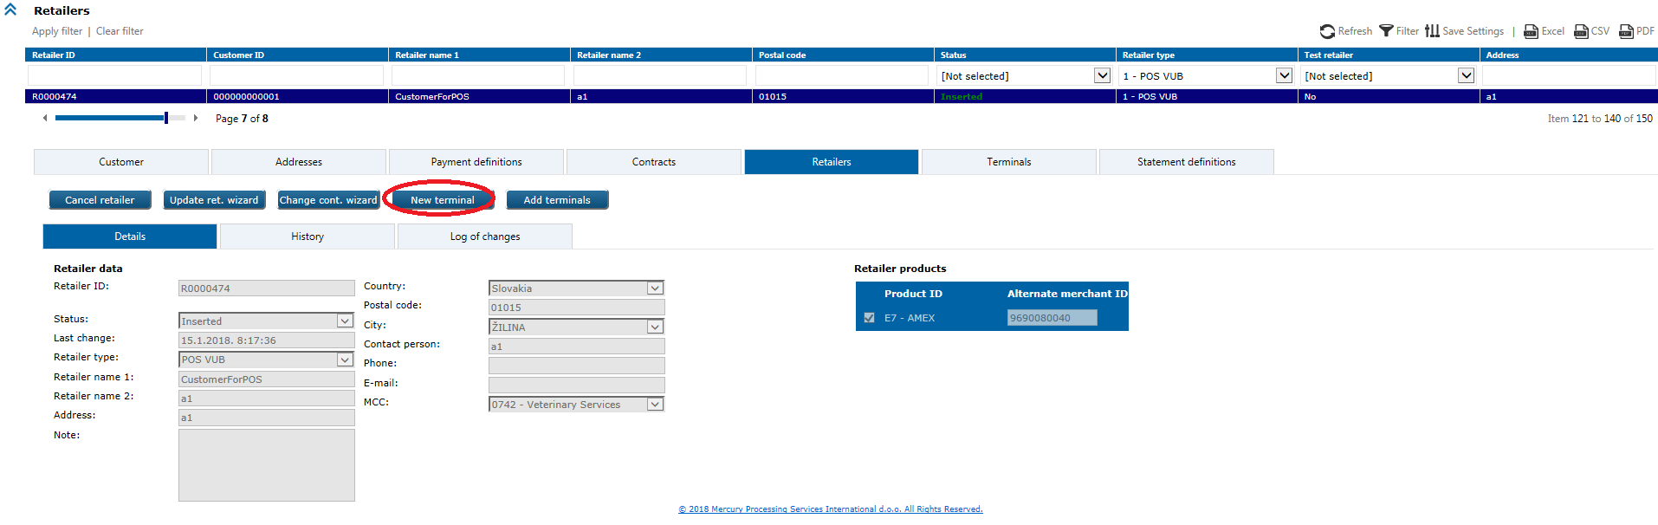

Click on the New terminal button to open following wizard, each step must be populated with valid data in order to finish wizard successfully. Dimmed fields are populated with already input data in previous application options, white fields are possible to input.

1) Basic terminal data:

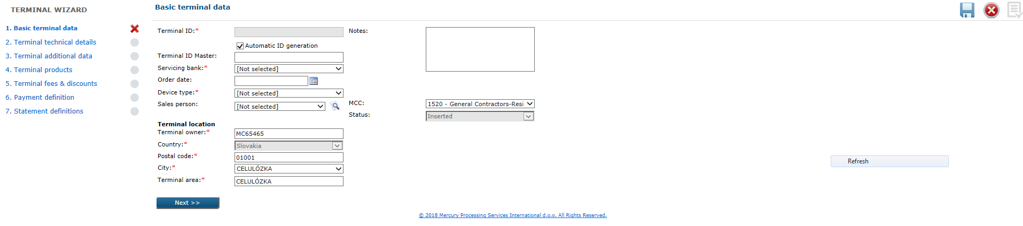

2) Terminal technical details:

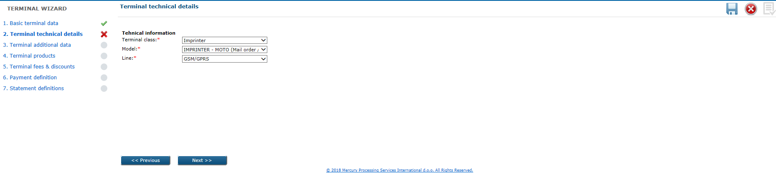

3) Terminal additional data:

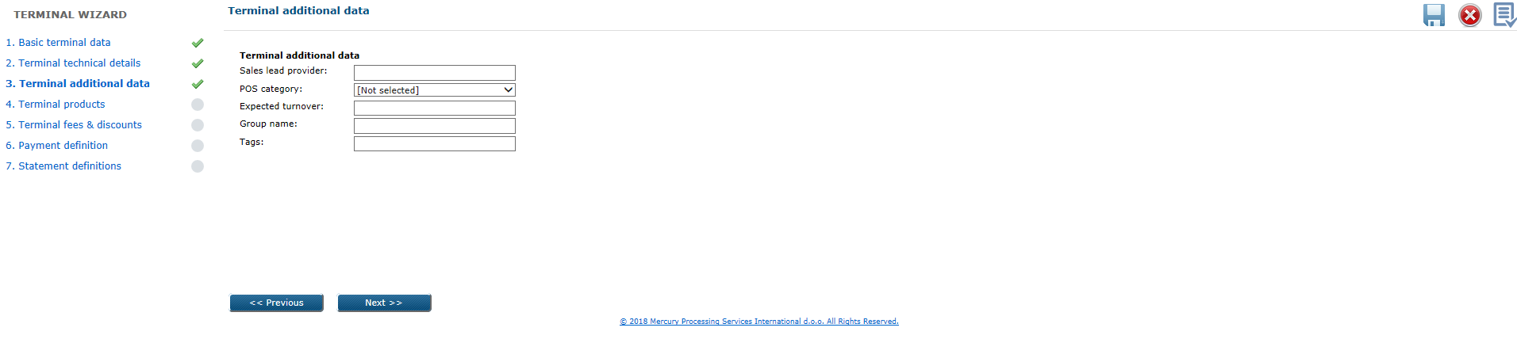

4) Terminal products

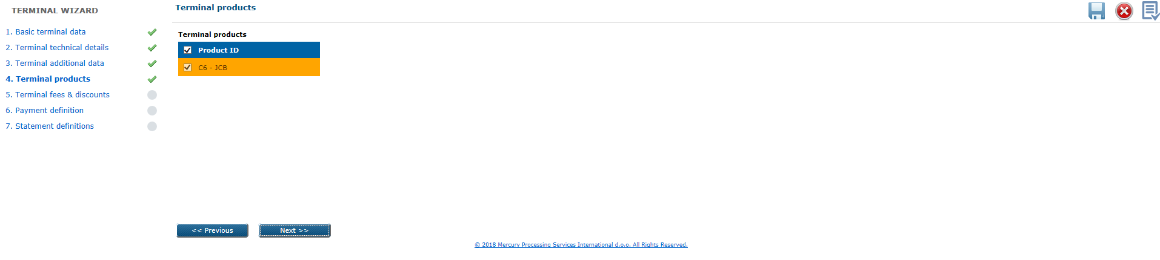

5) Terminal fees & discounts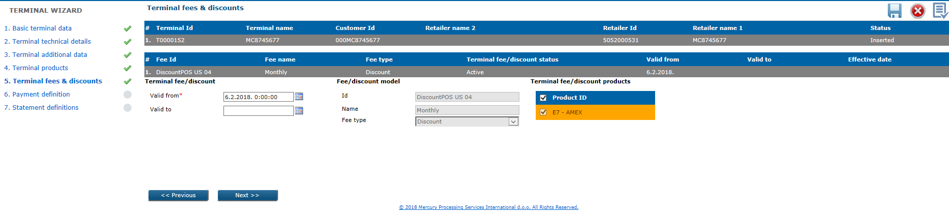

Detailed explained in POS UC 044.

6) Payment definition:

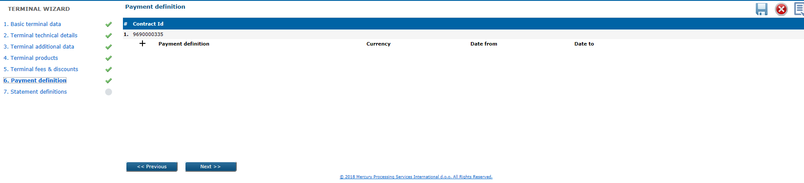

Detailed explained in POS UC 014.

7) Statement definitions

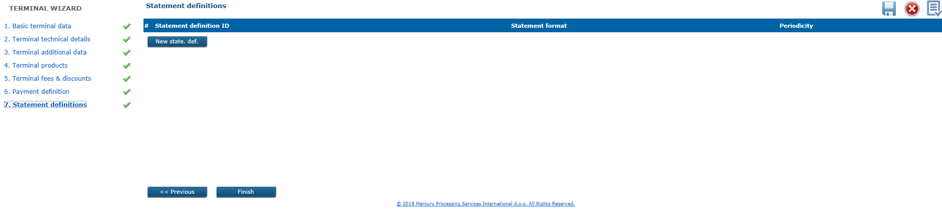

Detailed explained in POS UC 009.

By click on the Finish button at the last step, terminal will be added.

You can also add new terminal by click on Add terminals button, wizard with 4 steps will open:

1. Retailer basic data

2. Terminals

3. Payment definitions

4. Statement definitions.

**Business & system rules**

* active terminal should have at least one active product,
* new added terminal will have **2 - *Sent to installation*** status and will be activate (**3 - *Installed***) after first processed transaction, or it can be activate manually from the user side (*Change status* option), in wizard-mode status is **0 - Inserted**
* set of products defined on terminal level is subset of products defined on retailer level,
* POS terminals are type ‘2’ in eXact system,
* new terminal won’t be propagated automatically to the authorisation system
* if retailer Participant is Top-up ATM - New terminal button will not be visible

*Terminal ID* – autogenerate by system (If Foreign terminal = N, then Autogenerated + manual override, ELSE not generated and possible to manually enter)

*Terminal ID master* – used only for terminals type = 2 (POS purchase) and with multi-TID

setup for 1 physical terminal, reference to existing terminal (“master”) and

validation method check if it exist in DB and is it active,

manual user input with max. 20 digits length,

*Foreign terminal* – used only for terminals type = 2 (POS foreign) if is terminal managed by

non-VUB provider, in this field user should select from drop down menu:

* Y (yes)
* N (no)
  + - * if Retailer Type (participant) == POS foreign then Y ELSE N, with possibility to be overriden

*Servicing bank* - available for select only if is selected ‘Y’ in the *Foreign terminal* field

* + - * If NOT Foreign Terminal then must be VUB Bank. If Foreign terminal - must not be VUB bank

Device type – choose possibility from drop down menu:

* POS (for POS terminal)
* Imprinter (for POS terminal)
* MOTE (for POS terminal)
* Unattended (for POS terminal)
* E-Commerce (for e-commerce terminal)

*Order date* - optional field

*Activation date* - optional field

*Cancellation date* - optional field

*Notes* - optional field

*Status* - 0 – Inserted (in wizard mode)

*MCC* - optional field

*Terminal owner*

*Terminal location*

*Terminal City*

*Terminal country* - 703 - Slovakia

*Terminal Region* - optional field

*Cancellation reason* – mandatory to select in web application option for terminal cancellation,

possible reasons are:

* Company termination
* Fraudulent merchant
* Temporary cancellation
* Permanent cancellation

*Cancellation - more info -* optional field

*Substatus* – optional field provided only when terminal is cancelled/deactivated, drop down

menu with possible values:

* Blocked by risk
* Never used

Terminal Tech data:

*Terminal class –* from drop down menu you can choose:

* GPRS (for POS terminal)
* Stationary (for POS terminal)
* Imprinter (for POS terminal)
* Internet (for e-Commerce)

*Communication line –* from drop down menu you can choose:

* TCP/IP
* GSM/GPRS

*Model -* codelist

Terminal Additional data:

*Sales lead provider -* codelist

*POS Category* – drop down menu with possible values

* Seasonal POS
* Replacement of POS
* Standby POS
* Other

*Expected turnover -* optional field

*Group name -* optional field

*Tags -* optional field

*Sales person -* optional field

# 5.2. UC POS 035: Add new terminal (e-Commerce) through the web application

This is option for new e-Commerce terminal entry through web application.

Preconditions

* terminal which you want to add, should not exist in eXact system,
* retailer Participant should be e-Commerce
* retailer must exist and be in status *Active*.

In order to properly setup e-Commerce retailer this prerequisites should be met.

1. On e-commerce terminal form additional data for NestPay must be populated:
   1. Set E-Comm store type. Default value for NestPay merchants is 3D_Pay_Hosting.
   2. Set URL of merchant. This field is mandatory for NestPay setup.
   3. In wizard-mode, status of the terminal is explicitly set to **0 – Inserted** to insure proper configuration of NestPay terminal.
   4. In order to create this terminal on **Test** NestPay system, terminal should be populated with all required fields and saved. Status **2 – Sent to installation**. All changes are sent to NestPay in next 30 minutes in order to be sure that terminal change is first sent to authorization system.
   5. In order to create this terminal on **Production** NestPay system, terminal should be manually changed to status **3 – Installed**.
2. If terminal should be temporary closed on NestPay, terminal status on Exact should be set to **C – Cancelled**.
3. If terminal should be disabled on NestPay, terminal status on Exact should be set to **D – De-Installed**.
4. For all other changes on terminal and products update is sent to NestPay in next 30 minutes.

**Triggers**

*Acquiring* module > *Review 2* form > *Retailers* level

Search first for retailer to which you want to add new terminal, click on it to open details:

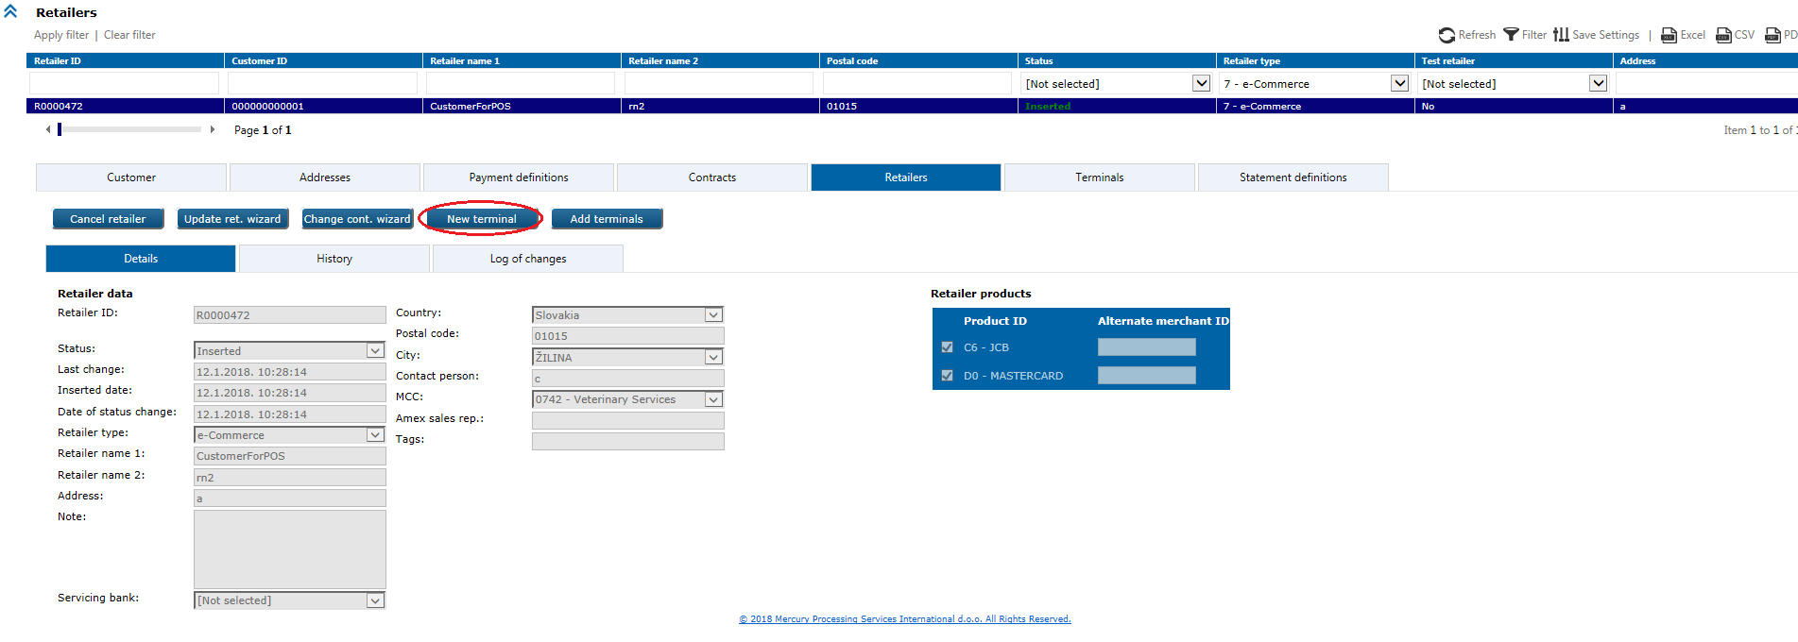

New terminal wizard can be used for *Retailer types*: e-Commerce. Cannot be used for Top-up (ATM) retailer type or any other POS related (POS VUB, POS foreign, MOTO, Cash advance, Imprinter or Unattended).

Each step must be populated with valid data in order to finish wizard successfully. Dimmed fields are populated with already input data in previous application options, white fields are possible to input.

Click on the New terminal button to open following wizard, each step must be populated with valid data in order to finish wizard successfully. Dimmed fields are populated with already input data in previous application options, white fields are possible to input.

1) Basic terminal data:

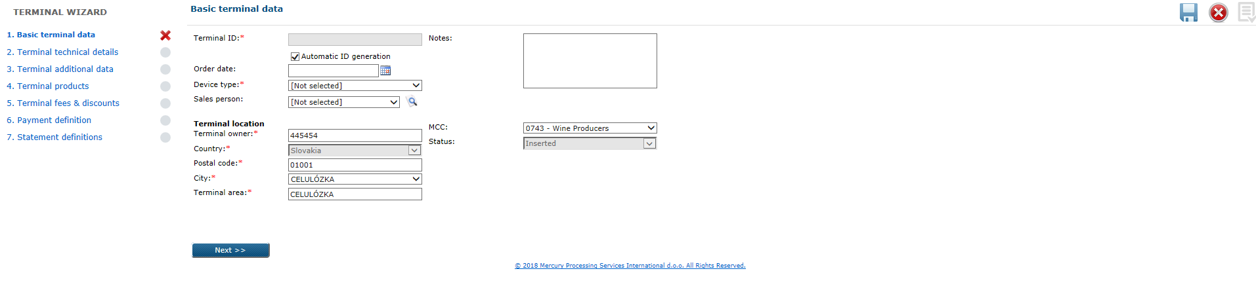

2) Terminal technical details:

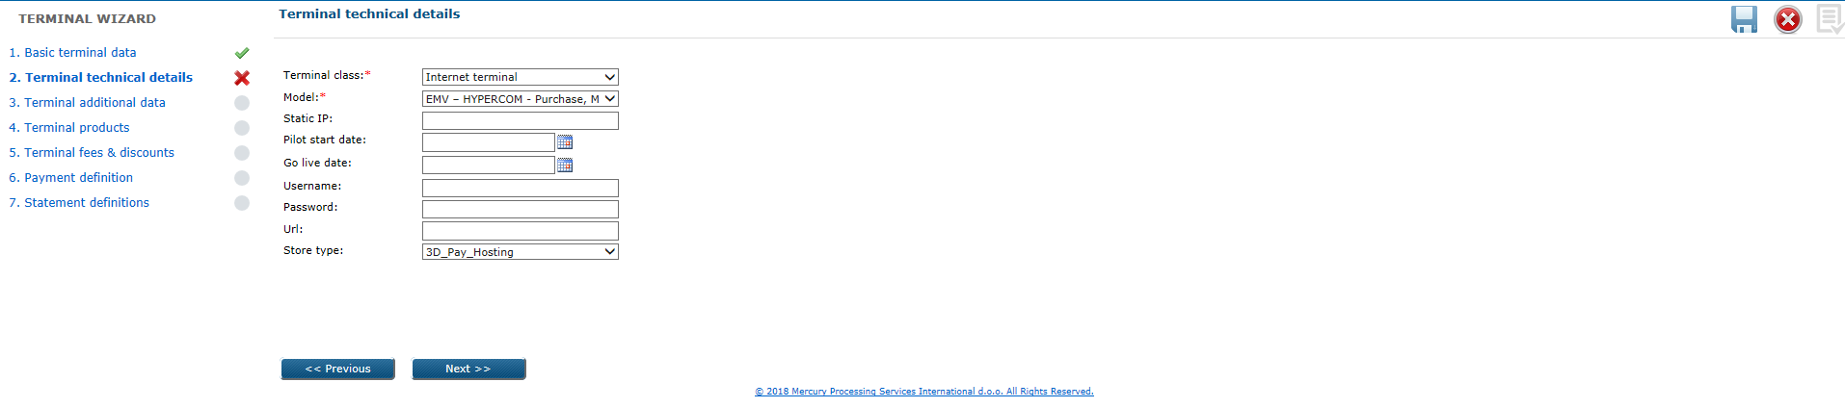

3) Terminal additional data:

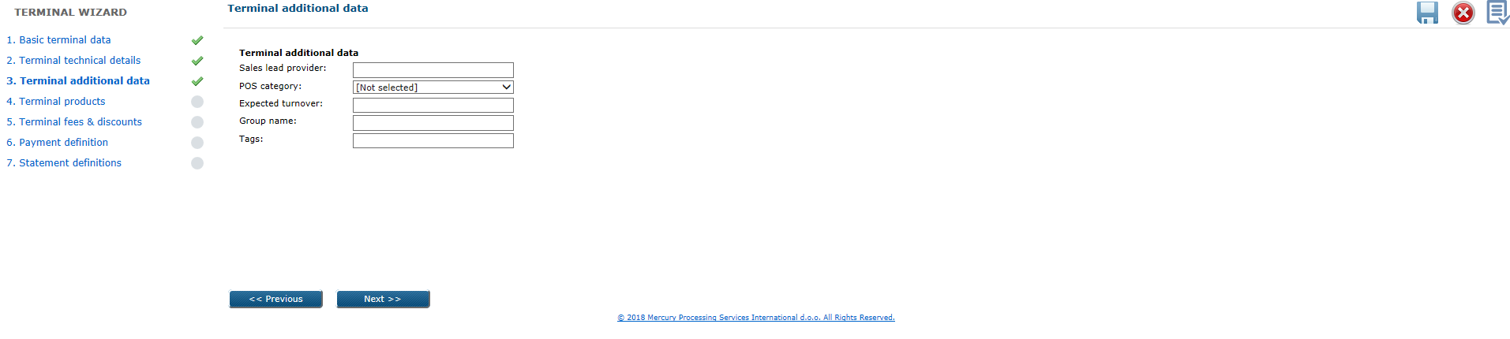

4) Terminal products

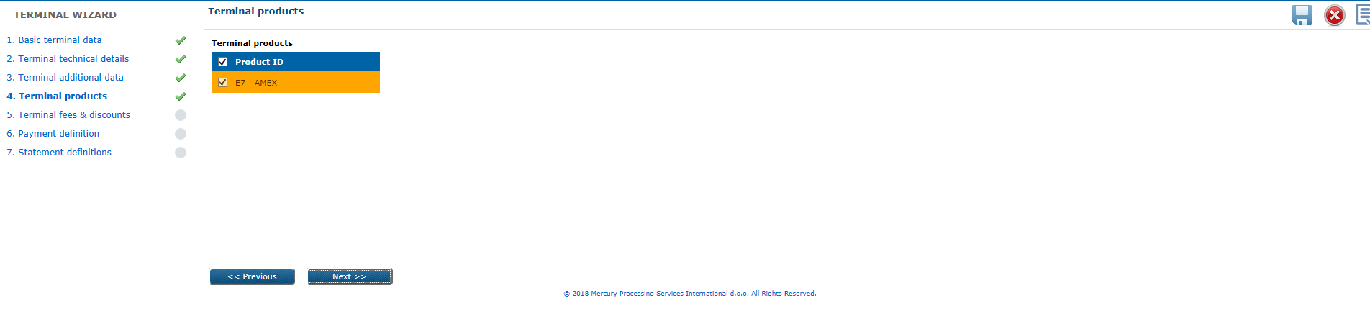

5) Terminal fees & discounts

Detailed explained in POS UC 044.

6) Payment definition:



Detailed explained in UC POS 014.

7) Statement definitions



Detailed explained in UC POS 009.

You can also add new terminal by click on Add terminals button.

**Business & system rules**

* active terminal should have at least one active product,
* new added terminal will have *Sent to installation* status and will be activate manually from the user side (*Change status* option),
* set of products defined on terminal level is subset of products defined on retailer level,
* e-Commerce terminals are type ‘3’ in eXact system,
* new terminal won’t be propagated automatically to the authorisation system
* if retailer Participant is Top-up ATM - New terminal button will not be visible

NestPay data:

*Static IP -* optional field

*Pilot Start Date -* optional field

*Go live date -* optional field

*Username -* optional field

*Password -* optional field

*Url -* optional field

*Store Type -* 3D_pay_hosting

# 5.2. UC POS 036: Update terminal

This is option for update terminal data in web application.

Preconditions

* terminal must exist in the system and be active.

**Triggers**

*Acquiring* module > *Review 2* form > *Terminals* level

Search first for the terminal which you want to update, then click on it to open details:

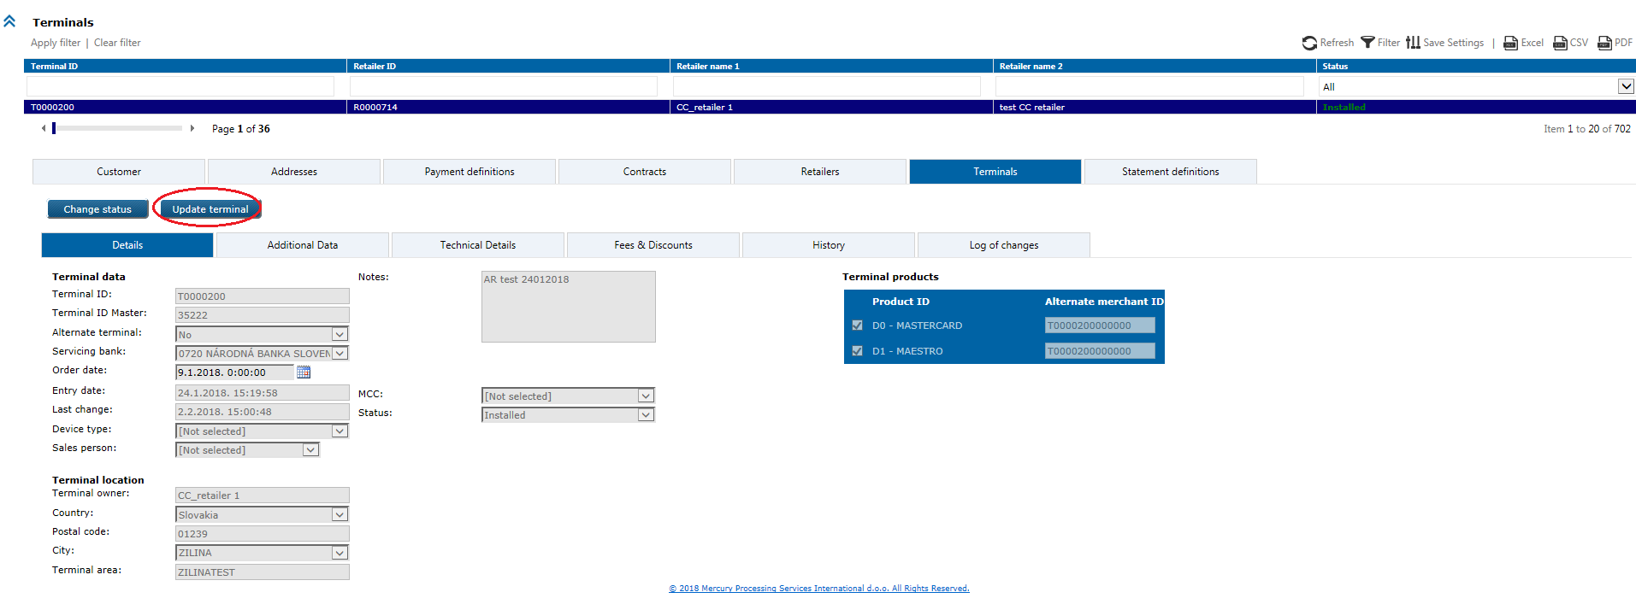

By click on the Update terminal button, wizard will open with the following steps where you can change undimmed fields:

1. Basic terminal data

2. Terminal technical details

3. Terminal additional data

4. Terminal products

5. Terminal fees & discounts

6. Payment definitions

7. Statement definitions.

Update terminal wizard can be used for *Retailer types*: POS VUB, POS foreign, Imprinter, MOTO, CASH advance, e-Commerce, Unattended. Cannot be used for Top-up (ATM) retailer type.

On step 4. Terminal products you can change *Alternate MID* for AMEX.

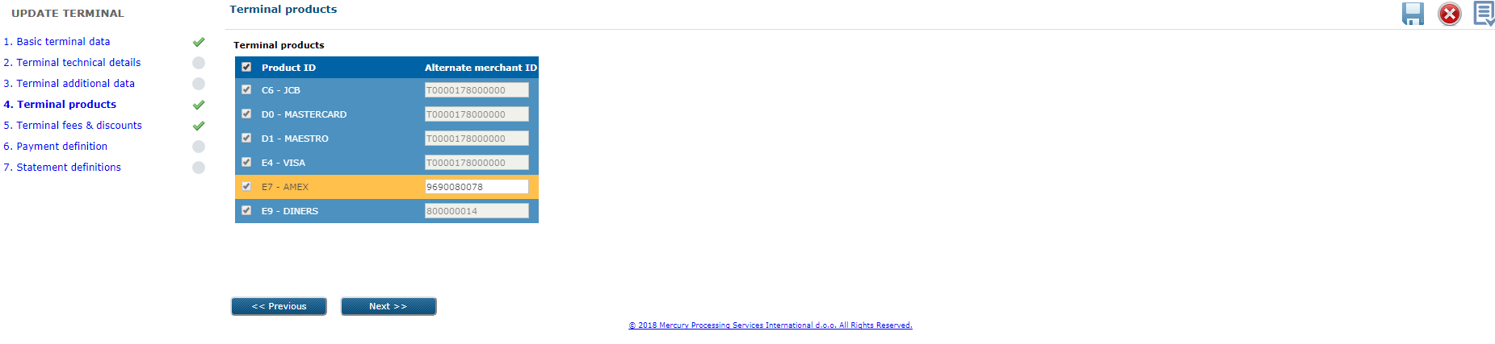

**Business & system rules**

* e.g. of business cases:

- terminal replacement or relocation (MID cannot be modified except for Amex)

- change of terminal type group

* terminal changes have been logged,
* terminal changes will be automatically propagated to the authorisation system.

# 5.2. UC POS 037: Change terminal status

This is option in web application for manually (user) change of terminal status.

**Preconditions**

* terminal must exist in the eXact system, and should not be in *De-installed* status.

**Triggers**

*Acquiring* module > *Review 2* form > *Terminals* level

Search first for the terminal to which you want to change status, then click on the Change status button. Pop-up window will appears and user should choose status which he want to apply on terminal.

**Business & system rules**

* possible terminal statuses are:

0 – Inserted

2 – Sent to installation (& sent to Front-end system) will be treated as active status for

processing (regardless to POS LC system or not)

3 – Installed (activated)

C – Cancelled

D – De-installed

* terminal status transitions:

0 -> 2 - automatically after required data entry through web application, related to

necessary data for synchronization of data with front-end systems

2 -> 3 - implemented as:

                a) manual transition by user through this option

                b) automatic according to pre-defined criteria in system.

* terminal transaction processing:

0 – Inserted – transactions are not accepted

2 – Sent to installation - transactions are accepted (just first, after is set to 3-Installed)

3 – Installed (activated) - transactions are accepted

C – Cancelled - transactions are not accepted *

D – De-installed - transactions are not accepted *

*transaction processing process compares transaction time and status change time. Meaning all transactions made before cancellation will be processed regardless terminal status.

* transactions manually entered via Exact should be processed even in these statuses

Appendix A – Terminal status change diagram

# 5.2. UC POS 038: Add/Update dual new terminal

This is option for new dual terminal definition (one physical terminal and two logic devices in the system). In eXact one terminal will be marked as “master” and on the second terminal (“slave” TID) will be assigned “master” TID.

Each terminal can be update separately.

Preconditions

* both terminals (“master” and “slave”) should exist in the system with different TIDs,
* retailer must exist and be in *Inserted* status.

**Triggers**

Same as explained in UC POS 034 and UC POS 036.

**Business & system rules**

* explained in UC POS 034 and UC POS 036.

# 5.2. UC POS 039: Cancel/Reactivate dual TID terminal

This is option for dual terminals update possibilities in web application.

Each terminal can be cancel/reactivate separately, but the master/slave relation should not be changed.

Preconditions

* both terminals (“master” and “slave”) should exist in the system with different TIDs,
* retailer must exist and be in *Inserted* status.

**Triggers**

Same as explained in UC POS 038.

**Business & system rules**

* explained in UC POS 038.

# 5.2. UC POS 040: Retrieve terminal(s)

Retrieval of existing terminal(s) can be done by web service or web application. In web application by using possible search parameters: *Terminal ID*, *Retailer ID*, *Retailer name 1*, *Retailer name 2*, *Status*.

User can select by click with the right mouse button on grid column names line, from the columns submenu, which columns he want to see.

Retrieved will be: terminal data and products, terminal messages, terminal location, technical details, payment definition data, history data.

Preconditions

* terminal must exist in the system.

**Triggers  
  
1)** WS: *GetTerminalByFilter* method will retrieve terminal(es) data

**2)** Web: Acquiring modul > Review 2 form > Terminals

Search can be performedby applying different search filter(s) on the screen. When the particular terminal found, details can be displayed by click on the retrieved record.

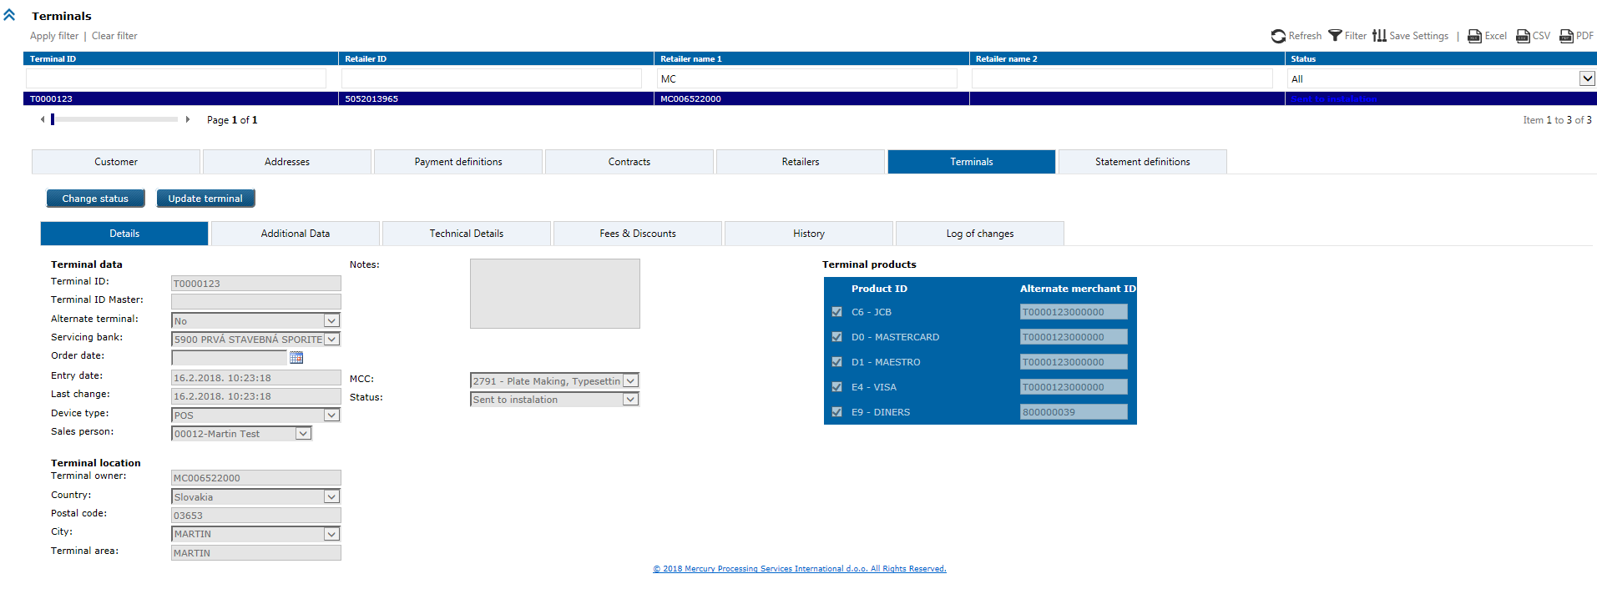

# 5.2. UC POS 041: Add/Update standard commission model

This is option to add new standard commission model (CM) in the system, or update it if isn’t assign to any active contract. Standard CM is one of method for commission assignment (the second one is dynamic commission model).

Standard CM uses fixed parameters (brand, issuing area, card type, card data input mode,…) and daily commission calculation.

**Triggers**

*Administration* module *> Commission models* option

1. Select first calculation type:

Total commission (TC) or Schema fee (SF) or Merchant margin (MM)

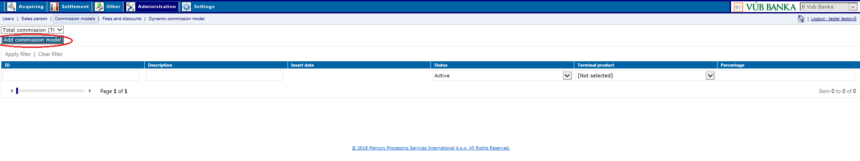

Then click on Add commission model button and new window will open:

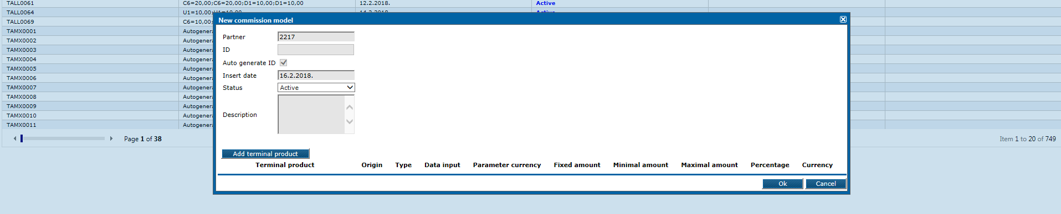

*ID* - commission model identifier is unique for VUB, will be autogenerated by the system:

CM type prefix + brand + sequence (8 characters totally in length)

brand – possibilities:

AMX (Amex)

MCV (Mastercard, Maestro, Visa, Diners, JCB)

ALL (Amex, Mastercard, Maestro, Visa, Diners, JCB)

sequence – 4 digits starting from ‘0001’, separate sequence for each CM type.

*CM type* (purpose) can be:

Total commission (prefix ‘T’) – commission defined in contract as total commission

Merchant margin (prefix ‘M’) – commission defined in contract as separate

component, it is bank’s margin.

Payment schema fee (prefix ‘S’) – payment schema’s cost approximation

*Description* – optional textual field for some notes, max. 200 characters length

*Status* – possibilities from drop down:

* Active
* Inactive.

By click on Add terminal product button, you can define the following parameters per product:



*Terminal product* – offers from drop down menu list of possible products (Visa, Mastercard, Diners, JCB, Maestro, Amex)

*Origin* (issuing area) – possibilities are:

* Onus
* International
* Regional
* Domestic
* All

*Type* (card) – possibilities are:

* Business
* Debit
* Credit
* MealCard
* All

*Data input* (card data input mode) – possibilities are:

* Chip
* Contactless
* Mag-stripe
* Key-Entry
* All

In this window you can delete defined terminal product parameters, with red X sign on the right line side:

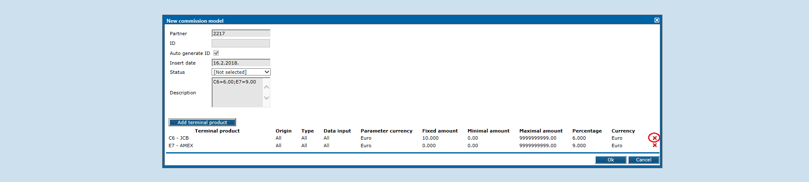

Modification of standard commission models will be disabled for user only if it is assigned to any active contract. Then modification can be done only by MPSI upon submitted VUB request (team track) via Serena.

Modification of existing commission model which isn’t assigned to any active contract, user can do under the same web application option. Select first the model you want to modify (Apply filter) and then click on it to open details:

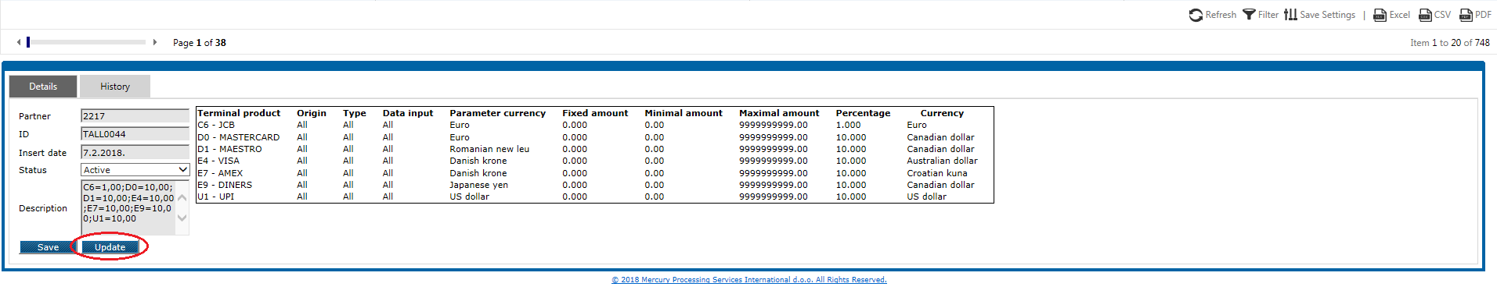

Click on the Update button to open window where you can modify data:

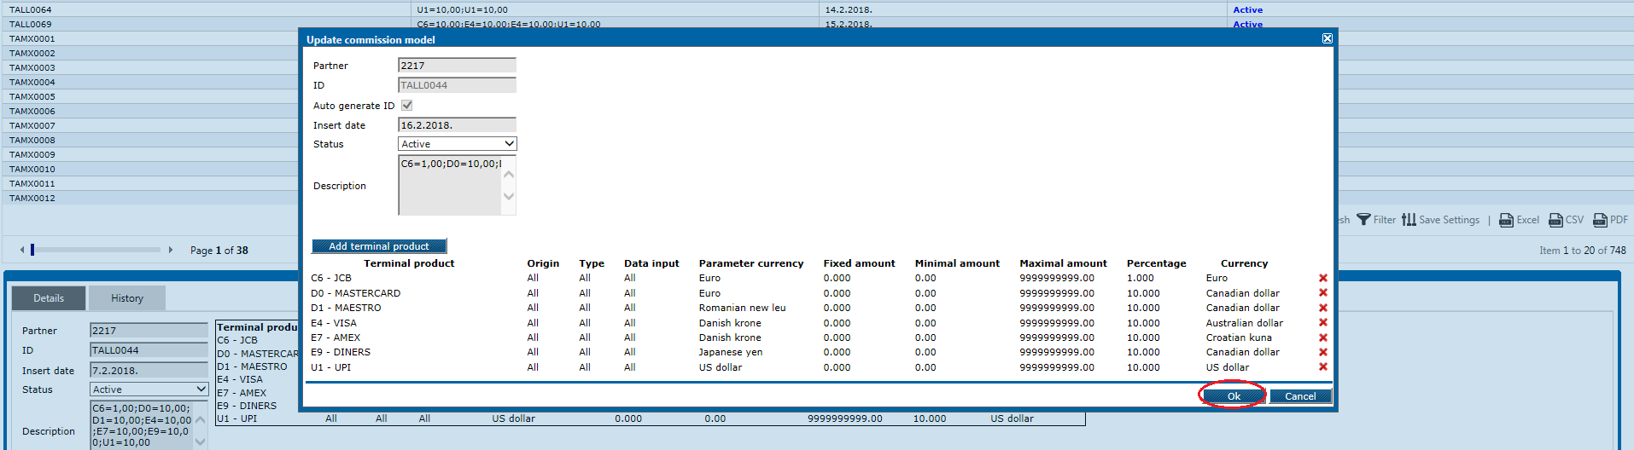

confim modification(s) by OK button, then Save it in the system.

**Business & system rules**

* calculation methods for standard commsision model are:

- Total commission

- Merchant margin

- Schema fee

* active commission model should have at least one defined terminal product,
* with update functionality under this option, you can deactivate commission model and reactivate it again,

# 5.2. UC POS 042: Add/Update dynamic commission model

Add new dynamic commission model for VUB partner in the system. With the same option you can modify it afterwards if model isn’t assigned to any active contract.

Dynamic commission model is one of method for commission assignment (the second one is Standard commission model).

Dynamic commission model is dynamic commission model with expressions, can have different parameters and end of month commission calculation (monthly).

**Triggers**

*Administration* module *> Dynamic commission model* option

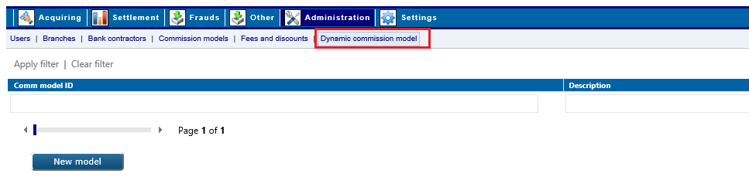

Click on the New model button to open the following form, input model identifier as mandatory field and eventually model description, then save it:

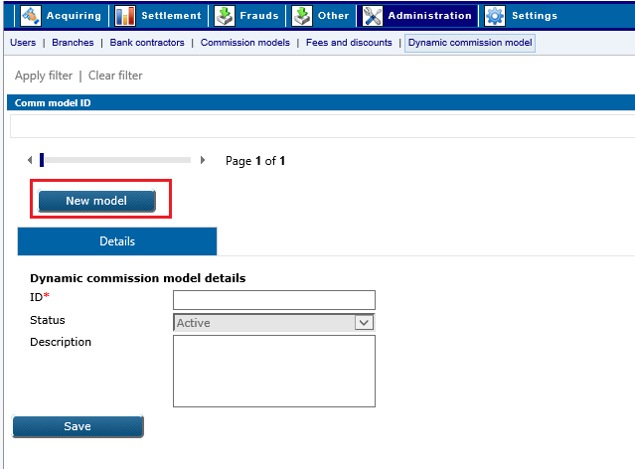

*ID* - commission model identifier is unique for VUB, will be autogenerated by the system:

prefix + ‘POSNET’ + 4-digits sequence starting from ‘0001’ (11 characters totally in length)

prefix - ‘T’ for all dynamic commission models

‘M’ if POSnet would be used for TC models (= MM + IF + PS)

*Status* – mandatory and user can select from:

* Active
* Inactive.

Search for new added model (*Apply filer*) and open it:

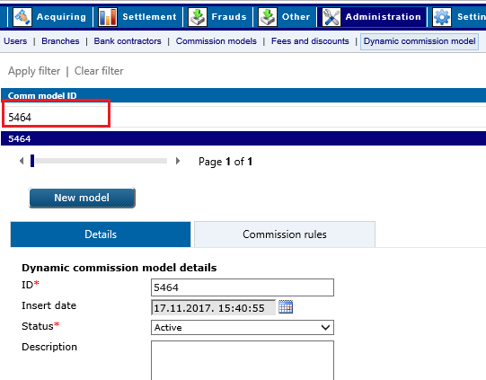

then continue to input commission rules for that model, save it when you’ll finish:

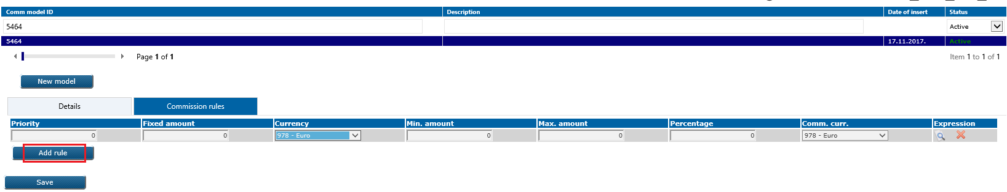

Modification of dynamic commission models will be disabled for user only if it is assigned to any active contract (then modification can be done only by MPSI upon submitted VUB team track request via Serena),

Modification of existing commission model which isn’t assigned to any active contract, user can do under the same web application option. Select first the model you want to modify (Apply filter) and then click on it to open details.

Particular commission rule in opened model can be deleted with orange X sign:

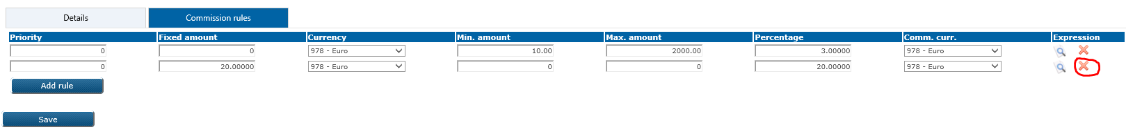

You can deactivate dynamic commission model in the system under the same web option, if you open it and change *Status* manually to ‘Not active’.

By click on Add terminal product button, you can define parameters per product.

The same as for standard commission model. Explained in UC POS 041.

**Business & system rules**

* dynamic commission model can be:

- Total commission

- Merchant margin.

# 5.2. UC POS 043: Add fees/discounts model

Add new fees&discounts model in the system through web application, which can be assign to terminal or some terminal product.

**Preconditions**

* fees&discounts model which you want to add, should not exist in the system.

**Trigger**

*Administration* module > *Fees and discounts* option

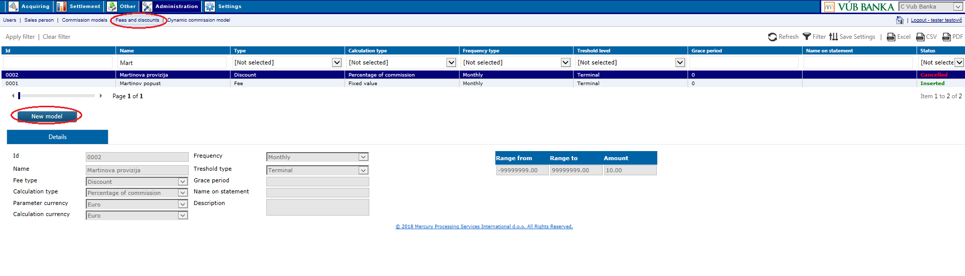

Click on the**New model**button to open new entry window:

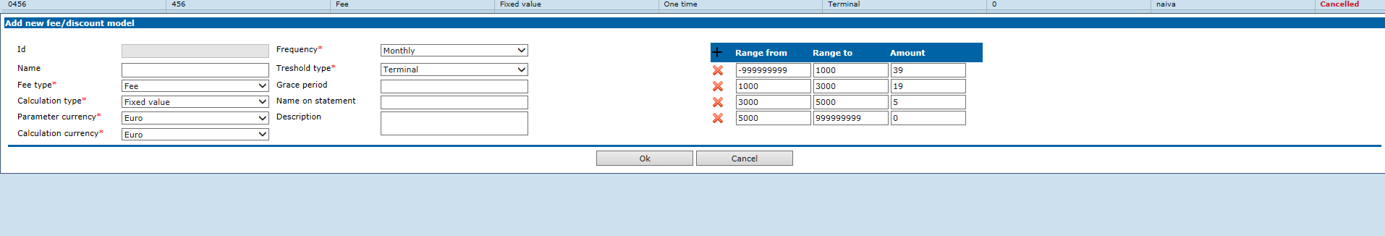

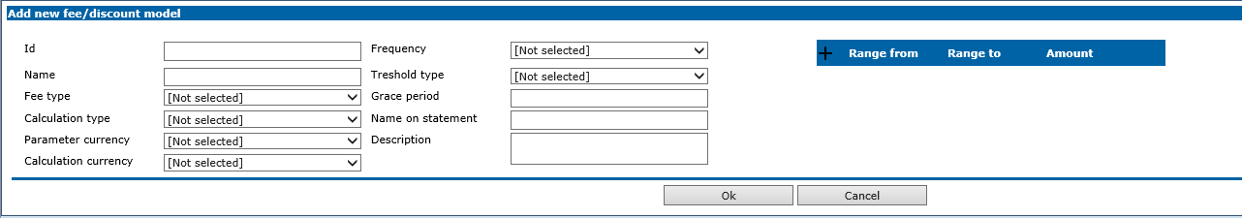

*Fee Id* - mandatory and autogenerated by system, 4 digits sequence start from ‘0001’

*Type* - mandatory to select from drop down:

* Fee
* Discount

*Calculation type* – can be:

* + - Fixed value
    - Percentage (% is shown next to Amount)
    - Minimum value of commission

*Frequency* - can be:

* One time
* Monthly

*Threshold type* – can be:

* Terminal
* Retailer

*Parameter currency* - 978 - EUR

*Calculation currency* - 978 – EUR

*From – minimum is -999999999*

*To – maximum is 999999999*

*Amount -*

Enter/choose possible data and submit it by click on *OK* button, for successfully created model user will receive message.

**Business & system rules**

* It is possible to enter n ranges but they cannot overlap.
* Fee calculation:

*<-999999999;1000] -> 39*

*<1000;3000] -> 19*

*<3000;5000] -> 5*

*<5000;999999999] -> 0*

*I.e. if value 1000, fee is 39.*

# 5.2. UC POS 044: Assign fees/discounts model to terminal

In web application options for new terminal entry and update terminal data, is possible to apply existing fees/discounts model in system to the certain terminal:

select first terminal on the wizard step for fees/discount apply wizard step

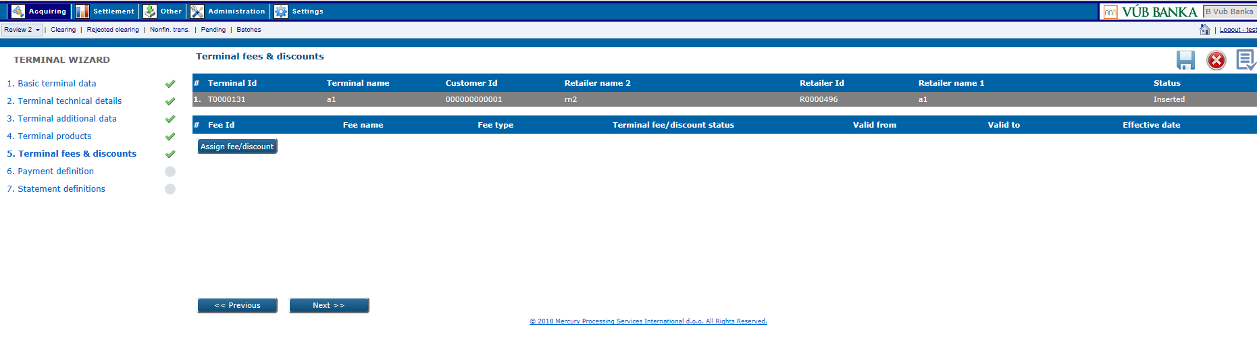

pop-up window will appears where you have possibility to search and choose existing model in the system

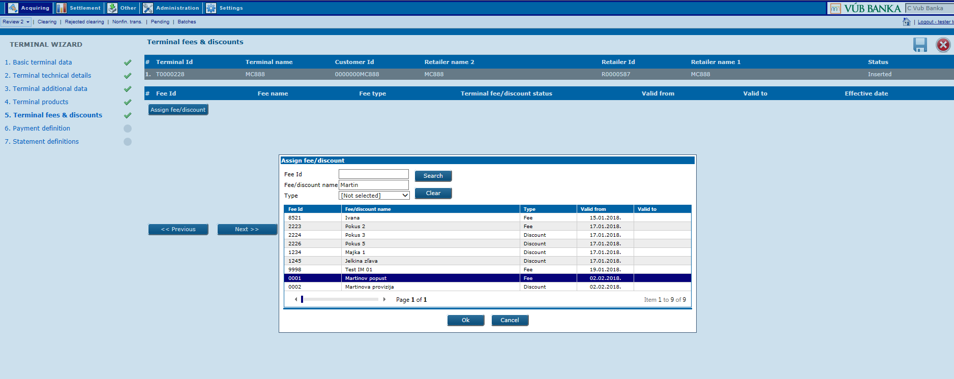

And set Valid from, Valid to and Terminal fee/discount products

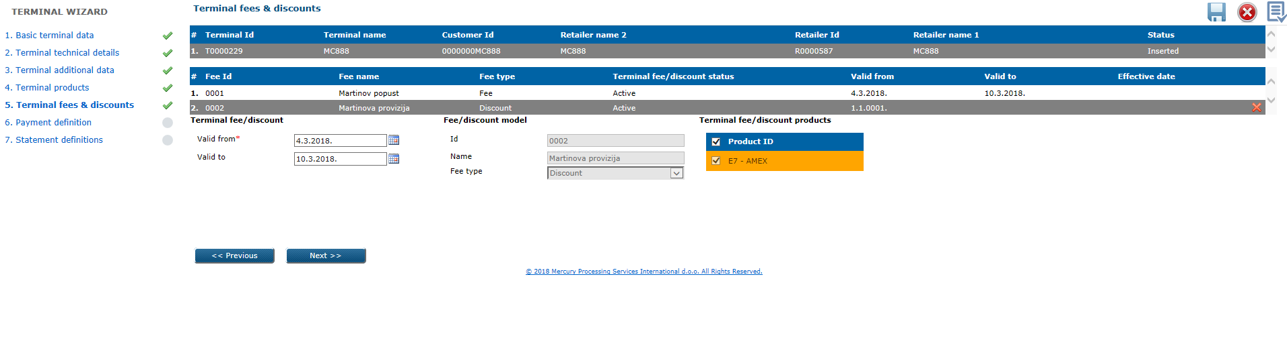

Details of assigned Fees/Discounts are visible in the web application grid under Terminal level:

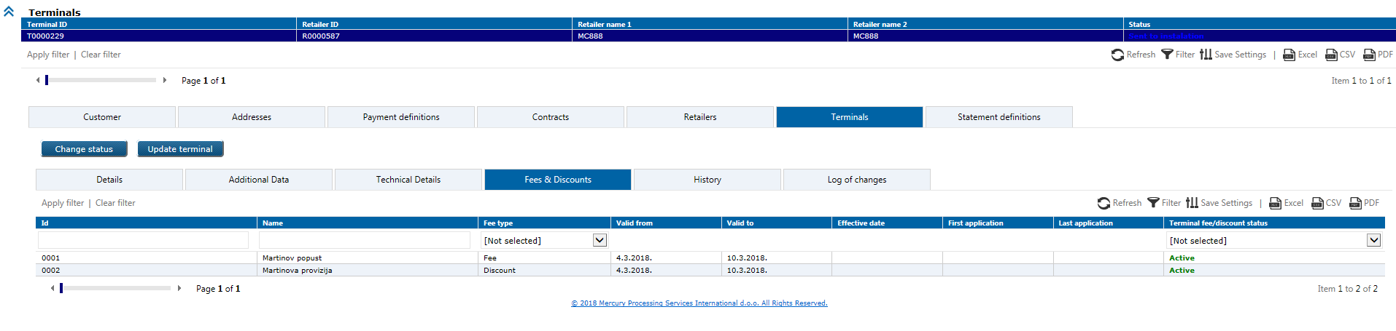

**Business & system rules**

* It is possible to enter more than 1 same Fee/Discount but they cannot overlap
* At least one Terminal product must be selected

# 5.2. UC POS 045: Cancel fees/discounts model

Cancel fees/discounts model in web application.

**Preconditions**

* fees/discounts model must exist in eXact and be active (*Inserted*).

**Trigger**

*Administration* module > *Fees and discounts*

Search first for the fees/discounts model in the grid (Apply filter) which you want to cancel, then click on it.

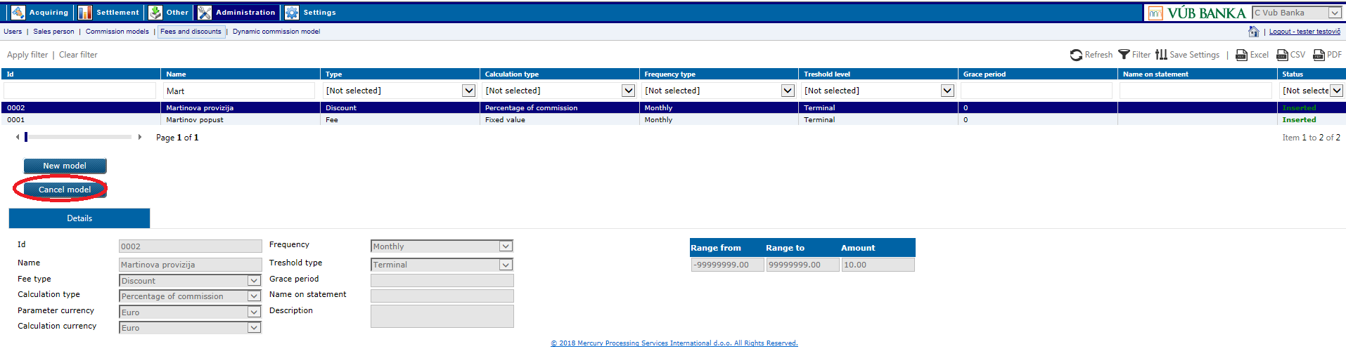

Click on the Cancel model button and model status will changed to ‘Cancelled’.

**Business & system rules**:

You can cancel any F/D model – for assigned entities will remain to be valid; but not possible to add new. Warning message appears: ‘'Warning! fees&discounts are deactivated for further assignment, but remain active for existing ones.'”

# 5.2. UC POS 046: Add statement definition

Statement definition is possible to add in web application.

**Preconditions**

* statement definition which you want to add, should not exist in the system,
* customer should have at least one contract, retailer and terminal so that you can create statement definition.

**Trigger**

*Acquiring* module > *Review 2* form > *Customers* level

Search first for existing customer in the system, then click on active one to open data details:

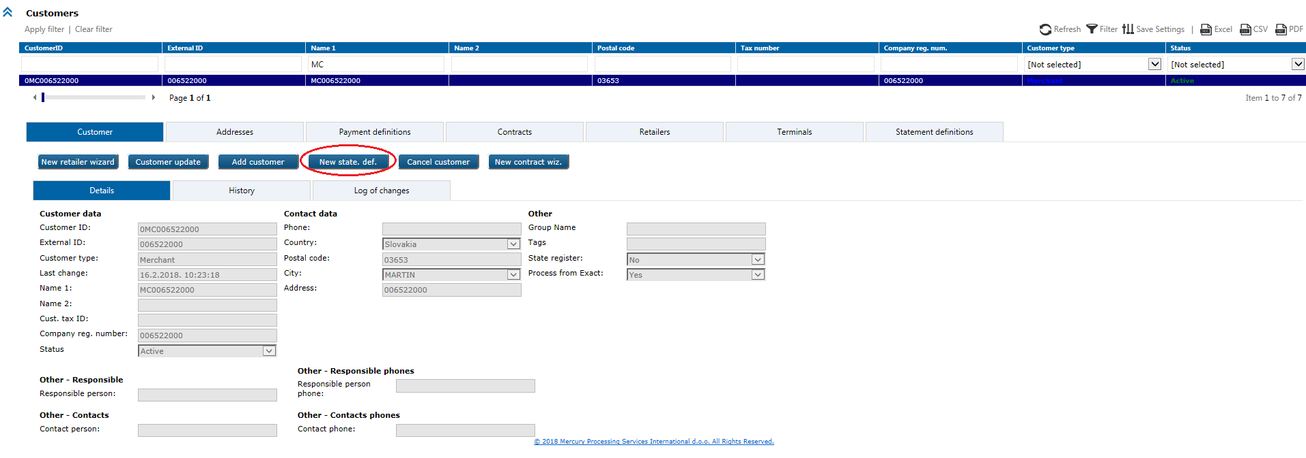

Click on the New state. def. to open the following wizard:

1) Basic statement definition data (header level):

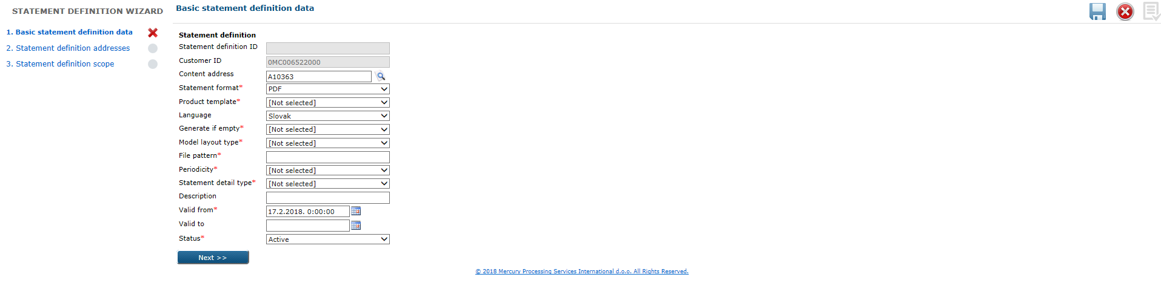

2) Statement definition addresses:

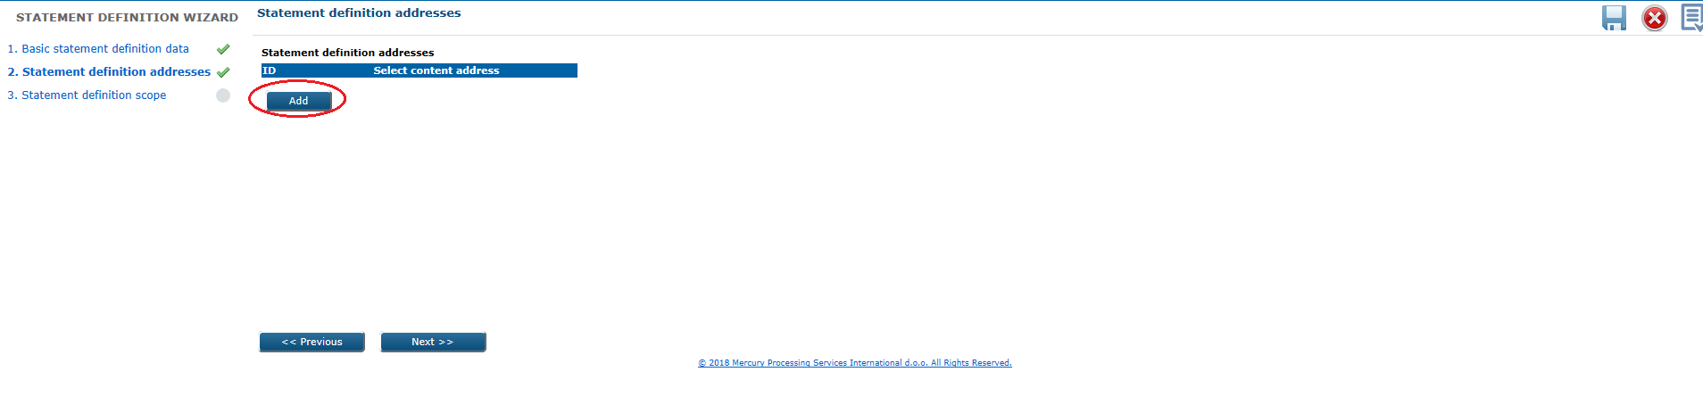



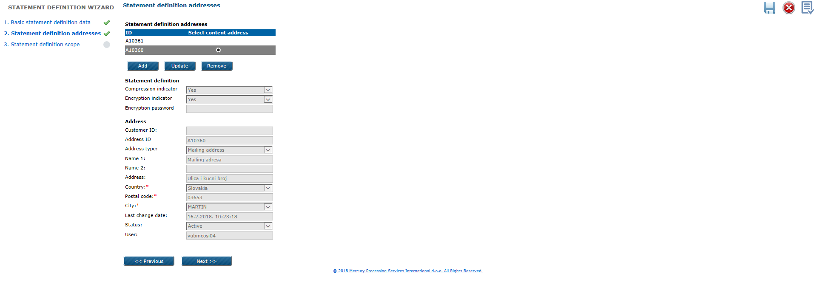

3) Statement definition scope:

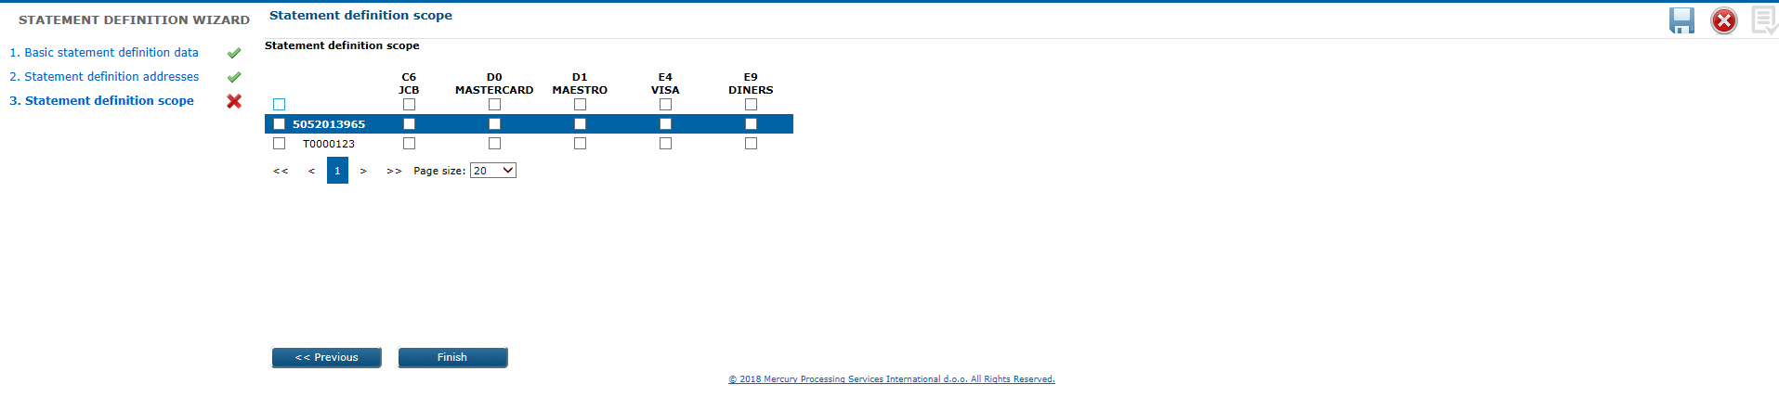

**Business & system rules**:

* possible is to have multiple statement definitions for the same address (in different formats, timelines … ),
* possible is to have multiple addresses in the statement delivery list,
* only the lowest level of merchant data selected in customer-retailer-terminal hierarchy is stored in statement definition (this implies that when e.g. adding new terminal, one of the existing statement definitions must be updated to include the new terminal or a new statement definition must be defined to include newly created terminal)
* merchant data hierarchy selection is combined with the product specification, information about selected product for selected merchant data entity is stored in statement definition (this implies that, e.g. when adding support for additional brand on the terminal, a statement definition  must be updated to include this product or new statement definition must be registered to support newly added product on the terminal)
* Amex-only retailers for which VUB is not providing the terminal-managing service do not have terminals stored in eXact (this means that the lowest level of selection for these Amex merchants is the retailer level for which there is not terminal-level registered in the system)
* eXact will not control duplicity in statement definitions, by defining several statement definitions which are concurrent in terms of validity period and have overlapping merchant data scope, it is possible that two or more statements will be sent with the partially duplicated content
* eXact will not control, but will indicate possible gaps in merchant data scope that omit some terminals / retailers or products in overall set of statement definitions of the customer (omitting some of the entities of merchant data hierarchy can lead to having only portions of transaction data included in statements sent to merchants)

*Statement definition ID* – mandatory, autogenerated by system and unique per VUB:

prefix ‘S’ + autogenerated sequence, stuffed to 10 characters with zeros, starting with number ‘000000001’

*Customer ID* – prepopulated, cannot change in Statement definition wizard

*Content address* – mandatory to select only permanent addreses and mailing address type,

this address can be changed through the customer update option (afterwards is not necessary to update statement definition which use that address for distribution, address changes will be automatically applied for all related statement definitions and be visible in the upper right screen corner) – e.g. when merchant change official address in the state register

*Statement format* – mandatory to select from the drop down menu:

* PDF
* XML
* HTML.

Product template – mandatory to select from the drop down menu:

* MCVI
* Amex
* All

*Generate if empty* - mandatory to select rom drop down menu:

* Y
* N

*Periodicity* – mandatory to select from the drop down menu:

* Daily
* Weekly
* Monthly

Statement detail type – mandatory to select from the drop down menu:

* Standard
* Extended

*Model layout type* – mandatory to select from drop down:

* Blended
* Unblended

Status - system update it automatically (Active / Inactive)

# 5.2. UC POS 047: Update statement definition

Some statement definition data are possible to modify with this option in web application.

**Preconditions**

* statement definition you want to update, should exist in the system.

**Trigger**

*Acquiring* module > *Review 2* form > *Statement definitions* level

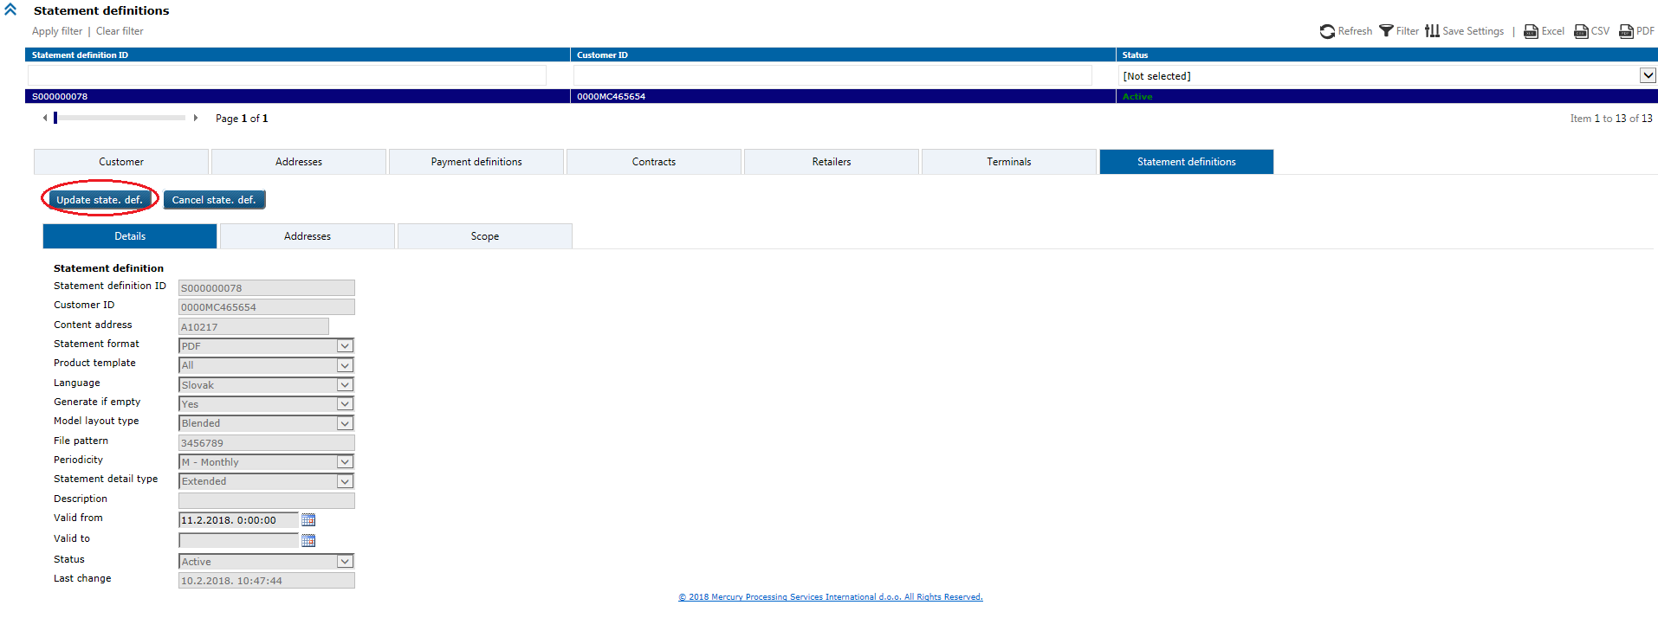

Click on the Update state. Def. button and wizard appears where user can change undimmed fields and confirm changes by Finish button.



Successfully message appears.

**Business & system rules**:

* possible is to have multiple statement definitions for the same address (in different formats, timelines)
* possible is to have multiple addresses in the statement delivery list.

# 5.2. UC POS 048: Update Statement definition validity

Statement definition validity is possible to change in web application.

**Preconditions**

* statement definition should exist in the system.

**Trigger**

Search first for existing entity for which you want to change validity of Statement definition

1. for Contract

on selected Contract click on Update cont. wizard



And go to step 4. Statement definition to change Valid to.

1. for Retailer

on selected Retailer click on Update ret. wizard



And go to step 4. Statement definition to change Valid to.

1. for Terminal

on selected Terminal click on Update terminal



And go to step 7. Statement definition to change Valid to.

# 5.2. UC POS 049: Cancel statement definition

Statement definition you want to cancel through the web application, should exist in the system and be *Active*.

**Trigger**

*Acquiring* module > *Review 2* form > *Statement definitions* level

Search first for the statement definition you want to cancel:

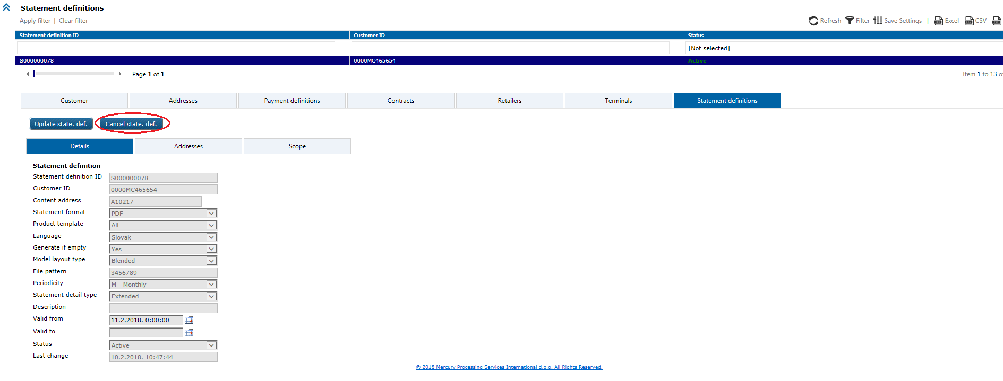

Then click on the Cancel state.def. button, pop-up will appears:

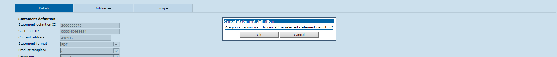

Confirm on the OK button.

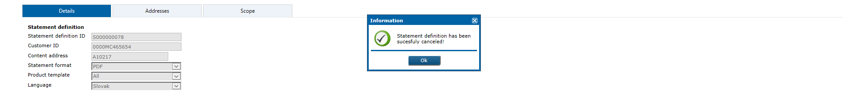

Successfully message appears.

# 5.2. UC POS 050: Reactivate statement definition

Cancelled statement definition is possible to reactivate again in web application, with this option.

**Preconditions**

* statement definition should exist in the system and be *Inactive*.

**Trigger**

*Acquiring* module > *Review 2* form > *Statement definitions* level

Search first for the cancelled statement definition which you want to reactivate again:

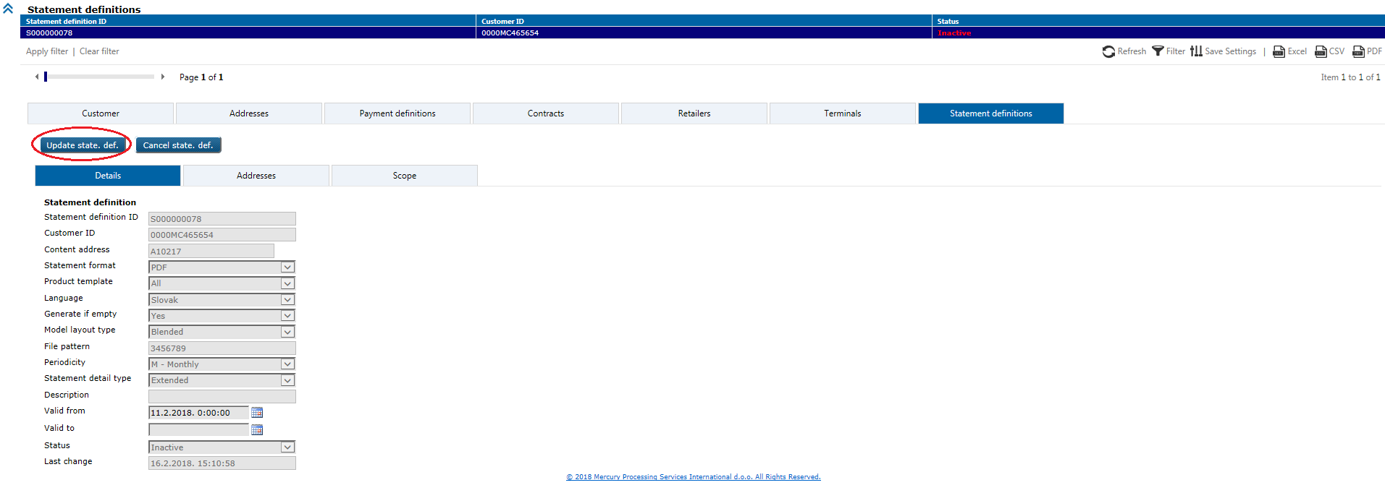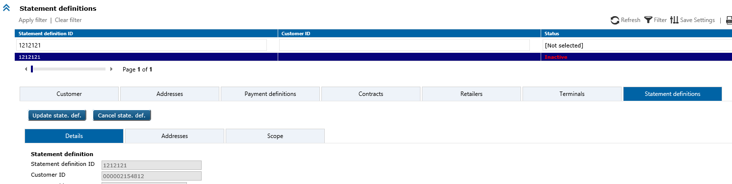

Click on the Update state. Def. button and wizard appears where user can change Status field to Active and confirm changes by Finish button.



Successfully message appears.

# 5.2. UC POS 051: Retrieve unfinished wizard case(s)

Retrieval of unfinished wizard cases in web application by using possible search parameters: *Wizard name*, *Description*, *Insert date*, *Last update date*, *Wizard case creator Id*, *Latest wizard case editor Id*.

User can select by click with the right mouse button on grid column names line, from the columns submenu, which columns he want to see.

List of existing cases will be retrieved sorted by last update date and time.

Preconditions

* unfinished wizard case should exist in the system.

Trigger

*Acquiring* module *> Review2* form *> Unfinished wizard cases* option

It is recommended to narrow the search by selecting particular case type from the *Wizard* *name* dropdown menu.

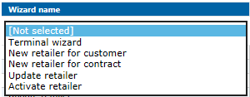

Results list will contain only selected type of wizard case. If nothing is selected from the dropdown menu, all types will be shown.

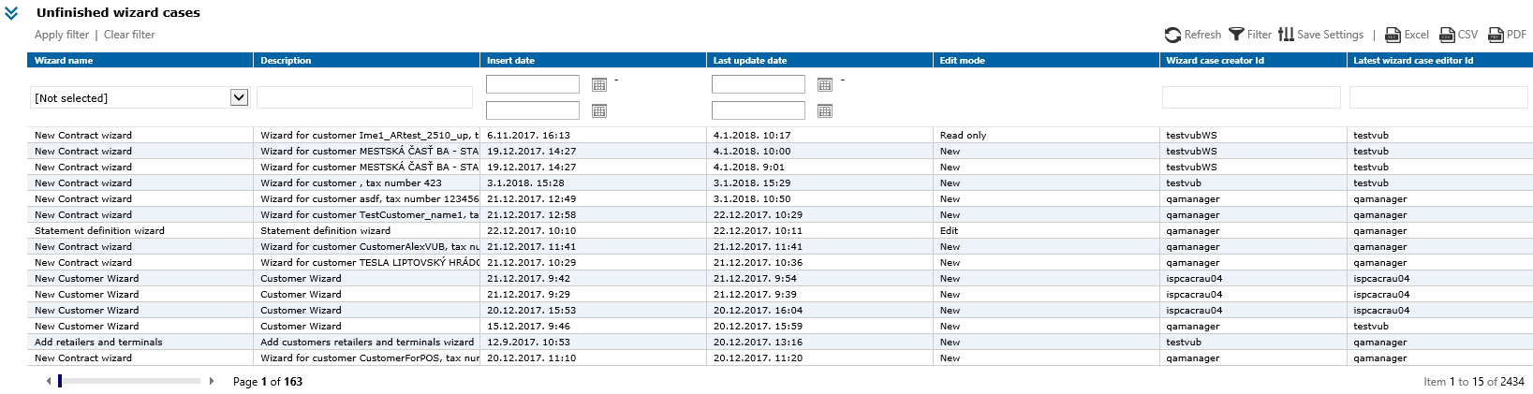

By select particular wizard case from the list of results, Continue wizard option will appear on the screen and user can continue to work on case.

Business & system rules

* explained in the UC POS 051,
* there are two user roles:

1. first role can retrieve, continue and delete only cases created by that user role,
2. second (admin) role can retrieve, continue and delete all existing cases.

# 5.2. UC POS 052: Publish unfinished wizard case

User can continue to work on unfinished wizard case in web application, and publish entered or updated wizard data.

Preconditions

* unfinished wizard case should exist in the system.

Trigger

*Acquiring* module > *Review 2* form > *Unfinished wizard cases* option

Search by possible filters for the case on which you want continue to work:

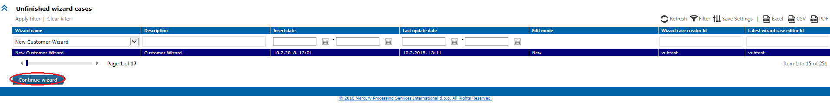

Select it and click on the Continue wizard button which will open wizard case at the last saved step.

Data entry or update can be continued, when it’s done by click on the Finish button data validation will be performed. If is validation successful, data will be published.

Note that case does not have to be finished at this point. It can be cancelled by click on the *Cancel* button in top right wizard corner of the wizard, three options will be offered:

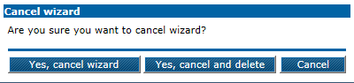

*Yes, cancel wizard* - unfinished case will be cancelled and temporary stored

*Yes, cancel and delete* - unfinished case will be deleted forever.

In wizard user can:

a) cancel data modification without any data saving

b) cancel data modification and temporary save data entered in wizard

(unfinished wizard case – possible continue to work afterwards)

c) publish (permanent save) data entered in wizard.

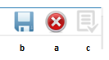

Business & system rules

* wizard case can be published only when all wizard steps contain valid data
* there are two user roles:

1. first role can retrieve, continue and delete only cases created by that user role,
2. second (admin) role can retrieve, continue and delete all existing cases.

# 5.2. UC POS 053: Add/Update sales person

Option in web application.

Trigger

*Administration* module > *Sales person* option

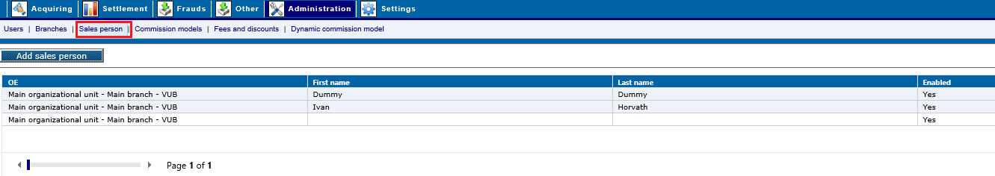

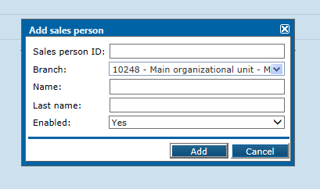

*Enabled* – select from drop down menu:

* Yes
* No

*Sales person ID* – possible to enter manually

If you want to change data about sales person, click on it in results list grid and new window appears:

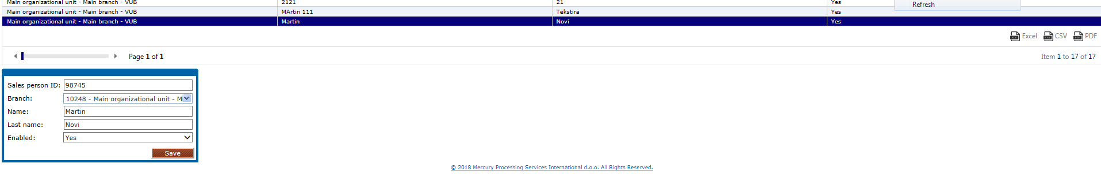

then change data and click on the *Save* button.

# 5.2. UC POS 054: Retrieve clearing transaction

Displays details of clearing transactions in web application. Details contain transaction data, terminal data, authorization data, card data, outgoing data.Outgoing details contain additional information about transactions sent to payment schemas.

Preconditions

Clearing transaction exist.

Trigger

Clearing transaction data retrieval starts with opening the: *Acquiring > Clearing* screen*.*

Search can be performedby applying different search filters on the screen. There is a set of predefined search parameters (e.g. *PAN*, *Package number*, *Authorization code*, *Retailer ID*, *Terminal ID*, *Transaction ID*, etc.). When particular transaction is found details can be displayed by clicking on the retrieved record in the search results grid. Details will be shown below the search grid.

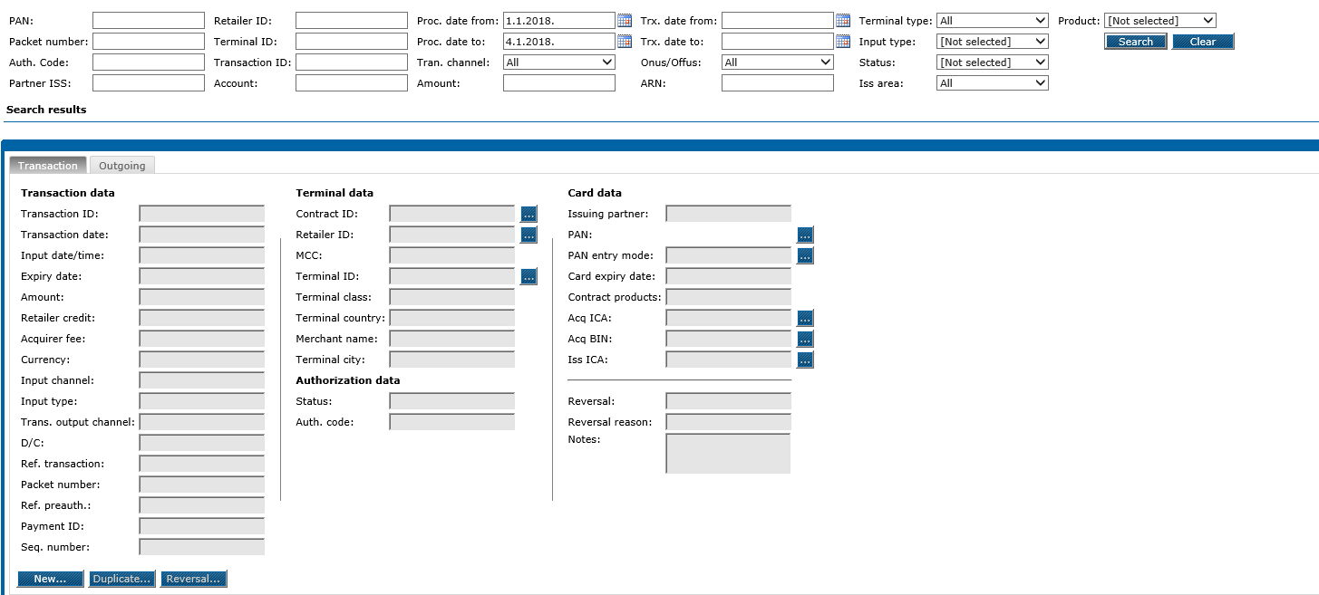

Business cases

* Clearing transaction data must be reviewed in case of an inquiry or analysis.

Business rules

* Clearing transactions are regularly processed transactions.

# 5.2. UC POS 055: Search for transactions/ Add manual transaction

Types of transactions for searching:

2010 – POS common purchase (EX, RO)

2100 – Refund/ Credit slip (EX, RO)

2210 - POS Cash advance (EX, RO)

2400 - Special POS transaction. Transactions with following MCCs:

4829 - Money Transfer-Merchant

6050 - Quasi Cash-Member Financial Institution

6051 - Quasi Cash-Merchant

6529 - Remote Stored Value Load-Member Financial Institution

6530 - Merchant-Remote Stored Value Load

6534 - Money Transfer-Member Financial Institution

7511 - Truck Stop Transactions

7995 - Gambling Transactions

~~T000 Top-up transactions~~

2010 – POS common purchase – manual transaction entry

2100 – Refund/ Credit slip - manual transaction entry

2210 - POS Cash advance – manual transaction entry

Trigger

Manual transaction entry starts with opening the *Acquiring > Clearing* screen*.* Entry is initiated by selecting option *New…* on *Transaction* tab.

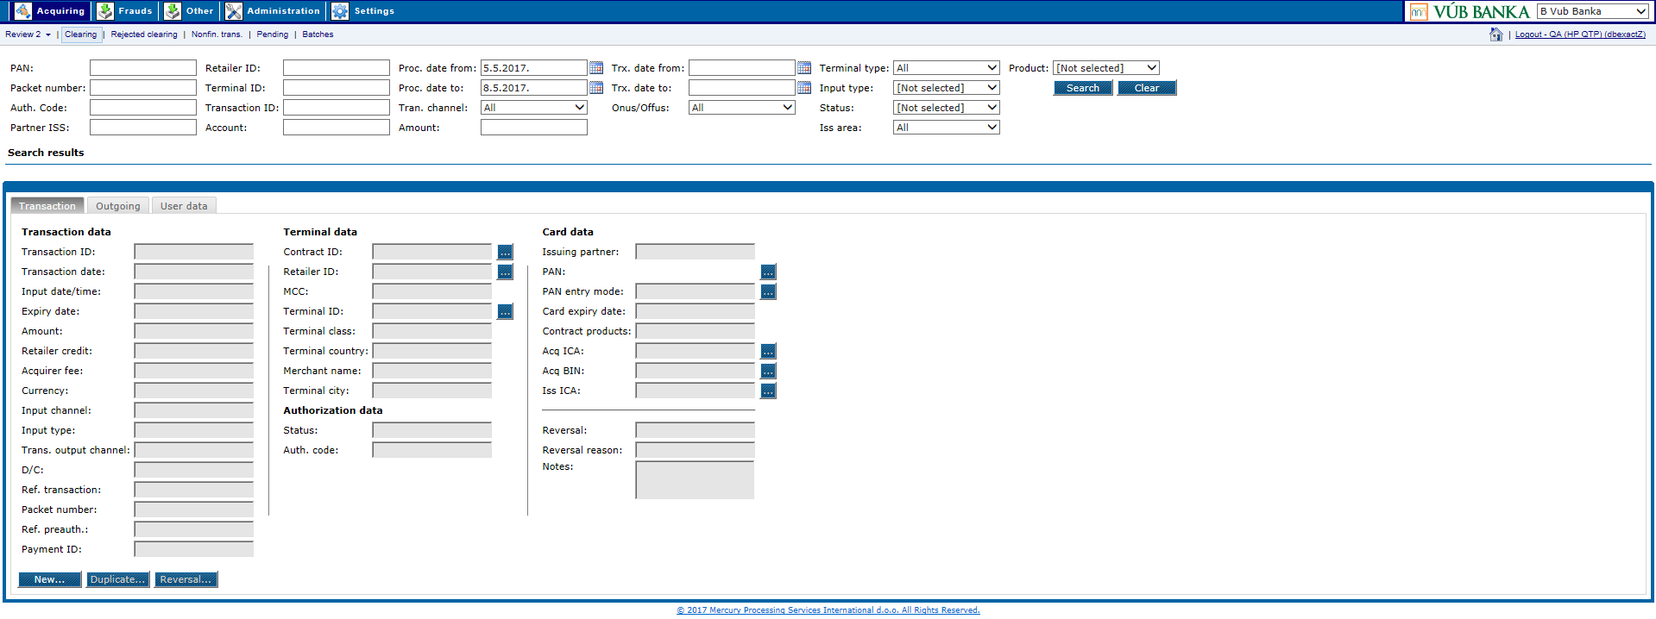

Action will open a screen on which the transaction data should be populated.

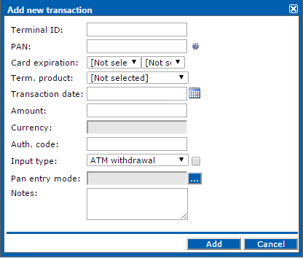

By clicking on the A*dd* button transaction will be added.

Business cases

* Processing of a partial reversal (partial reversal consists of full reversal and new manual transaction with partial amount)
* Manual transaction on Banks request

Business rules

* Transaction will be processed with the next daily processing
* In case of Off-Us transaction will be sent to the payment schema within outgoing files.
* in case manually added transaction is Off-Us, it will be sent to payment schema.

# 5.2. UC POS 056: Duplicate transaction

Duplication of transaction data from a previously selected existing transaction. Some data can be altered if necessary.

Preconditions

Clearing transaction must exist. Clearing transaction must be selected from the search grid.

Trigger

Duplication starts with search for a transaction which should be duplicated.

*Web –* Duplication is initiated by selecting option *Duplicate* on *Transaction* tab.

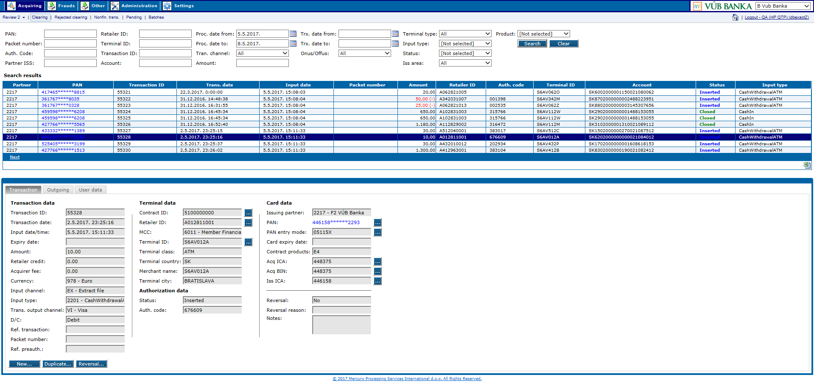

Action will open a new screen on which some of the transaction data can be altered before submit. After the change data should be submitted.

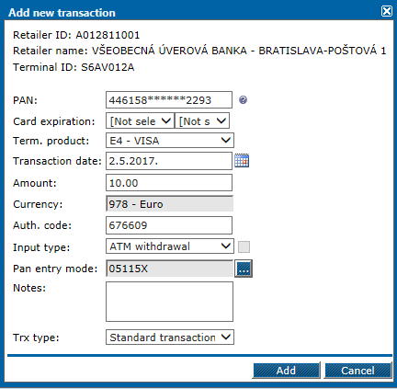

By clicking on the A*dd* button transaction will be duplicated.

Business & system rules

* processing of a partial reversal (partial reversal consists of full reversal and a duplicated transaction with the amount different from the original transaction),
* transaction will be processed with the next daily processing,
* in case of off-us transaction, it will be sent to payment schema within outgoing.

# 5.2. UC POS 057: Reverse transaction

Reversal of a cleared transaction. Transaction can be fully or partially reversed by changing the transaction amount. Reversal reason must be selected from a set of predefined reasons.

Preconditions

Clearing transaction must exist. Clearing transaction must be selected from the search grid.

Trigger

Reversal starts with search for a transaction which should be reversed.

*Web –* Reversal is initiated by selecting option *Reversal* on *Transaction* tab.



Action will open a screen on which the transaction amount can be altered. Reversal reason should be selected before the reversal.

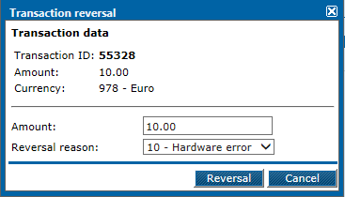

By clicking on the *Reversal* button transaction will be sent to pending transactions where it will be reviewed before processing.

Business & system rules

* reversal of transactions which have been done by mistake,
* reversal of erroneous or duplicated transaction,
* transaction will be processed with the next daily processing,
* in case of off-us transaction, it will be sent to payment schema within outgoing.

Postcondition

Transaction has been reversed successfully and sent to pending transactions for review.

# 5.2. UC POS 058: Reverse transaction (Chargeback reasons)

Reversal of a cleared transaction. Transaction can be fully or partially reversed by changing the transaction amount. Reversal reason must be selected from a set of predefined reasons. For chargeback reason must be *Chargeback transaction*.

Preconditions

Clearing transaction must exist. Clearing transaction must be selected from the search grid.

Trigger

Reversal starts with search for a transaction which should be reversed.

*Web –* Reversal is initiated by selecting option *Reversal* on *Transaction* tab.



Action will open a screen on which the transaction amount can be altered. Reversal reason should be selected before the reversal.

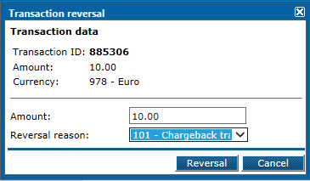

By clicking on the *Reversal* button transaction will be sent to pending transactions where it will be reviewed before processing.

Business & system rules

* chargeback transaction will be processed with the next daily processing
* off-us transaction will not be sent to payment schema within outgoing,
* reversed transaction sent to pending transactions for review.

# 5.2. UC POS 059: Retrieve rejected transaction

Displays details of transactions that have not been processed because of missing or incorrect data in the database. Details consist of error data, transaction data, terminal data, card data and various other data.

Preconditions

Rejected transaction exists.

Trigger

*Web –* Rejected transaction data retrieval starts with opening the *Acquiring > Rejected clearing* screen*.* Search can be performedby applying different search filters on the screen. There is a set of predefined search parameters (e.g. *PAN*, *Retailer ID*, *Terminal ID*, *Transaction ID*, *Rejection type*, *Amount,* *Process date*, etc.). When a particular transaction is found details can be displayed by clicking on the retrieved record in the search results grid. Details will be shown below the search grid.

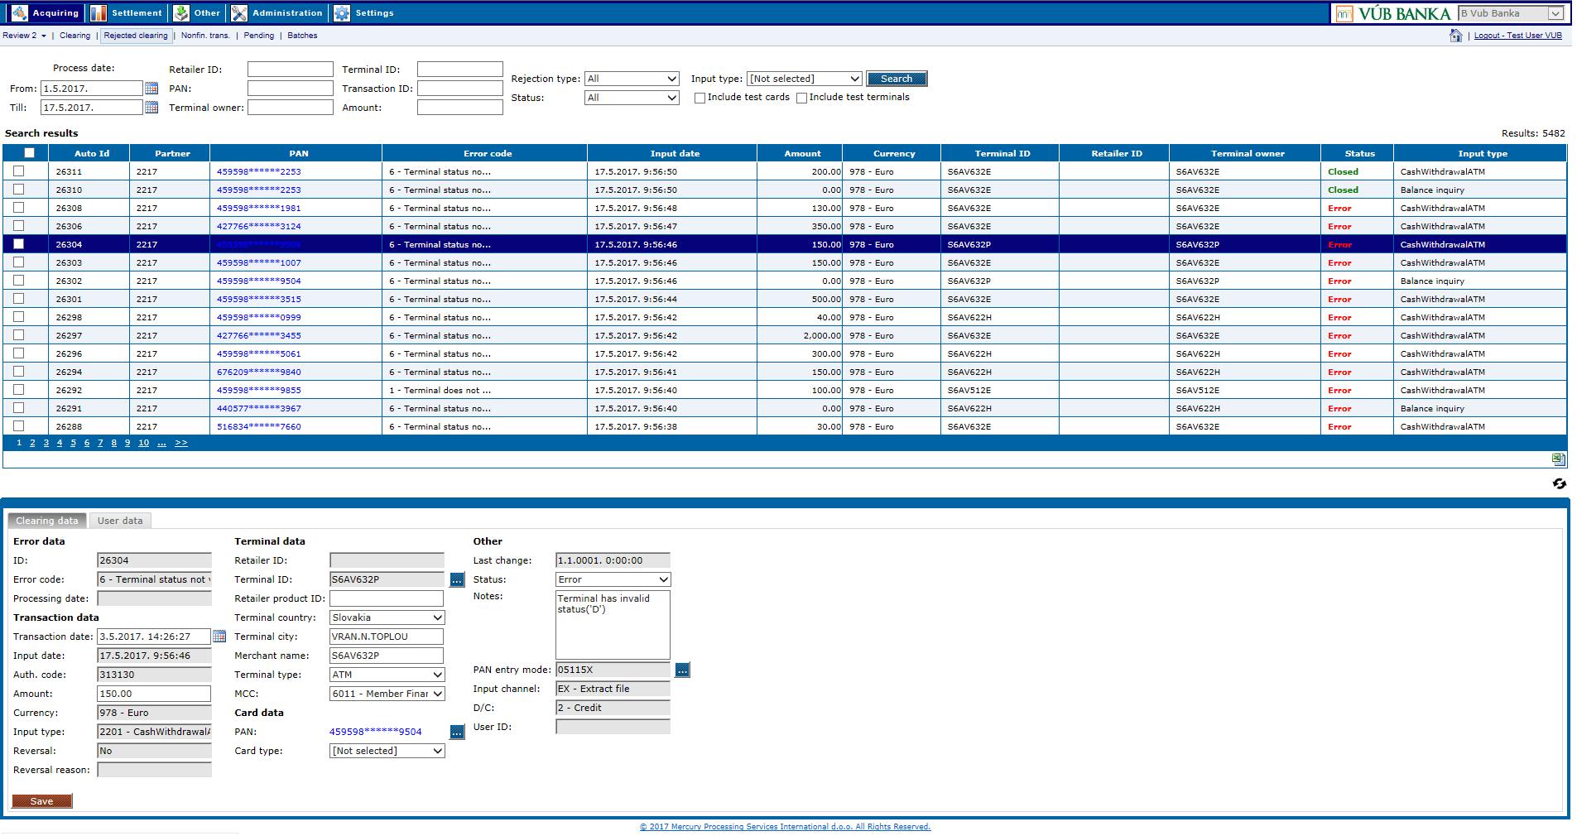

Business cases

* Rejected transaction data must be reviewed in case of an inquiry, analysis or change of data (usually in case of reprocessing)

Business & system rules

Rejected transaction details have been successfully displayed.

# 5.2. UC POS 060: Update rejected transaction

Change of rejected transaction details. Details consist of error data, transaction data, terminal data, card data and various other data. Data are usually changed in case a transaction needs to be reprocessed.

Preconditions

Rejected transaction exists.

Trigger

Rejected transaction update starts with search for a rejected transaction which should be changed.

*Web –* Change is performed by updating data on the *Clearing* tab of the rejected transaction. Only part of the transaction data can be changed (*Transaction date, Amount, Retailer product ID, Terminal country, Terminal city, Merchant name, Terminal type, MCC, Card type, Status* and *Notes*).



By clicking on the *Save* button transaction will be updated.

**Note:** When multiple transactions are selected at the same time, only their status can be changed and optionally some notescan be added. Status can be changed only from *Error* to *Closed* in this case.

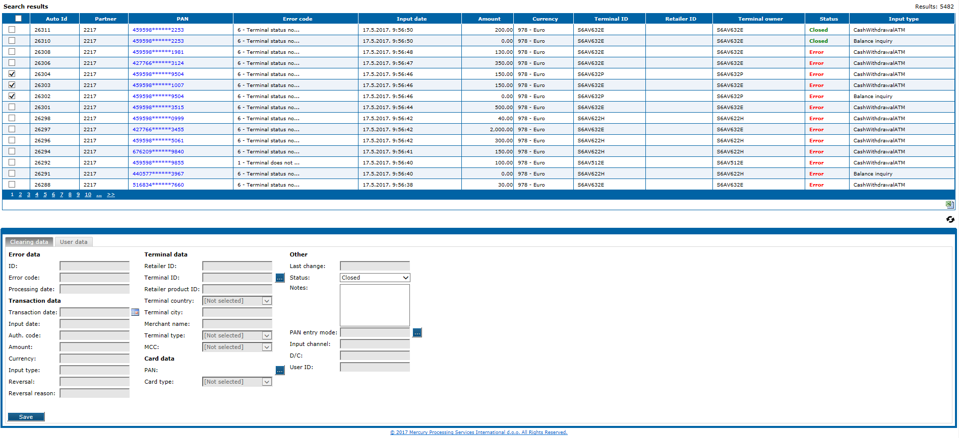

Business cases

* Rejected transaction data have to be changed and the transaction needs to be reprocessed.

Business & system rules

* In order to reprocess a transaction status has to be changed to *Inserted*. Any other status will not be ignored when reprocessing transactions.
* In case multiple transactions are selected only their status can be changed. Status can be changed to *Closed*.

Postcondition

Rejected transaction has been successfully updated.

# 5.2. UC POS 061: Retrieve nonfinancial transaction

Description

Displays details of nonfinancial transactions. Details contain information about the transaction type, merchant and terminal data, authorization data, etc.

Preconditions

Nonfinancial transaction exist.

Trigger

*Web –* Nonfinancial transaction data retrieval starts with opening the *Acquiring > Nonfin. trans.* screen*.* Search can be performedby applying different search filters on the screen. There is a set of predefined search parameters (e.g. *PAN*, *Merchant ID*, *Terminal ID*, *Input type, Status*, etc.). When a particular transaction is found details can be displayed by clicking on the retrieved record in the search results grid. Details will be shown below the search grid.

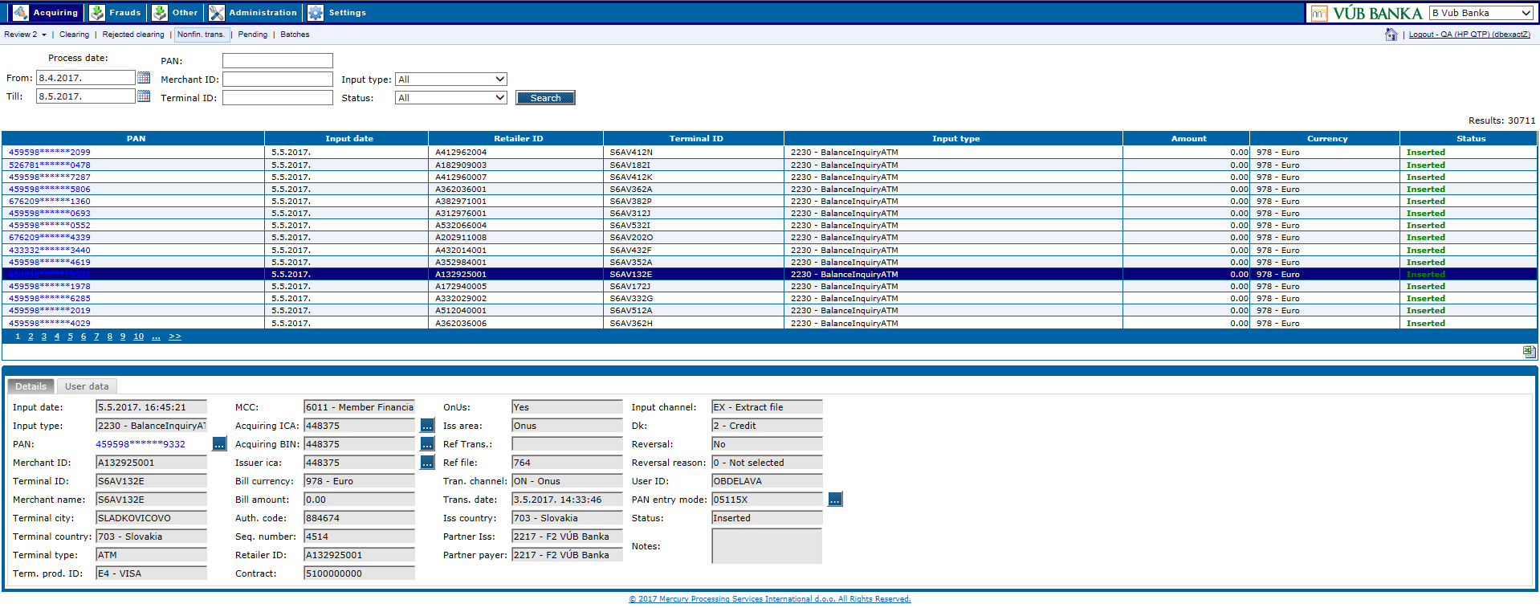

Business & system rules

* Nonfinancial transaction must be reviewed in case of an inquiry or analysis

Postcondition

Nonfinancial transaction details have been successfully displayed.

# 5.2. UC POS 062: Retrieve pending transaction

Displays details of pending transactions which are manually inserted or changed transactions waiting to be processed. Details contain clearing data and user data. Clearing data consist of transaction data, terminal data, card data and various other data. User data contain various partner specific data.

Preconditions

Pending transaction exist.

Trigger

*Web –* Review of pending transaction data is initiated by selecting a transaction from the search grid results. Details will be shown below the search grid. Search can be performed using the predefined set of parameters (e.g. *Processing date From*, *Processing date Till*, *Transaction ID*, *PAN*, *Status*, *Retailer ID*, *Terminal ID*, *Terminal owner*).

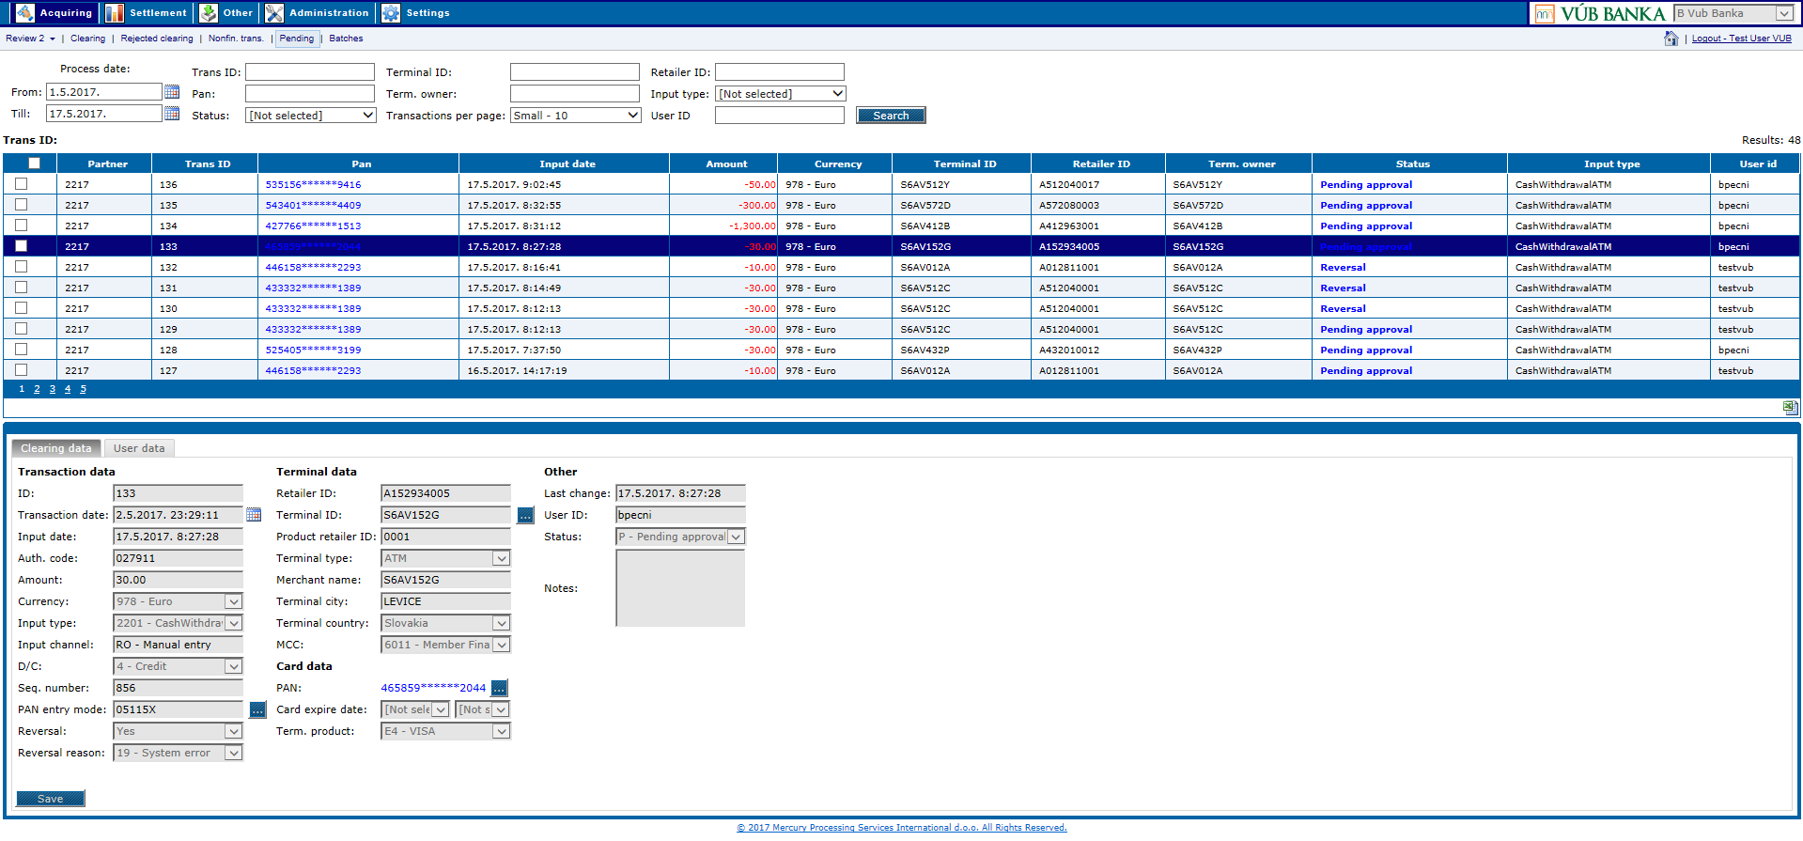

Business & system rules

* manually inserted or changed transaction needs to be reviewed in case of an inquiry, analysis or change of data

Postcondition

Details of a manually inserted or changed transaction have been successfully displayed.

# 5.2. UC POS 063: Update pending transaction

Change of pending transaction details. Pending transactions are manually inserted or changed transactions waiting to be processed. Details contain clearing data and user data, but only part of the clearing data can be changed.

Preconditions

Pending transaction exist.

Trigger

Pending transaction update starts with search for a pending transaction which should be changed.

*Web –* Change is performed by updating data on the *Clearing* tab of the pending transaction.



By clicking on the *Save* button transaction will be updated.

**Note:** When multiple transactions are selected at the same time, only their status can be changed by clicking on the *Update status* button and optionally some notescan be added. Status can be changed from *Pending approval* to *Reversal*  or *Inserted*.

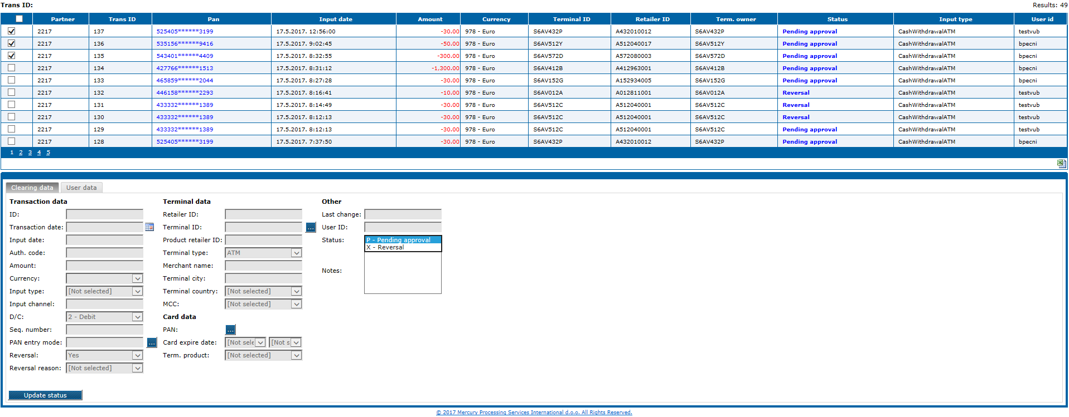

Business cases

* Pending transaction data have to be reviewed and updated before processing e.g. some data have not been populated properly.

Business & system rules

* Only transactions in status *Inserted* will be processed
* Transaction will be processed with the next daily processing
* In case of Off-Us transaction will be sent to the payment schema within outgoing
* In case multiple transactions are selected only their status can be changed.
* For pending transactions four eye principle applies, meaning that two users will have to review a transaction before it can be processed.
* For pending transactions “four eye principle” applies, meaning that one user creates and another user reviews and approves manually created transaction before transaction can be processed.

There are two user roles needed for “four eye principle” implementation:

- “Transaction elaboration - Specialist” role with rights to create manual transactions and edit your own transaction data on manually created transactions

- “Verifier” role with rights to approve (verify) transaction for processing

“Verifier” role can be added to “Transaction elaboration - Specialist” role to the user.

There are rules for creating and approving process:

* User with only “Transaction elaboration - Specialist” role can:
  + Create new manual transactions
  + Can edit only his own pending transactions
  + Can see transactions from other users
* User with “Transaction elaboration - Specialist” and “Verifier” roles can:
  + Create new manual transactions
  + Can edit pending transactions and transactions in status “Inserted”
  + Can “approve” transactions in status “Pending approval” only from other users
  + Cannot “approve” his own transactions – another user with “Verifier” role can approve his transactions

Postcondition

Pending transaction details have been successfully updated.

# 5.2. UC POS 064: Wizard validations report

*Other* module > *Online reports* form > *Wizard validations* report

Select from the drop down menu report if you want to view existing validations triggered on steps in web application wizards, and errors messages as result of failed validations.

Report is possible to export in the following formats:

* + Excel
  + PDF
  + Word

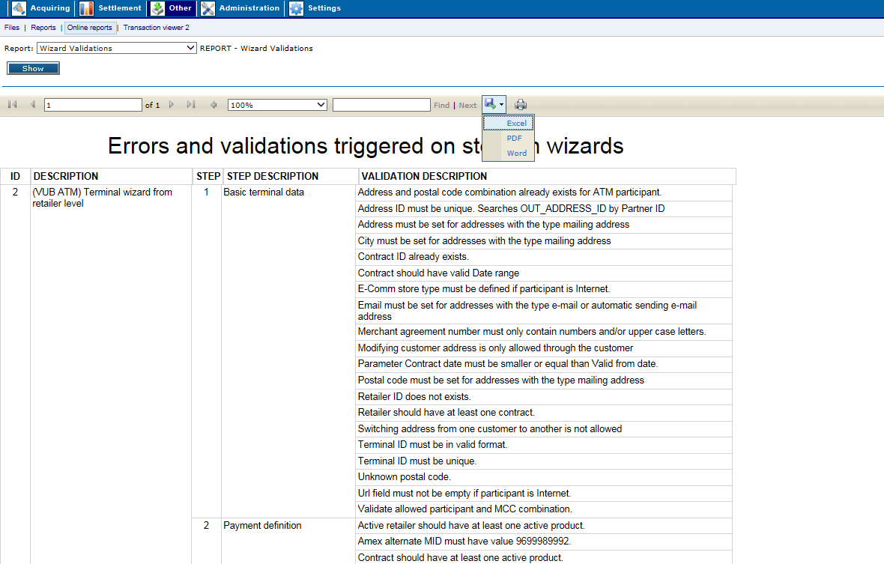

In user settings (*Settings* module > *User settings* option) should be activated possibility to use this online report, for the certain user.

# 6. References

The list of documents, to which references are made during the creation of this document:

a) *ID-Generation policies_VUB_v_0_4_2.xlsx*

b) *DataMapping_VUB_POS_v_0_9_8.xlsx*

c) *VUB_Wizards_v_0_11.xlsx*

d) *CustomerSynchronization-VUB-Exact_v_0_4.docx*

# 7. Appendices

# 7.1. Links to the web services schemas

On the eXact test environment:

<https://exactdev:4436/UP/WS/WSDL/Acquiring_VUB.wsdl>

<https://exactdev:4436/UP/WS/XSD/AcquiringExact_VUB.xsd>

<https://exactdev:4436/UP/WS/XSD/CommonTypes.xsd>

# 7.2. Appendix A – Terminal status change diagram (UC POS 035, UC POS 038):



 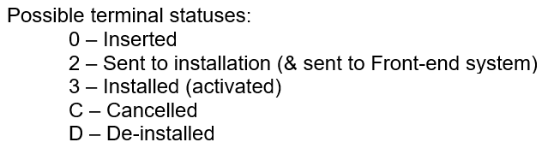

# 7.3. Appendix B - UML sequence diagram

# 7.4. ACQ-POS Create Customer

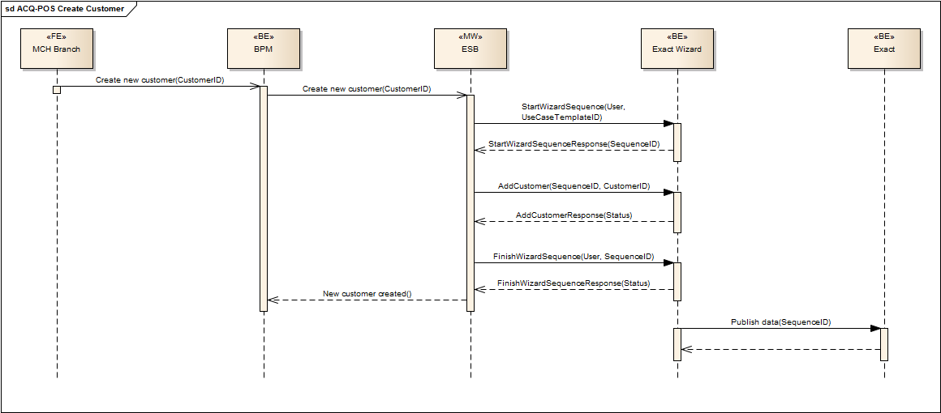

# 7.5. ACQ-POS Create Contracts

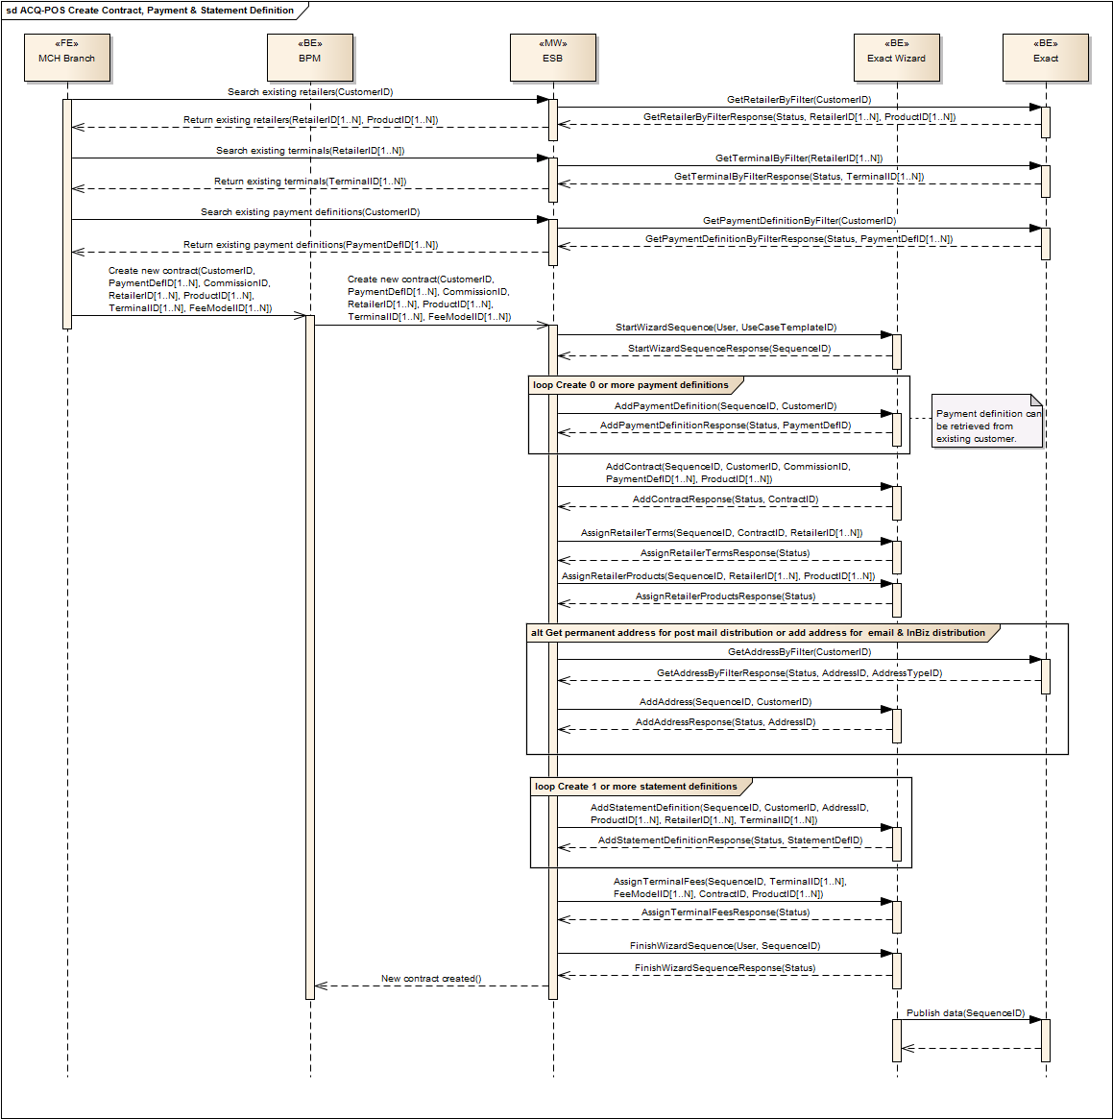

# 7.6. ACQ-POS Create Retailers & Terminals

# 